**



|  |  |
| --- | --- |
| Name student (incl. student number): | Name : Dimitar Rangelov  Student Number : 445392 |
| Name client: | REV'IT! Sport International B.V. -  Jorrit Memel |
| Name tutor: | Jenny Hesse |
| Names group members: | Isabel Wesselink (434129)  Femke Visser(435542)  Le Van Hoang Minh (467475) |
| Project name: | Testing device membrane fabrics for motercycling |
| Project number: | L.26195 |

1. *What does my client think of our delivered results?*

|  |
| --- |
| Feedback from REV’IT |

1. *What does my tutor think of my contribution to the group process?*

|  |
| --- |
| Feedback tutor: Jenny Hesse |

1. *What do my group members think of my contribution to the group process and the results?*

|  |
| --- |
| Feedback group members |

*Please add the pieces of evidence to this document.*

Table of Contents

1. Words List 4

2. Feedback from tutor 5

3. Feedback from the company: REVI’T 6

3.1Midterm Feedback 6

3.2 Final Feedback 7

4. Feedback from my group members 8

5. Saxion Festival Smart Solutions Semester 9

6. The assignment 11

6.1 Introduction organization 11

6.2 Assignment / Project goals 11

6.3 Requirements 11

6.4 What do we expect? 12

7. Final Product 13

8. Assessment rubic 15

9. Project Plan 23

10. Technical Research 42

11.Drilling wholes 63

12.Software Development 64

13. Software for firmware 67

14.Device 96

14.1 First Prototype 96

14.2 Second Prototype 96

14.3 Final Prototype / Final Device 97

15. Laser 99

16.Interview 100

17.Midterm presentation 101

18.Last Presentation REVIT 104

19. Product Manual 113

20. Testing 121

20.1 Testing final prototype – REV’IT! & Intrepid (21/01/2020 – 22/01/2020) 123

20.2 Graph testing final prototype – REV’IT! & Intrepid (04/01/20 – 09/01/20) 128

21. Problem solving 129

21.1 Accuracy problem solving 129

21.2 Burned sensors 129

21.3 Defected Chips 130

22. Skype interview Jorrit Memel 131

# 1. Words List

|  |  |
| --- | --- |
| Arduino | Arduino is very small mini computer based on easy-to-use hardware and software. |
| Humidity | Humidity is the concentration of water vapour present in air. |
| Breathability | Air permeability is the ability of a fabric to allow air to pass through it. While air permeable fabrics tend to have relatively high moisture vapor transmission, it is not necessary to be air permeable to be breathable. |

# 2. Feedback from tutor

The Smart Solution group of Femke, Isabel, Dimitar and Hoang worked together constantly and detailed on the project from Revit. I met them every week for questions and talking about their group work and progress. In the first quarter they actually did nearly most of the technical part so in the 2nd quarter they could really focus on constructing the actual machine Revit was asking for. They whole group work was very structured and they communicated well with the involved parties. During the midterm presentation they presented their work so far to the company Revit and they were very impressed and happy what the group actually made so far. I saw a lot of mails from Jorrit (Revit) about telling them how happy they are with the results so far and that they should go on with this great work. Furthermore they had some difficulties with one of the group members left earlier because of some circumstances. This group member was responsible for actually making the whole device but he left with no information left for the rest of the group so all of them dive deeper into the mechanical part and constructing part. They managed to make the whole machine by themselves however this wasn’t their expertise. They always communicated in a professional and respectful way with the company, with me but also in the group itself. They had some struggles in-between but they always managed to come to solutions with good communication, constantly reflecting with the goal to finish the device and deliver a great result to Revit.

# 3. Feedback from the company: REVI’T

## 3.1Midterm Feedback

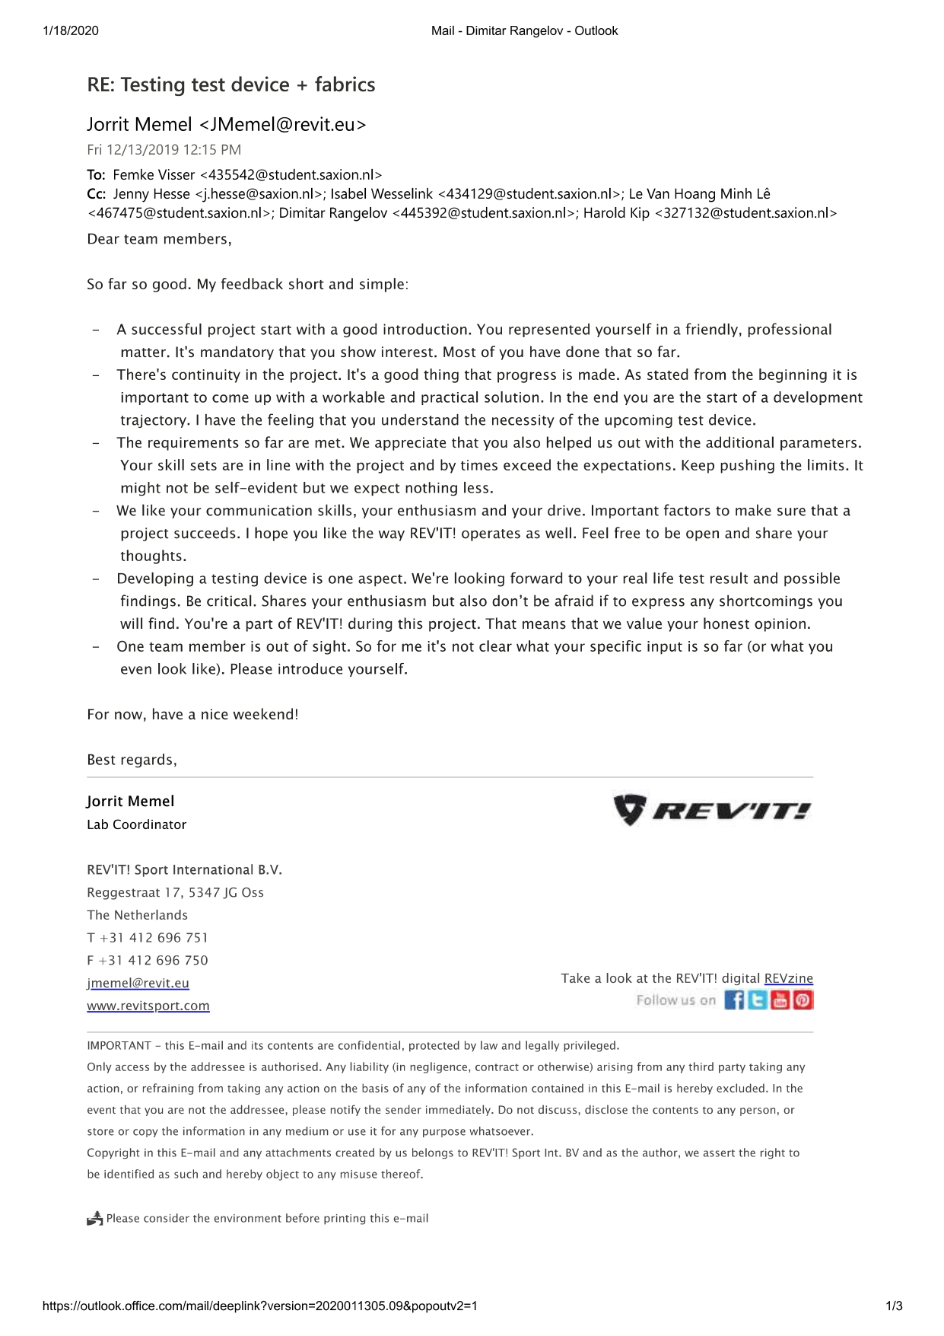

## 3.2 Final Feedback

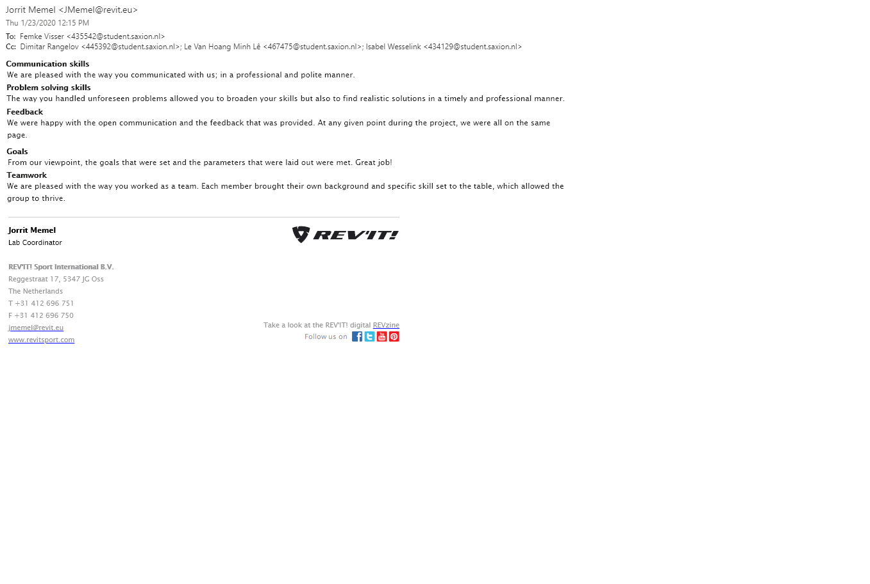

# 4. Feedback from my group members

**From Femke Visser:**

During the Smart Solutions Project I have worked with great pleasure with Dimitar. Dimitar always had a lot of input in the meetings and showed with enthusiasm his passion for his study Electronic Engineering by explaining a lot about sensors, software and hardware. He took a lot of initiative during the project by creating different prototypes and he was always open for discussions. Overall, Dimitar is a very motivated and hardworking student who has put a lot of time and effort into the Smart Solutions Semester project.

**From Isabel Wesselink:**

It was really nice to work together with Dimitar. He knows a lot about his studies and made sure that every sensor and program is working well. Without him this project would be a flop. He always meets the deadlines and does a great job by making everything work. He gave a lot of innovative ideas, input and is critical about the project. Dimitar works really hard and it was a real pleasure to work with him!

**From Le Van Hoang Minh:**

It was a great experience when I worked with Dimitar, he is a really smart guy and knowing what he was doing especially in his major. As a technical guy, I am really respect all the qualities and knowledge that he has and also his own effort in this project. Moreover, his energy and enthusiasm was actually playing an important role to make this project go further. As a friend and also co-worker, it was a real honor to work with him.

# 5. Saxion Festival Smart Solutions Semester

The picture below is representing the email from Saxion Festival Smart Solutions Semester to us the student and in it they are showing their appreciation that we join their festival.



The next figure is showing how was looking the table of our team in the Saxion Festival Smart Solutions Semester. There were poster, presentation on one of the computer and demonstration on another computer. Also in front of everything there are final prototype and the textiles from REVI’T.

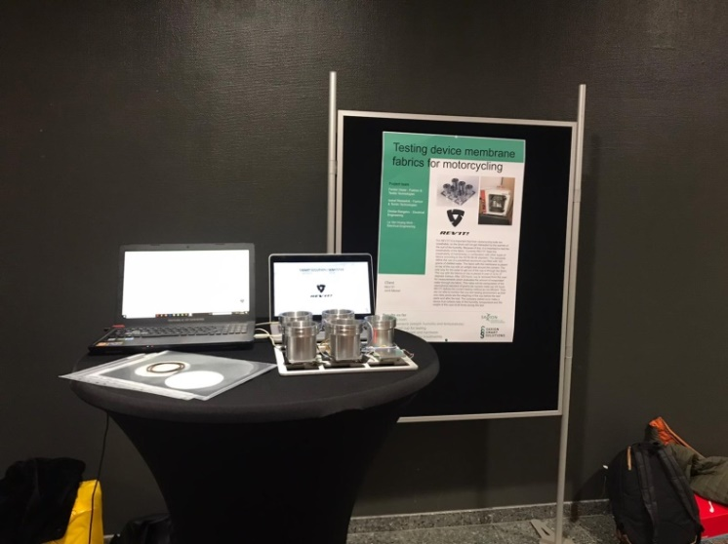

There is a picture of all the members of the team that joined the Saxion Festival Smart Solutions Semester.

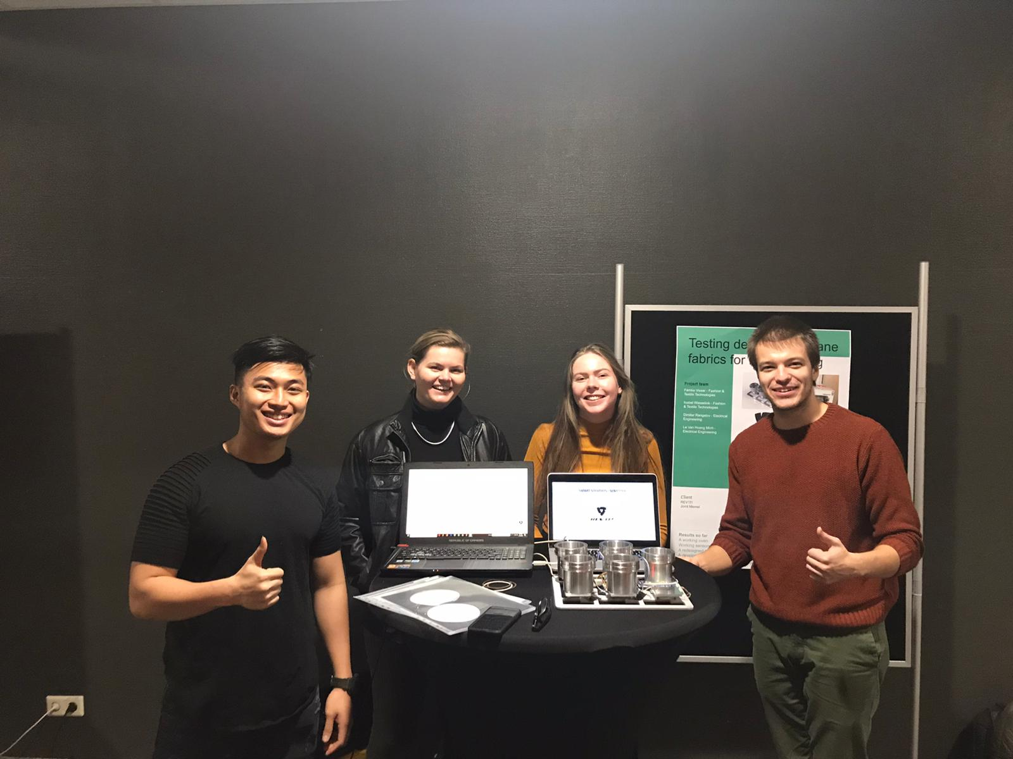

There were some problems on the final prototype after the Saxion Festival Smart Solutions Semester caused from visitors that pushed to much the load cells or damaged some of the sensors. But more details about that and how the problems were solved will be provided in 20. Problem solving.

# 6. The assignment

## 6.1 Introduction organization

REV'IT! Sport International designs and develops fashionable riding gear for motorcyclists. We work from our offices in Oss and New York. REV'IT! is a leading brand that produces the highest quality functional riding apparel available in more than 70 countries. Passionate motorcycle riders all over the world are wearing our brand.

## 6.2 Assignment / Project goals

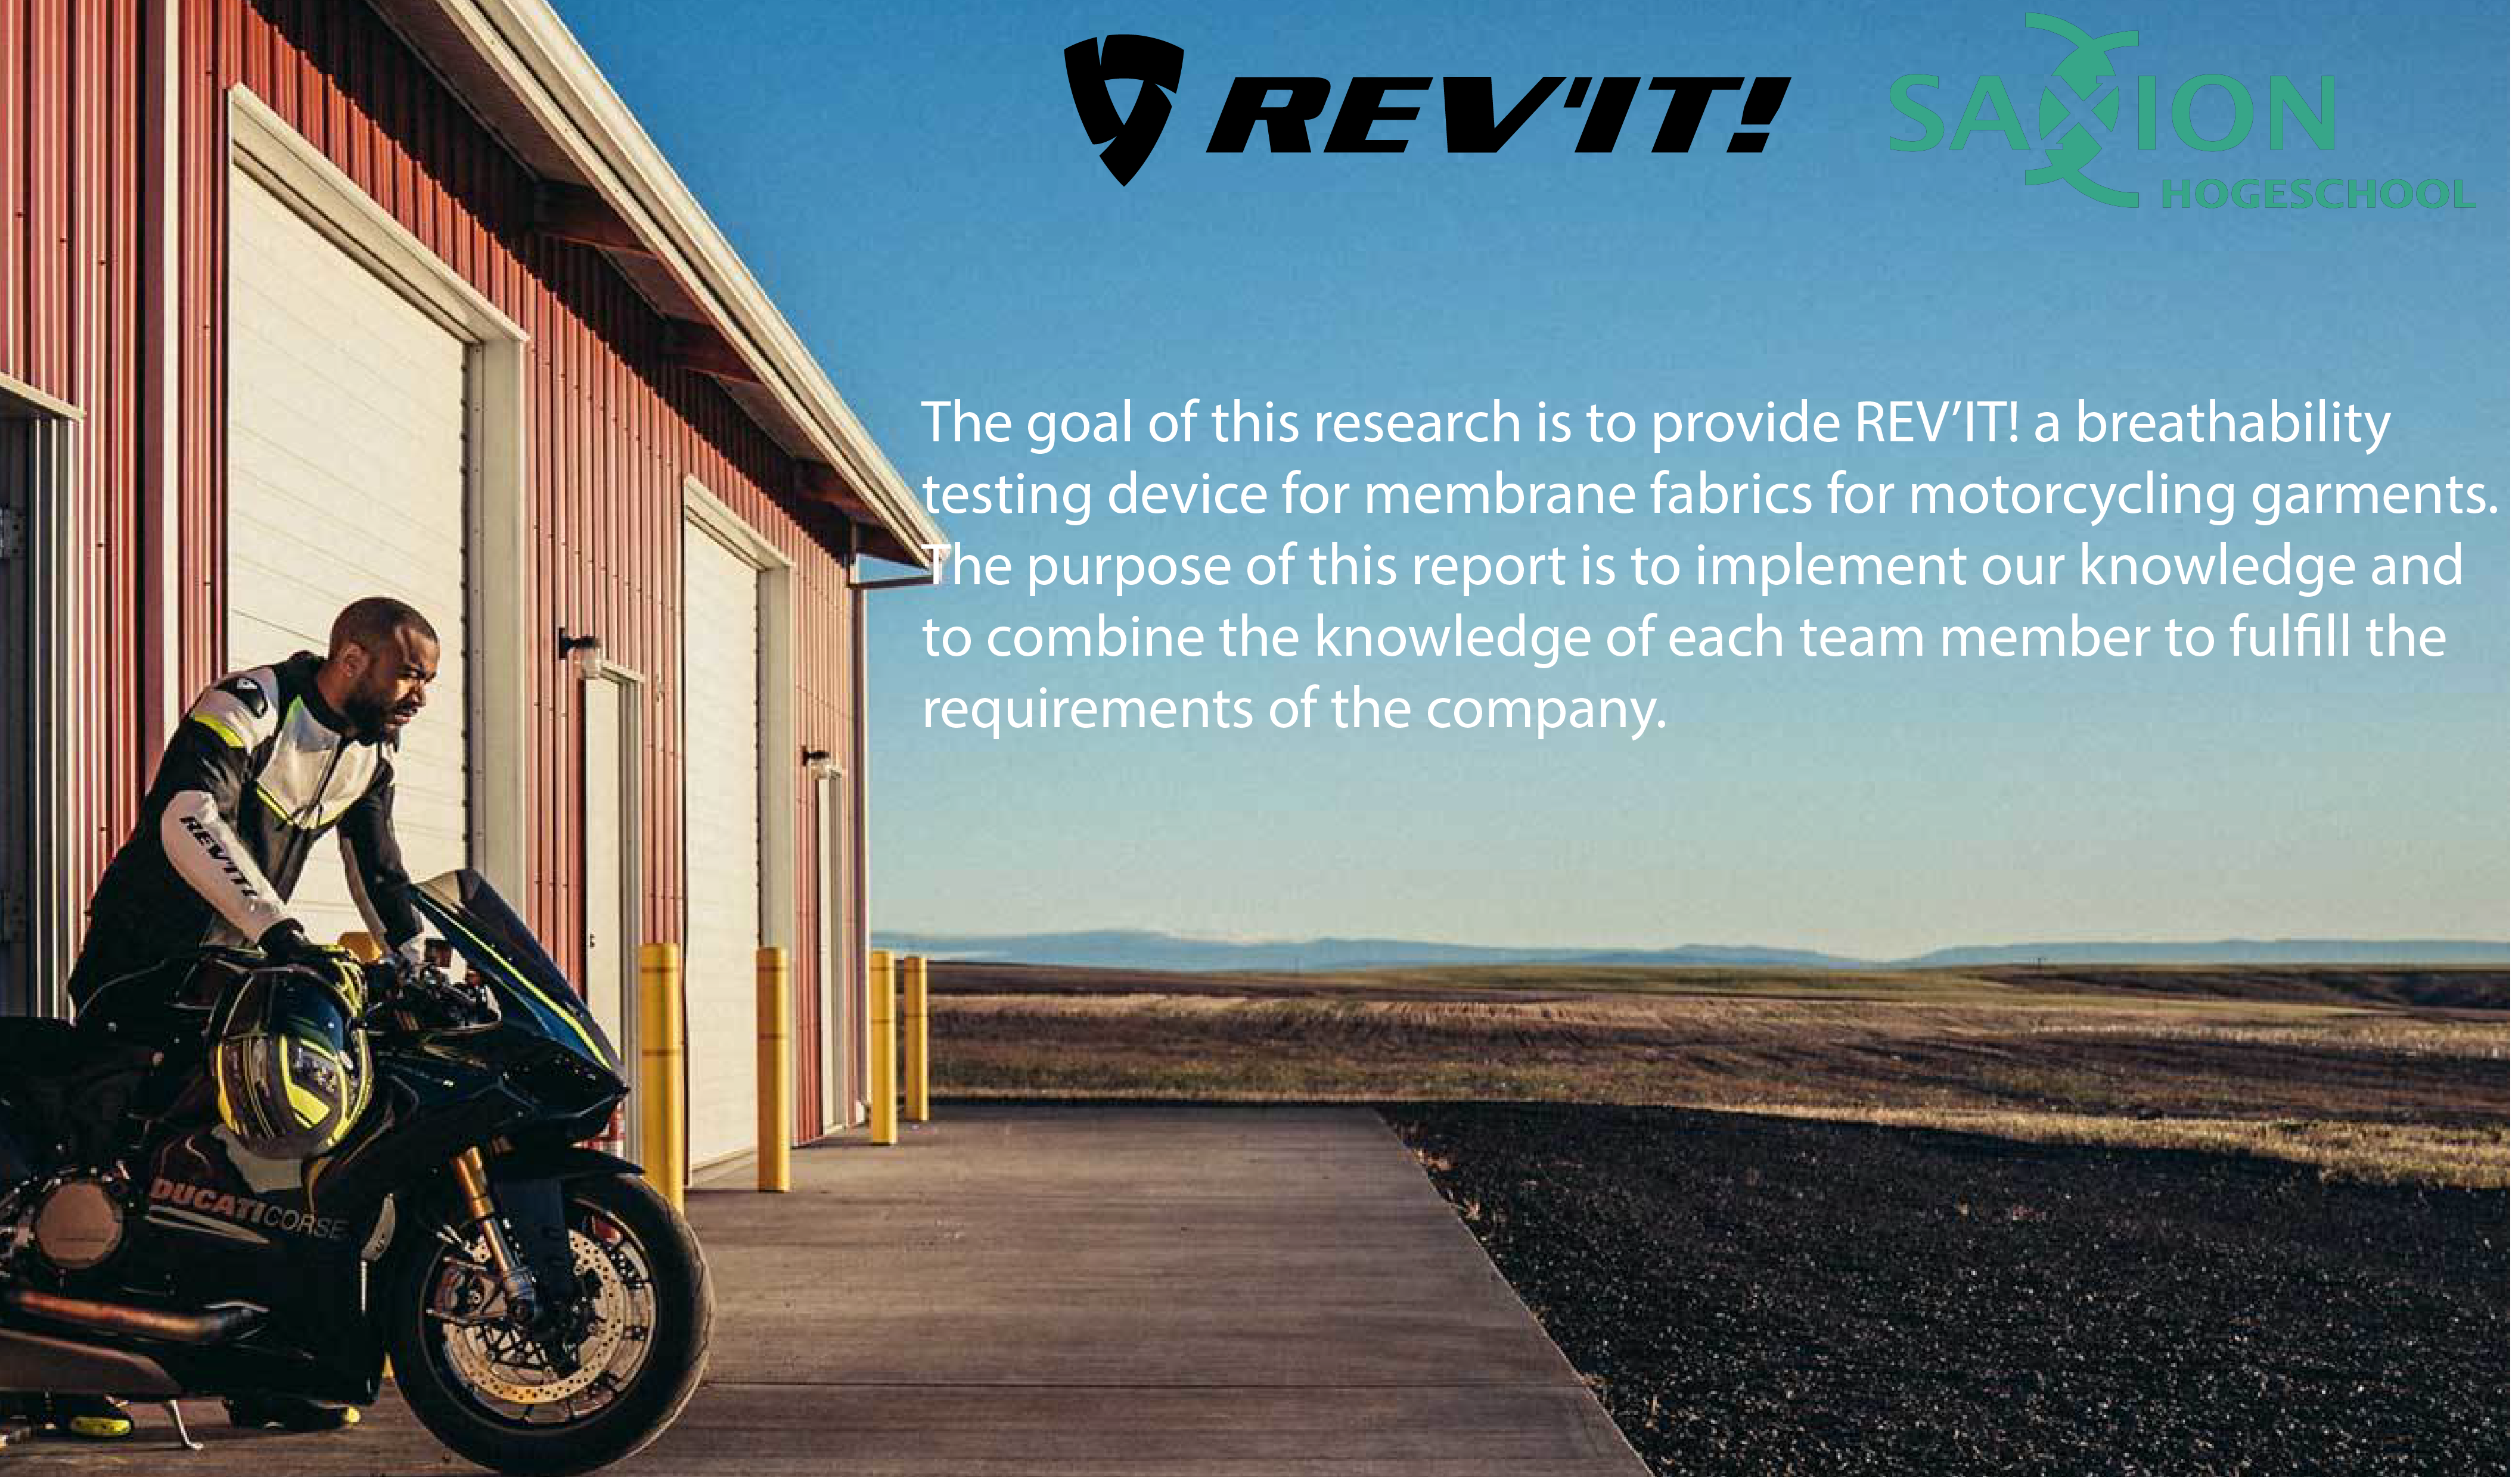

## 6.3 Requirements

* Measuring humidity, temperature and weight of REVI’T cups.
* To have real time access to the data in visible way. Making special software to manage the data and to represent it.
* To have the opportunity to save the data from the experiments.
* Тhe device to be able to work with 6 cups.

## 6.4 What do we expect?

* A research on how these parameters can be analyzed and what the density of sensors should be in order to obtain useful test results.
* To find the relationship between that the humidity and weight of the cups.
* To research the behavior of the textile that was provided by REVI’T.
* A physical and fully functional prototype that includes these electronic construction solutions and operating sensors.

# 7. Final Product

The final product consist from 6 packs of cup, SHT85 (temperature/humidity sensors), 2 x foam rings, 1 x plastic rings and also a metal plate that has on it one motherboard with 6 chips and 6 load cells that are measuring the weight of the cups. Everything is with hotspot connection and really easy changeable.

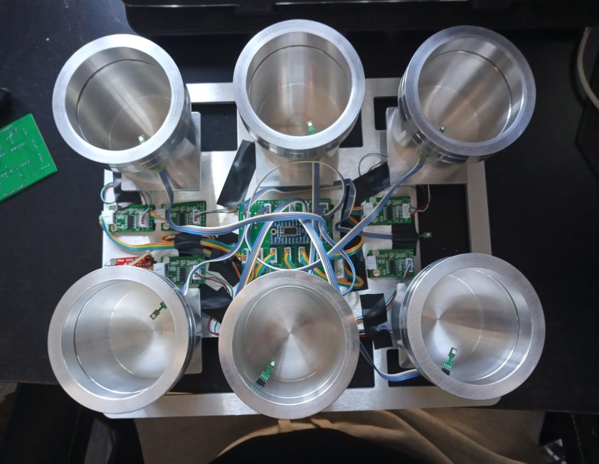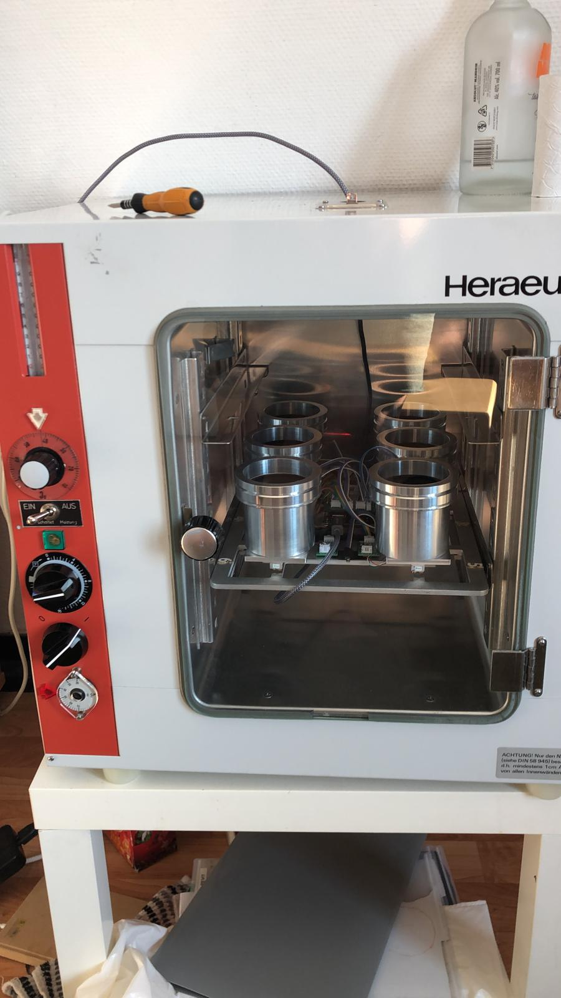

The figure below is representing a pseudo schematic of the final prototype. The schematic is prepared especially for non-engineering people and is representing all of the components and connection in really easy and accessible way. The top part of it they are six HX711 chips that are connected to 500g load cells bridges. In the bottom of the schematic there are seven SHT85 temperature/humidity sensors. Six of them are for the six cups and one for measuring the environment of the oven. They are connected directly to I2C extender which is connected to the microcontroller.

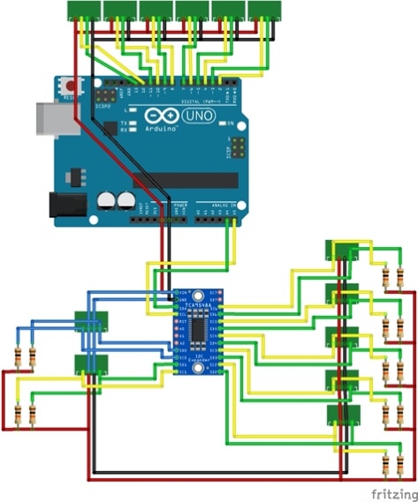

The figure below is representing the PCB (Printed circuit board) of the final prototype. This is a pseudo representation of it. In real the PCB won’t look like that. The PCB is containing only female 4 pin connector for all of the sensors and everything will be really easily to be disconnected or connected. In center there is socket for the I2C extender.

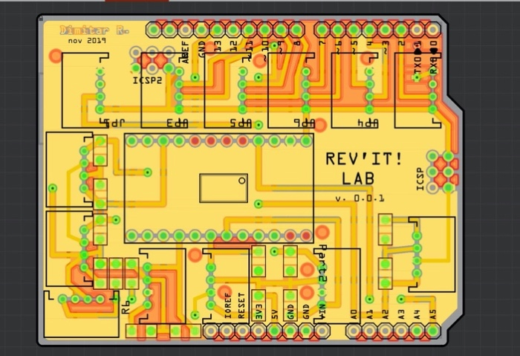

# 8. Assessment rubic

|  |  |  |  |
| --- | --- | --- | --- |
| **Assessment criterium** | **How would you grade yourself?** | **Indicate the evidence provided and explain why this evidence is relevant. \*** | **If the evidence indicated is part of a group project, describe your specific part of the group project here.** |
| 1. The student conducts research using a suitable research and design model and substantiates the choice of model and the steps taken. | I think I scored excellent, because at the beginning after the brainstorming I made a technical research about the sensors that we can use in the project. After that I also had interview with a teacher in my field to check if the outcome of my research is reliable. After considering that the outcome of the technical research is sufficient and choosing the right components for the project, I choose to use the rapid prototyping for making the first prototypes, so I could easily and quickly get results and start making experiments to figure out the correlation between humidity and weight in our devices.  According to the rapid prototyping it is important that we created a realistic and comprehensive product, rather than doing a lot of research. Because of that based on the first technical research made by me, I build the first prototypes and also the final product. Also because of that we do not have further researches.  In the end we had final report contain of the initial research that had be done, mainly described developing process and most importantly the product manual. | In the project plan all of the group members contributed something in all of the parts of the document. The project plan is defining the roles and reposiblities and the methodology of the project. Also in it is analyzing the problem that is the main topic of the project. Project Plan(Evidence 1)  The product manual is really important, because it is part of the rapid prototyping method. It shows in a quick and simple way how the product works and this is really valuable for REV’IT. Product manual(Evidence 11)  For more detailed information about the process of developing the device and the research that had be done the client can check the final report. The main part of the final report consist of technical research and developing part. In the developing part I am explaing the code of the firmware and the device. Also the hardware components and how they are working.  Technical Research (Evidence 2)  Firmware Software (Evidence 4 )  Device software (Evidence 5 )  Device (Evidence 6) | I worked with Minh and Femke together for the creation of the Product manual. My part is writing the instructions step by step and making the photos of each of the steps.  In the project plan all of the group members contributed something in all of the parts of the document.  I worked with Minh in the testing one of the sensors in my technical research. My part was making the technical research. |
| 1. The student collects, analyses, and processes relevant information in a traceable manner. | I think I scored excellent, because I contribute in head developing of the project plan.  Also I made technical research and detailed information about the devices in really clean and traceable manner to be easy in the end the client to understand everything. In the process of writing these documents I collected literature about the sensors and innovative solutions.  In the end we made the product manual in really understandable and traceable way step by step, so the client to have really client overview how to operate with the device.  Also we collect information from our experiments with the device and we analyze the manner of the textiles. And part of the team makes quality reports. | Our team analyzed the behaviour of the textiles from the results from the expriments with the prototypes and the final devices. Beforehand we knew how the textiles supposed to behave in theory but after the experiment we also can represent in graphs this behavior.  Testing(Evidence 12)  The project plan is analyzing the problem that is the main topic of the project. I helped in the anlyzing the problem and stucturating the main research question and the subquestions. Project Plan(Evidence 1)  My part was making the technical research and writing detailed information for the device which is a big part of the content of the final report. The information supposed to be delivered in really clear and traceable manner, so the client without any technical background to understand how the device is working.  Technical Research (Evidence 2)  Firmware Software (Evidence 4 )  Device software (Evidence 5 )  Device (Evidence 6)  The product manual shows in a quick and structured way how the product works. Product manual(Evidence 11) | I helped in the analyzing of the behavior of the Gortex from the results of experiments with the final device.  In the project plan all of the group members contributed something in all of the parts of the document.  I worked with Minh and Femke together for the creation of the Product manual. My part is writing the instructions step by step and making the photos of each of the steps. |
| 1. The student applies knowledge from their own particular discipline and substantiates their choices. | I think I scored excellent, because this project is mainly directed to my specialty and most of the things supposed to be done or supervise by me or my colleague Minh.  I make technical research that is involving some much literature and also so many innovative ways of working with the sensors used in the project.  I write detailed information about the device and with this information everybody with some technical background can reproduce the prototype really easy.  I have so many situations that the product had problems or bugs that I supposed to analyze and fix.  Also in other hand I was mainly responsible for the developing of the prototypes and the final product. And I helped in the analyzing of the behavior of the textiles, but this is not related with my specialty. | I have so many situations that the product had problems or bugs that I supposed to analyze and fix. For example at the beginning in the first experiments we did not have satisfying results because the accuracy of the weight sensors was like 140 gram without anything behind the zero. But after some investigating and hard work I made the accuracy to be [140.00] with two signs after that comma. This makes our device and our experiments way more accurate and better.  Problem Solving (Evidence 13)  My part was making the technical research and writing detailed information for the device which is a big part of the content of the final report. The information supposed to be delivered in really clear and traceable manner, so the client without any technical background to understand how the device is working.  Technical Research (Evidence 2)  Firmware Software (Evidence 4 )  Device software (Evidence 5 )  Device (Evidence 6)  I helped in the analyzing and understanding of the behavior of the textiles.  Testing (Evidence 12) | I worked with Minh in the testing one of the sensors in my technical research. My part was making the technical research. |
| 1. The student has provided an innovative solution or problem-solving approach for the client. | I think I scored excellent, because the client (REV’IT) is very content and really impressed with the product that we delivered. We started with the assignment they gave us and we succeeded to satisfy all of the requirements and all of the additional supplements that client wanted from us. The product we made is innovative, because there is no similar machine in the world for testing the breathability of textile. Also the sensors for the temperature and humidity SHT85 do not have library to work multiple sensors at once. But I build a brand new library that is able to read the data from multiple sensors at same time with accuracy of 99.7%.  In the end the product is not just a prototype or problem-solving approach, it is a real innovate product ready for use from the clients. We do not want to give them just a prototype. We wanted to give them a device that directly will be implemented in their labs and their verification process. | The assignment shows the problem REV’IT had and the expectations they had. The assignment  The feedback we got from REV’IT is important, because it shows that the client is impressed by the end result we made and that we provided a product that can be directly implemented in their labs. Feedback from the company: REV’IT  The technical research and more detailed description of the device and the software is giving the big picture how inovative is the product that our team build. And how many inovative solution we implement in the project as implementing way how multiple SHT85 sensors to work at same time.  Technical Reseach (Evidence 2)  Device (Evidence 6)  Testing (Evidence 12)  Because of the circumstances that one of our team members (Harold Kip) supposed to leave our team, we should finish his part of the work. He was responsible for the mechanical part of the project.Anything raleted with his speciality. Because of his missing we supposed to laser cut the foam and plastic rings for the cups. Also to drill wholes on the metal cups.  Drilling (Evidence 3)  Laser (Evidence 7)  Also there were some problems that I supposed to solve. For examples after Smart Solution festival there were burned sensors and defected board that I supposed to analyze the problem and fix everything on the device.  Problem Solving (Evidence 13) | I had the help of my team to solve some of the problems that pop up in the developing process, as laser cutting and drilling holes. |
| 1. The student communicates in a respectful, purposeful, and professional manner with all internal and external stakeholders. | I think I scored sufficient, because I have to make interview with teachers in my field and a group interview with Jorrit Memel from REVI’T. Also I have to communicate with the tutor and the other group members via mail and I communicated in a professional manner.    Also the client Jorrit Memel, the member of REV’IT, my tutor Jenny Hesse and my group member were content about the professional communication. | In the feedback of the client, my tutor and my group members one is able to read that the communication during the project was considered professional and pleasant with me.  Feedback from the client: REVI’T (Jorrit Memel)  Feedback from the tutor: Jenny Hesse  Feedback from my group members  Also as a group we supposed to make interview with our clients and try to keep the professional manner of communication. Interview with REVI’T (Evidence 14)  Also we had midterm and final presentation.  Midterm presentation (Evidence 9)  Final Presentation (Evidence 10)  I made an interview via email with Umit Guler in really direct and professional way.  Interview with Umit Guler (Evidence 8) | During the project I was the electrical and electronics engineer and as such I supposed to make interview with a teacher in my field for the purpose of research. |
| 1. The student takes responsibility within the group for the solutions and partial solutions as well as the processes. | I think I scored excellent, because my part in the project is to build the first prototypes and the final product. This means that I supposed to satisfy all of the main requirements of the client and also to add all of the additional supplements that REVI’T wanted.  Also to provide a technical research and detailed information about the developing process of this innovative product. I should write down all of the innovative solutions and I implement in the device.  Making the content of the product manual was also my responsibility.  Also my responsibility was to solve all of technical problem related with the device and to help my team with the mechanical work left from our ex-member. | My part was making prototypes, final product, and technical research and writing detailed information for the device which is a big part of the content of the final report. The information supposed to be delivered in really clear and traceable manner, so the client without any technical background to understand how the device is working.  Technical Research (Evidence 2)  Firmware Software (Evidence 4 )  Device software (Evidence 5 )  Device (Evidence 6)  Because of the circumstances that one of our team members (Harold Kip) supposed to leave our team, we should finish his part of the work. He was responsible for the mechanical part of the project.Anything raleted with his speciality. Because of his missing we supposed to laser cut the foam and plastic rings for the cups. I take the responsibility and make the holes in the cups by myown.  Drilling (Evidence 3)  Laser (Evidence 7)  I write all of the content in the poduct manual and also I make all of the pictures step by step in it.The product manual shows in a quick and structured way how the product works. Product manual(Evidence 11) | I had the help of my team to solve some of the problems as laser cutting and drilling holes.  I worked with Minh and Femke together for the creation of the Product manual. My part is writing the instructions step by step and making the photos of each of the steps. |
| 1. The student describes how they have looked at the project/question from the perspective of another discipline and what this means for the choices that were made. | I think I scored sufficiently, because I am always trying to discuss the solutions that I doing with other specialties. I am trying to put their ideas in the real product.  Also I helped my team in the analyzing of the behavior of the textiles from the results of experiments with the final device. I tried also to learn new thing from another discipline. | I helped in the analyzing of the behavior of the Gortex from the results of experiments with the final device.  Testing (Evidence 12)  I am trying to put their ideas in the real product.  Firmware Software (Evidence 4 )  Device software (Evidence 5)  Device (Evidence 6) | I gave electrical engineering ideas for analyzing of the textile. And we as team discuss different ideas from the different disciplines.  Together with the whole group we discussed this and made the decision. |
| 1. The student reflects on their actions and adjusts these actions based on this reflection. | I think I scored excellent, because I am always accepting feedback for my work or behavior. I adjusted the project plan and the final report after the feedback.  Also after the first experiment we did not have satisfying result and I adjusted the prototype to start to be more accurate and to have better and accurate results in the future. I am accepting also feedback about the prototypes and final device and I always doing my best to make the feedback in reality. | At the beginning in the first experiments we did not have satisfying results because the accuracy of the weight sensors was like 140 gram without anything behind the zero. But after some investigating and hard work I made the accuracy to be [140.00] with two signs after that comma. This makes our device and our experiments way more accurate and better.  Problem Solving (Evidence 13) | Every time when REVI’T wanted new thing to be add it in the prototype or in the final product I was implementing it. |

* ) Please add pieces of evidence (or a reference) to this document

# 9. Project Plan

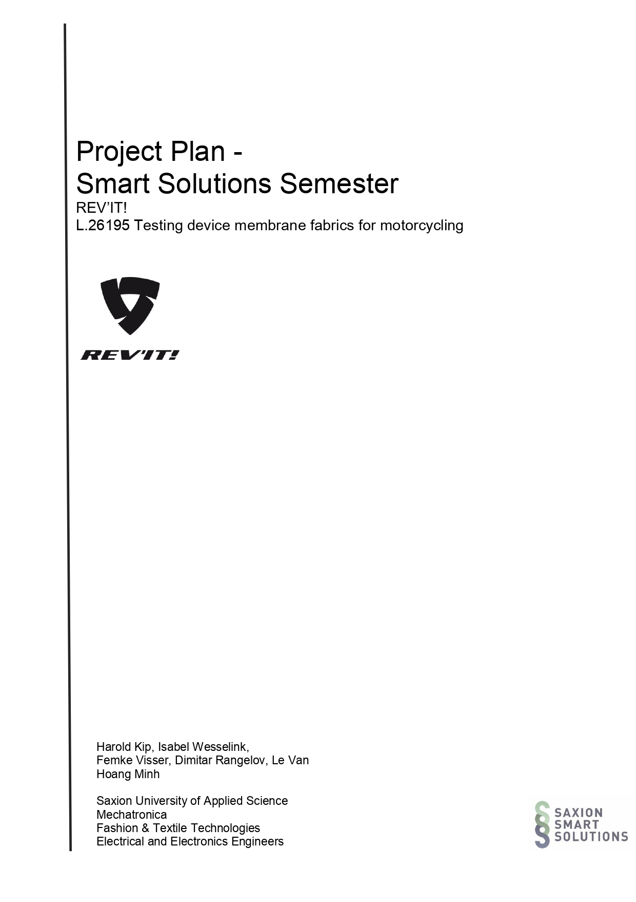

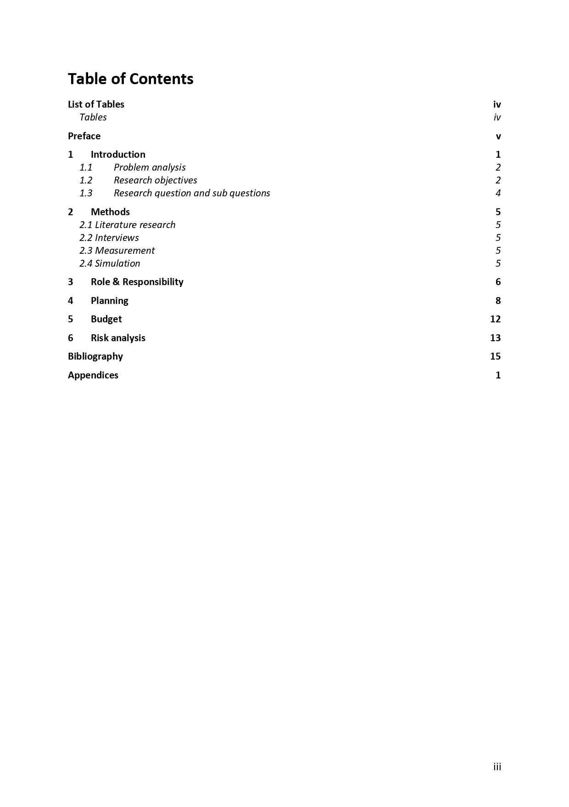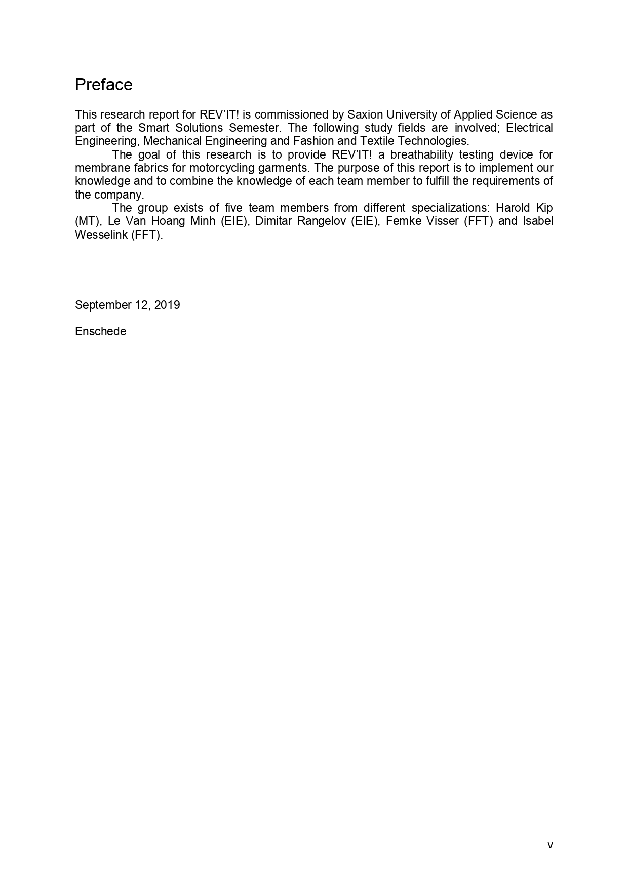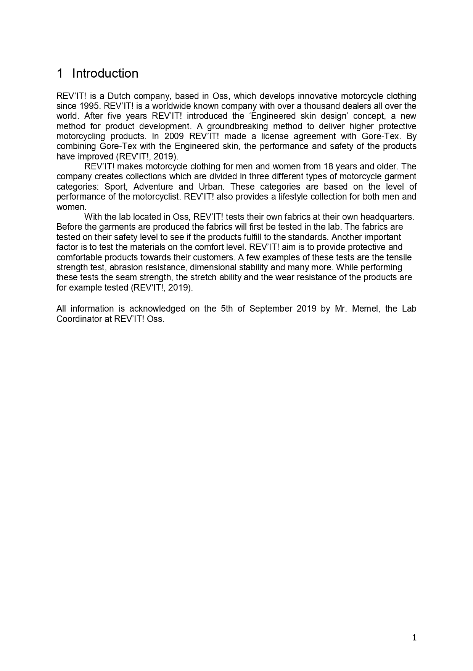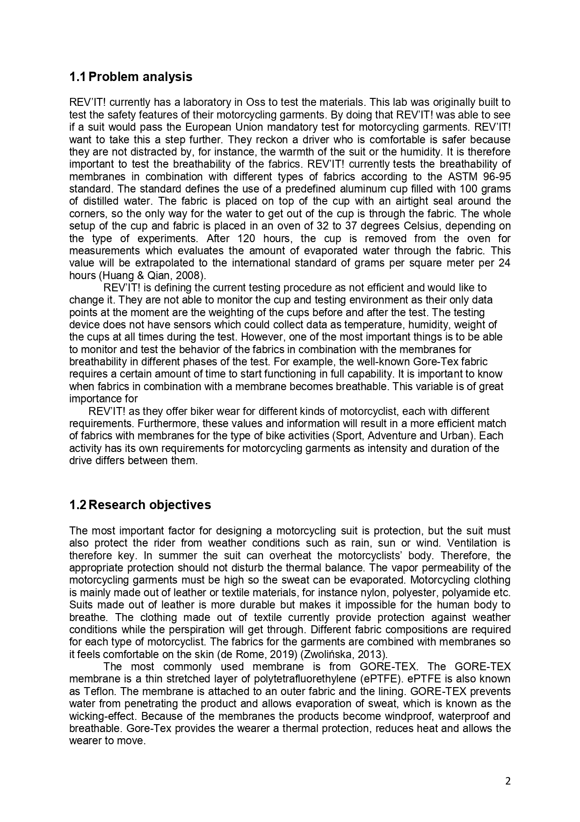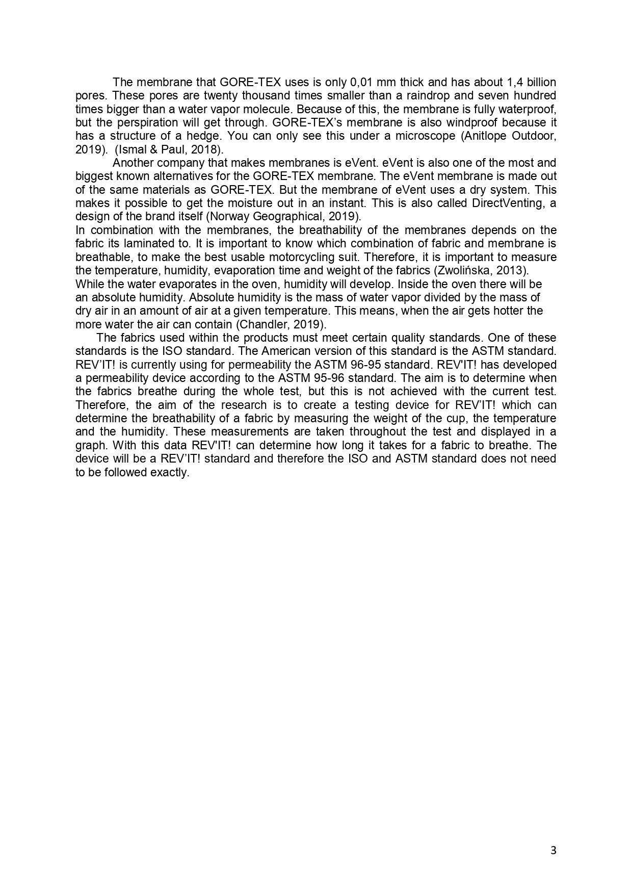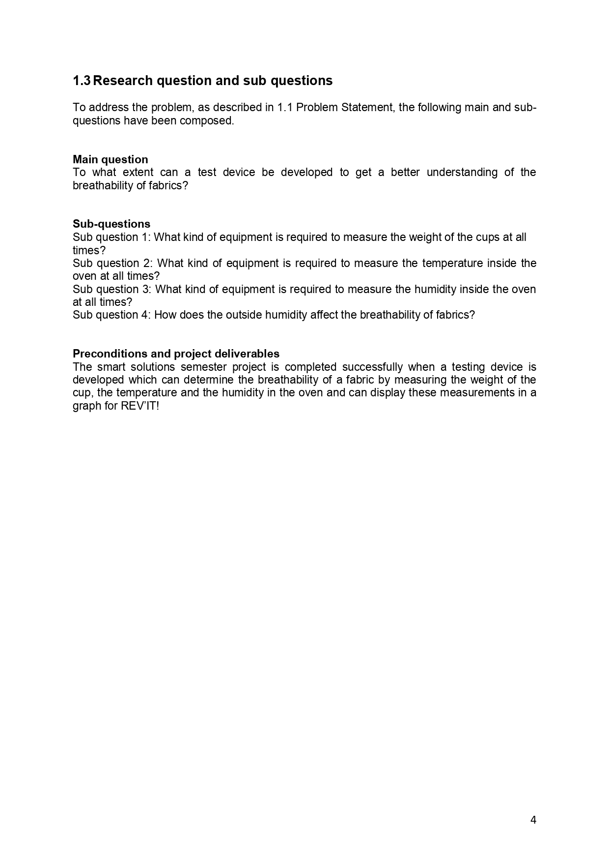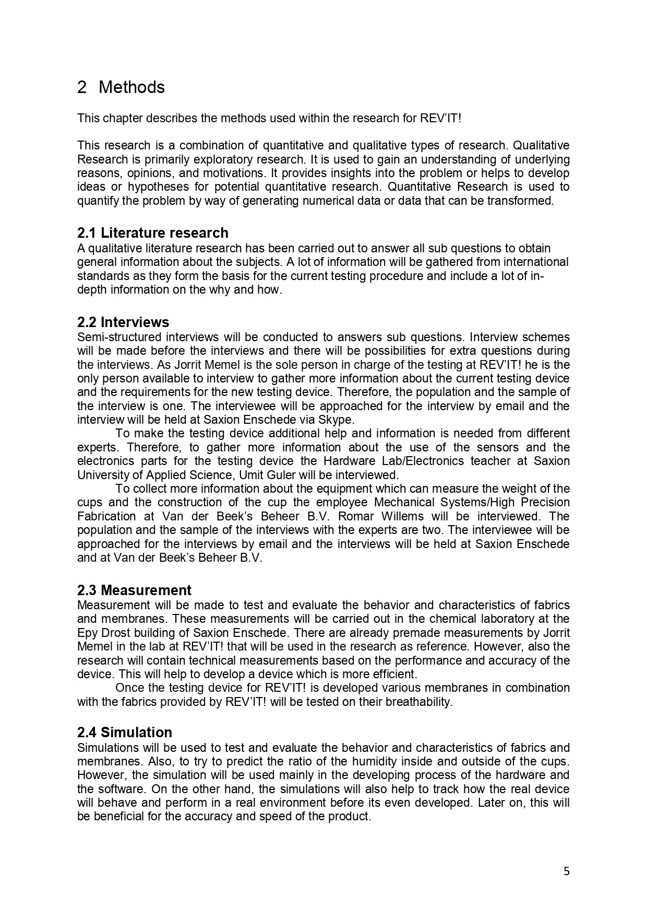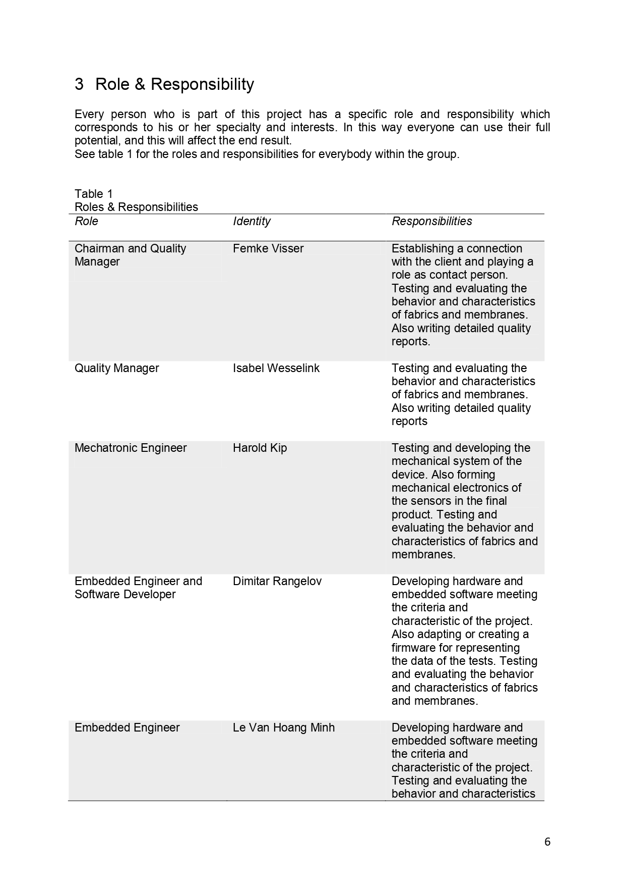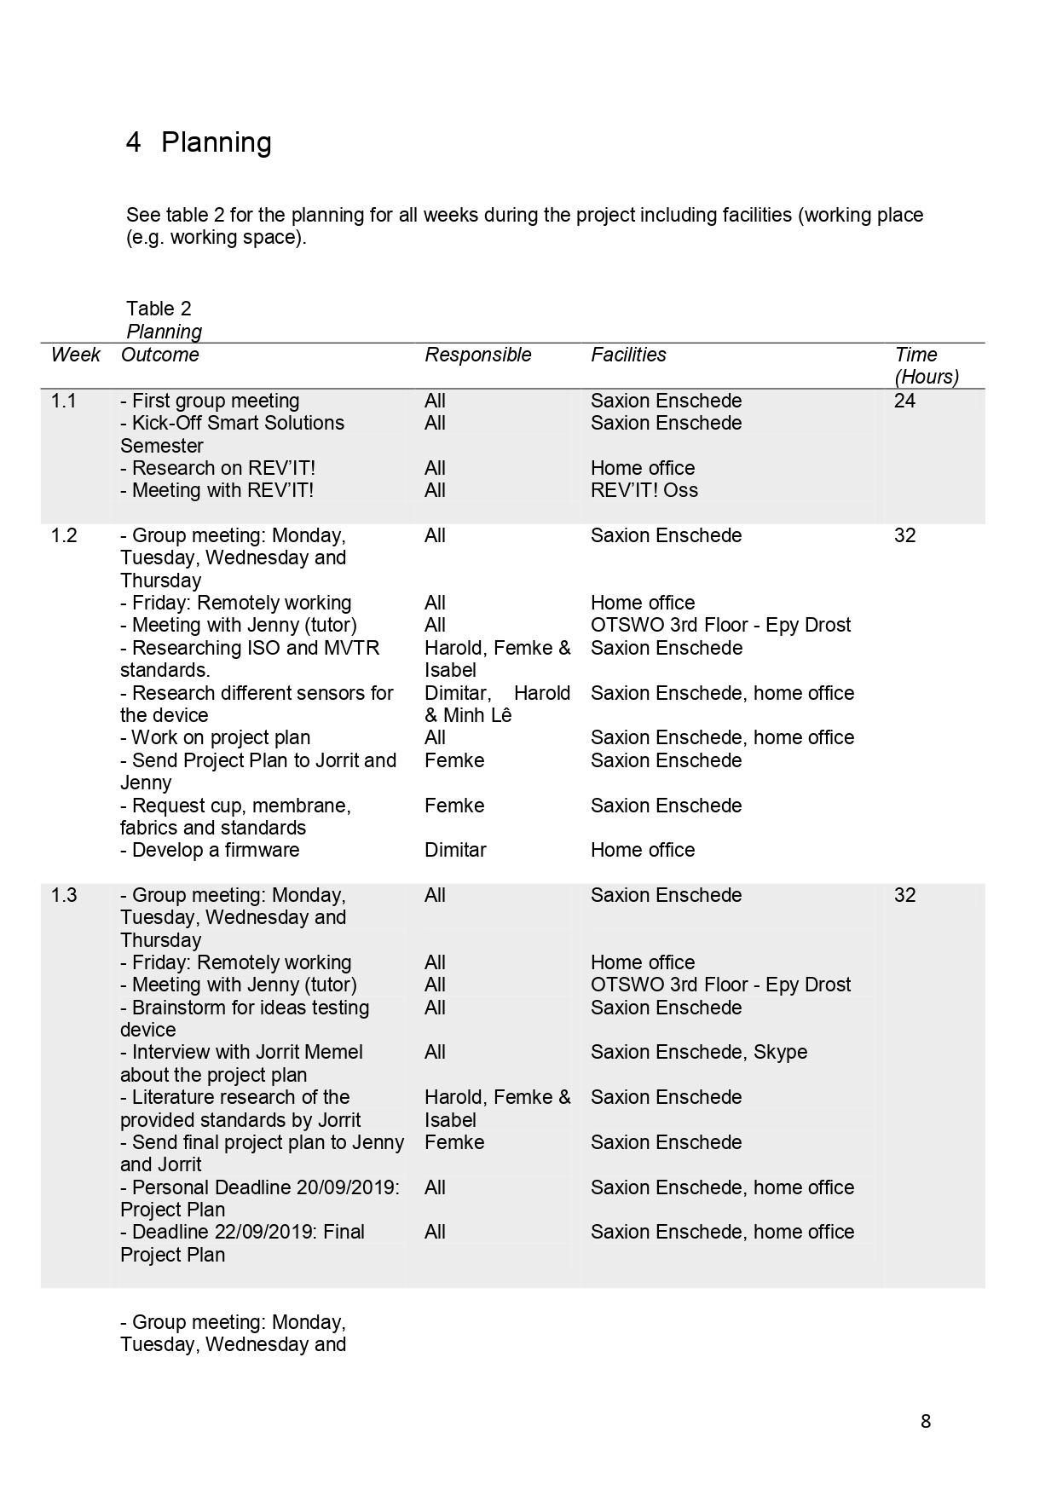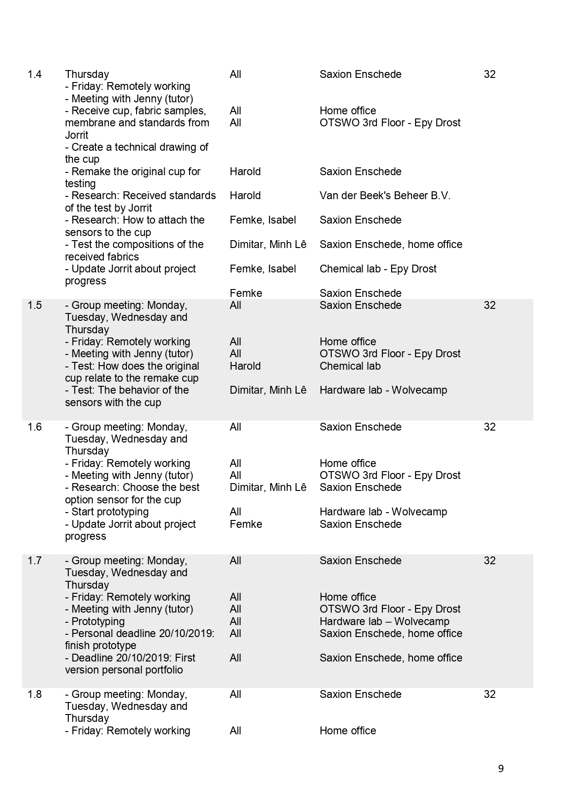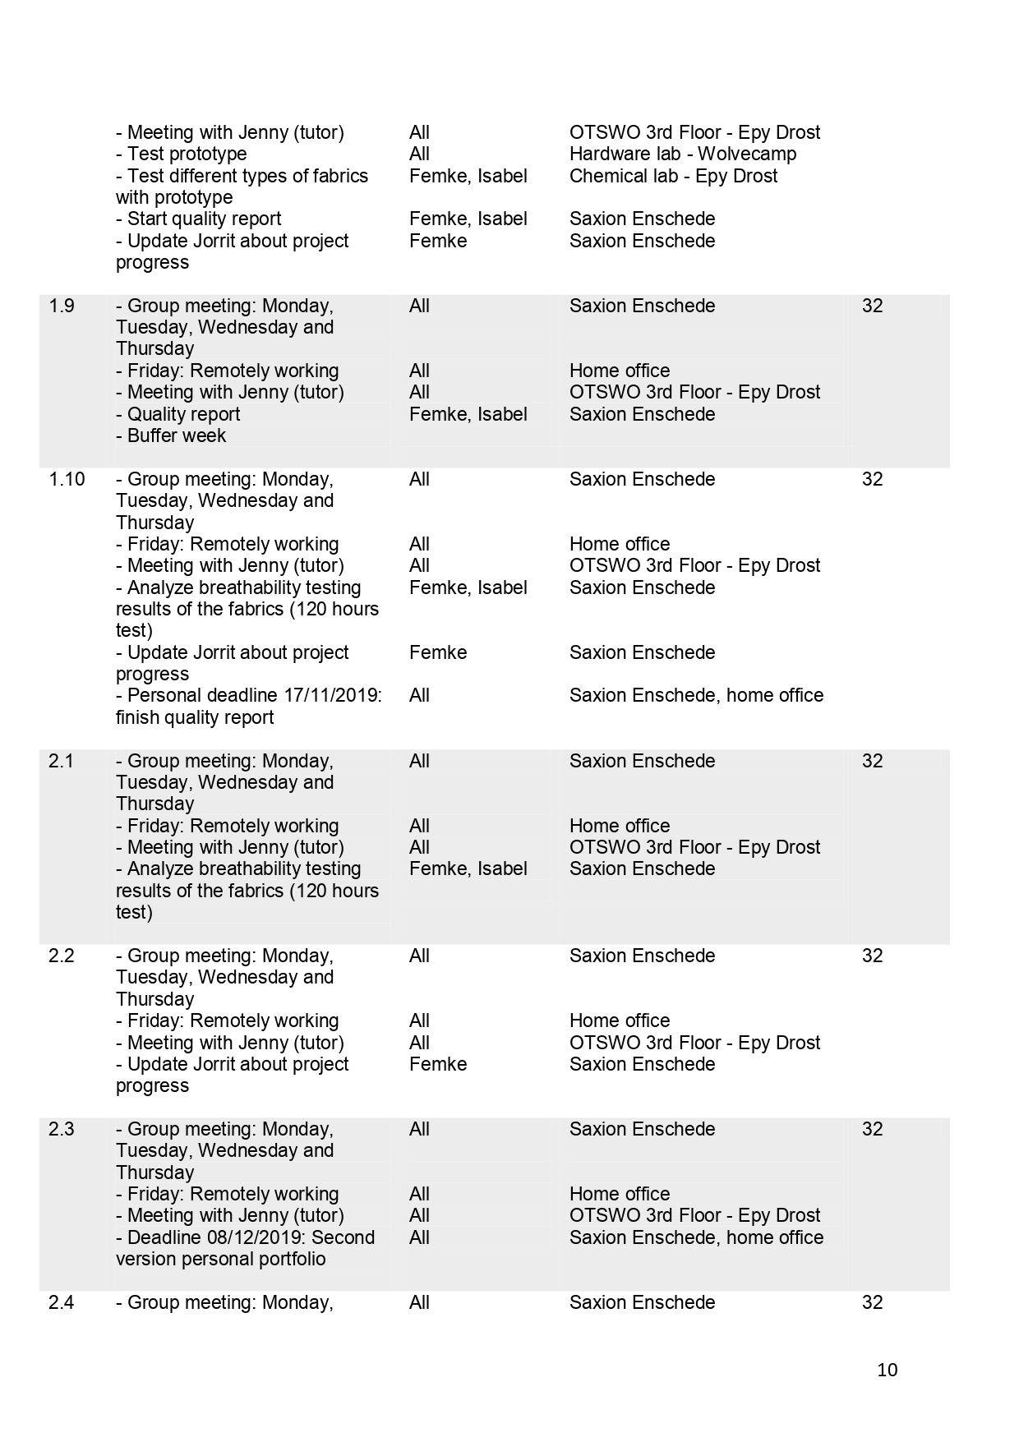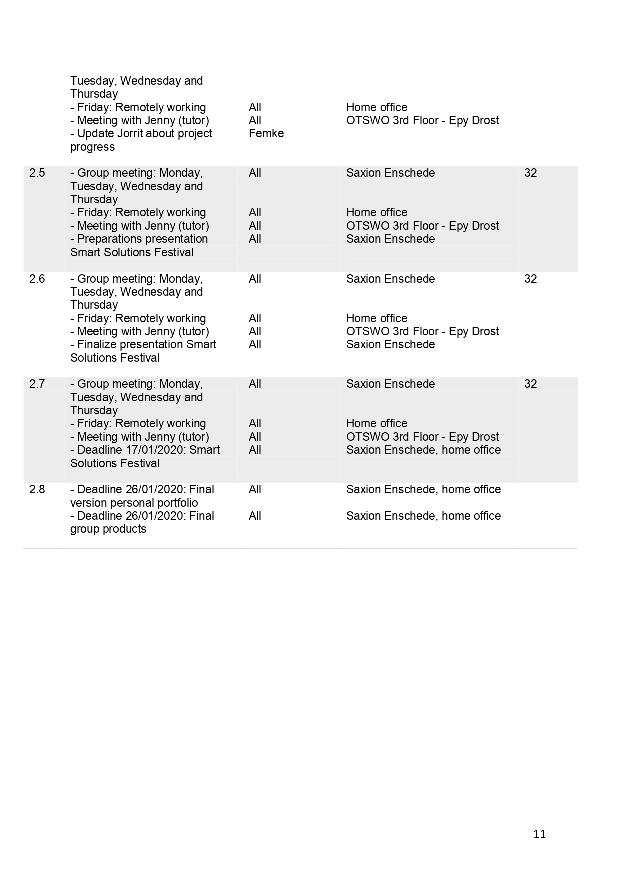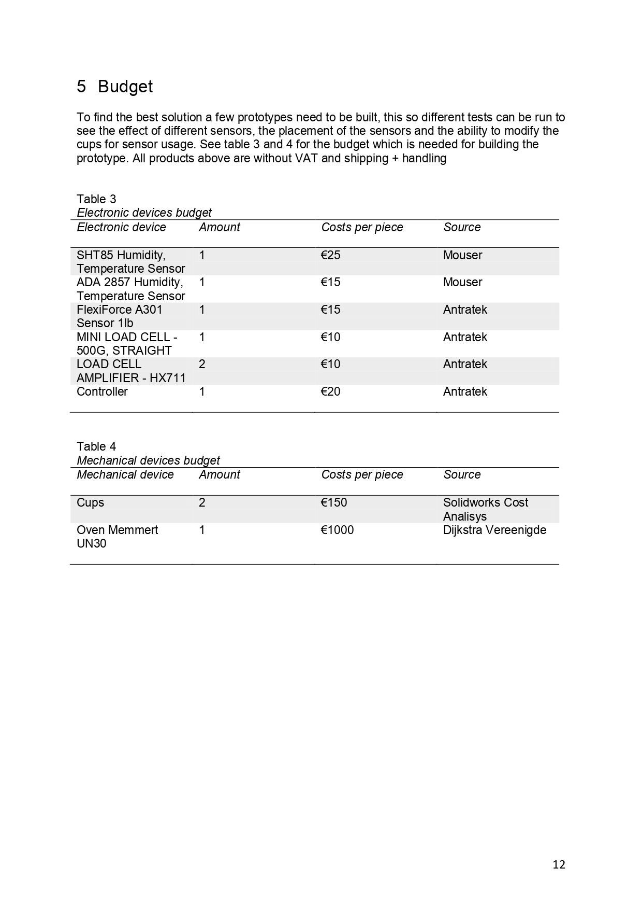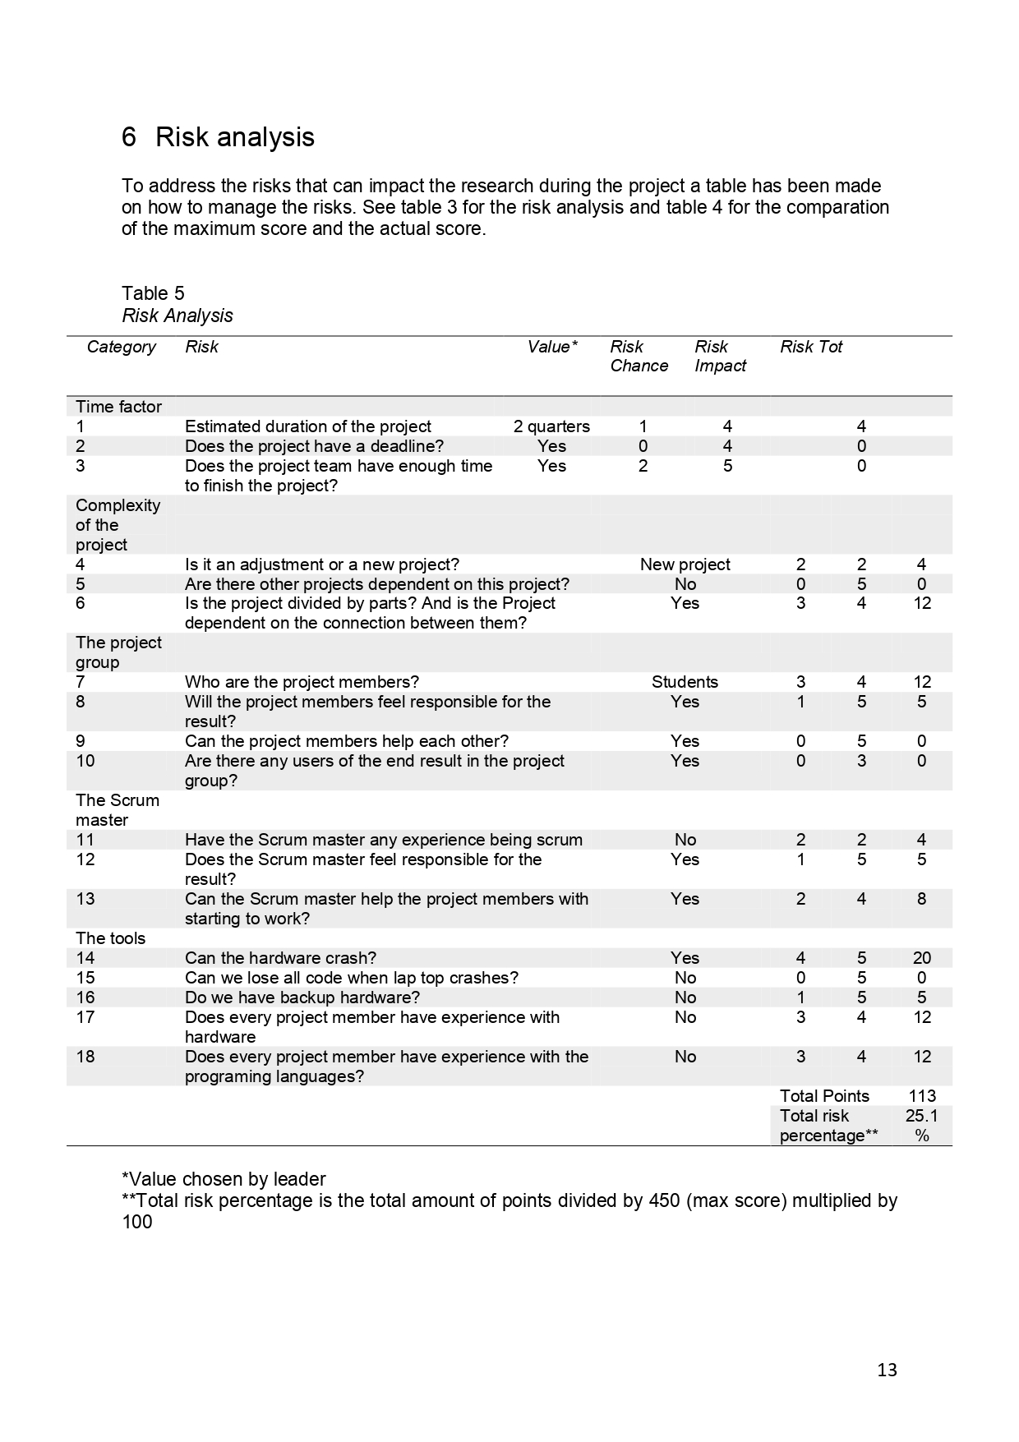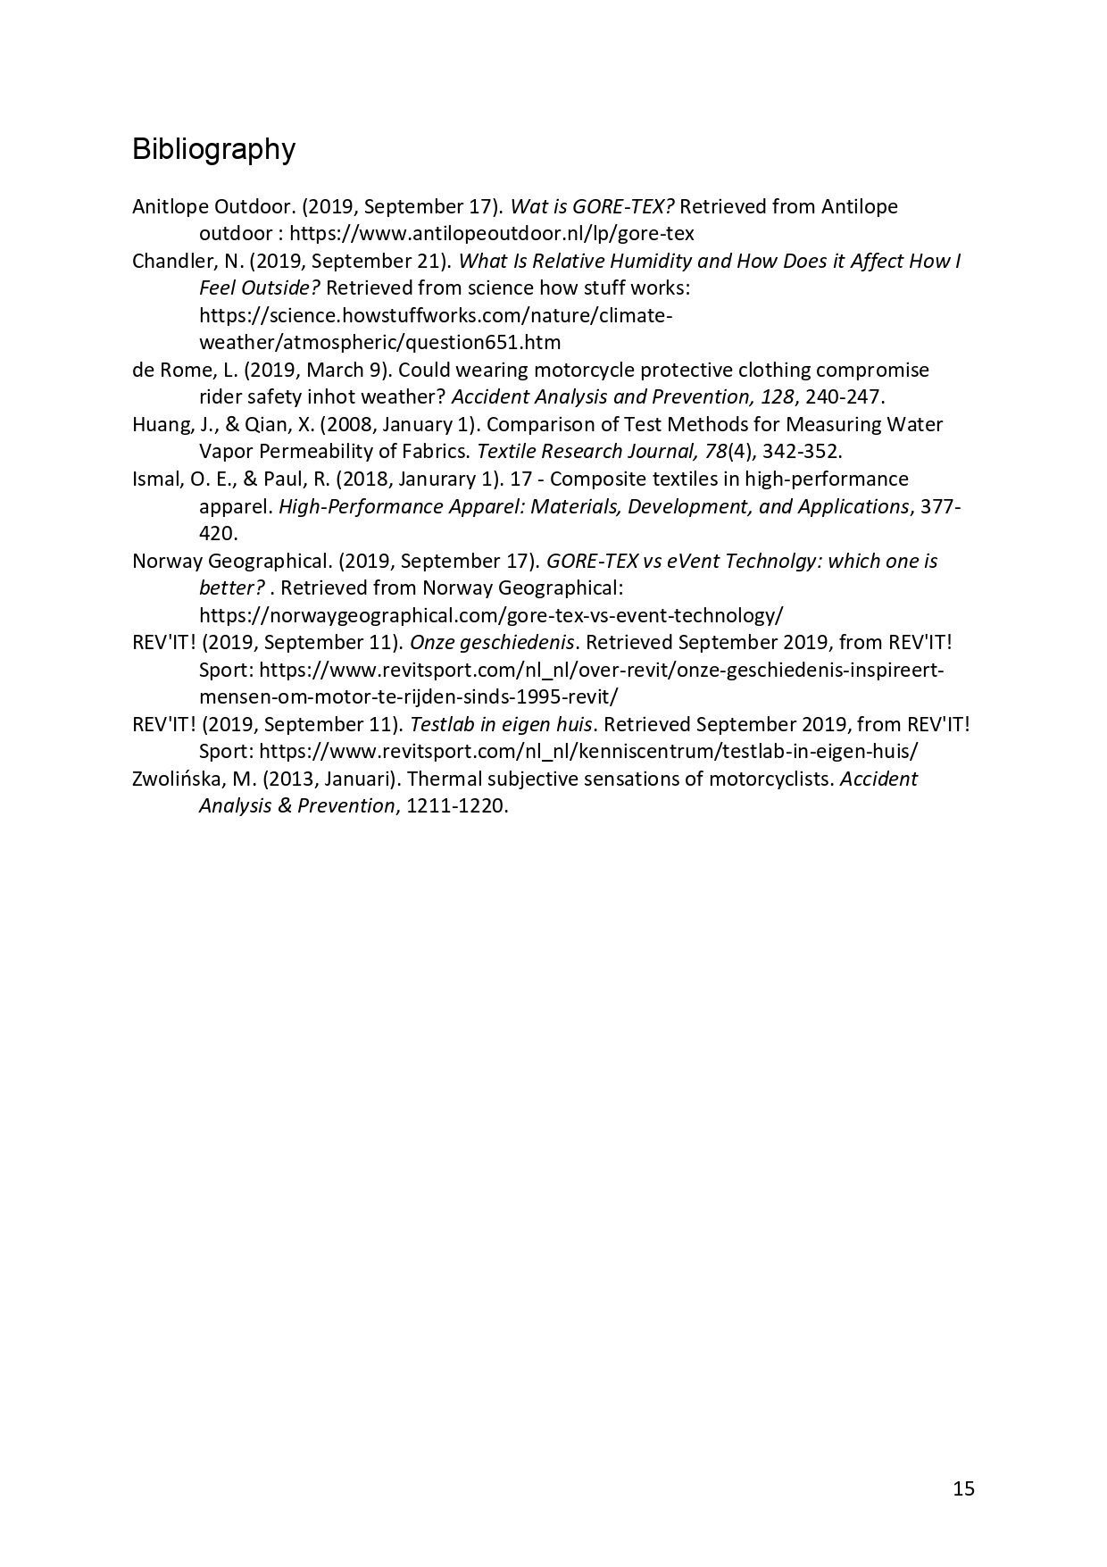

# 10. Technical Research

I fully write by my own the next document. The purpose of this it is to represent the technical research that has been done for the project.



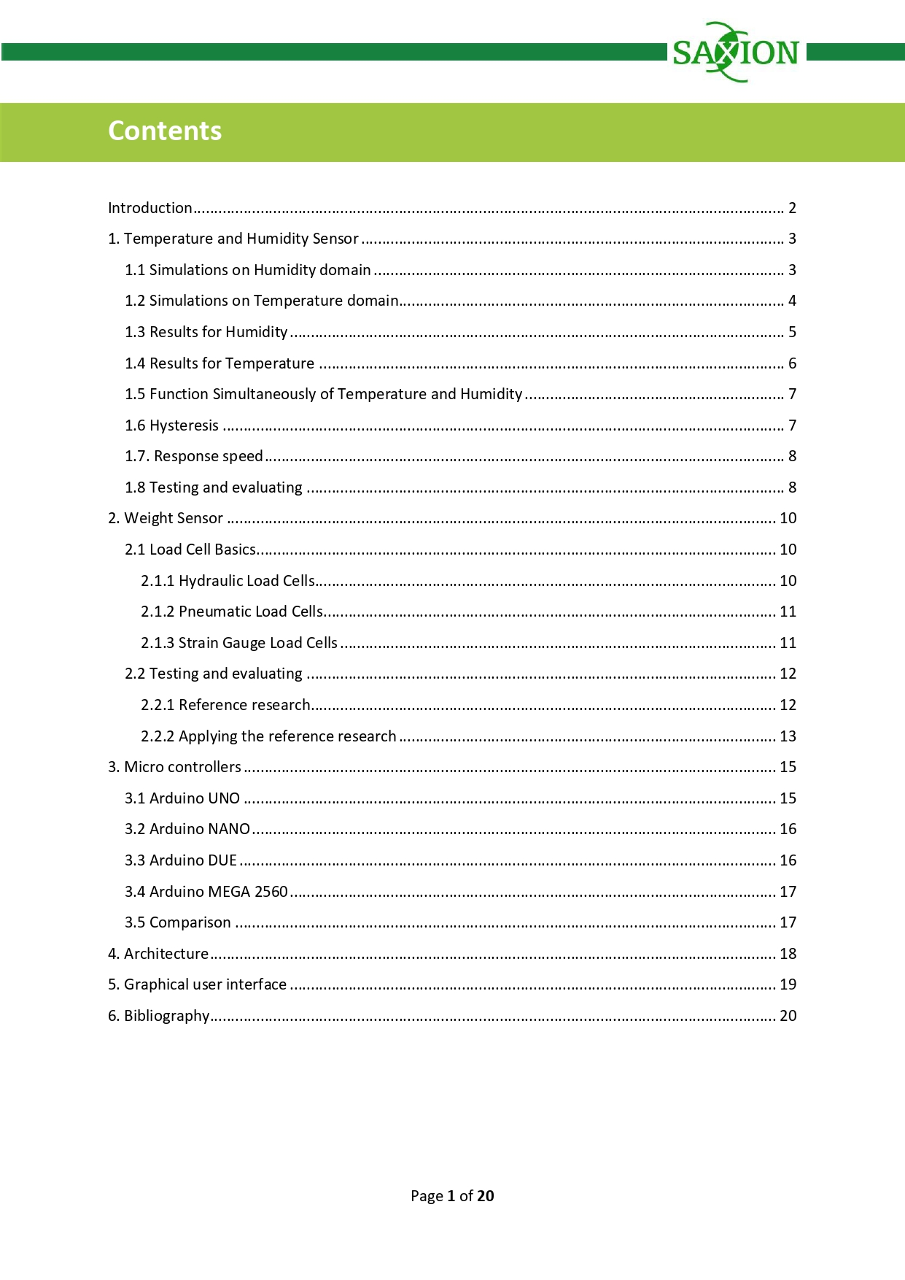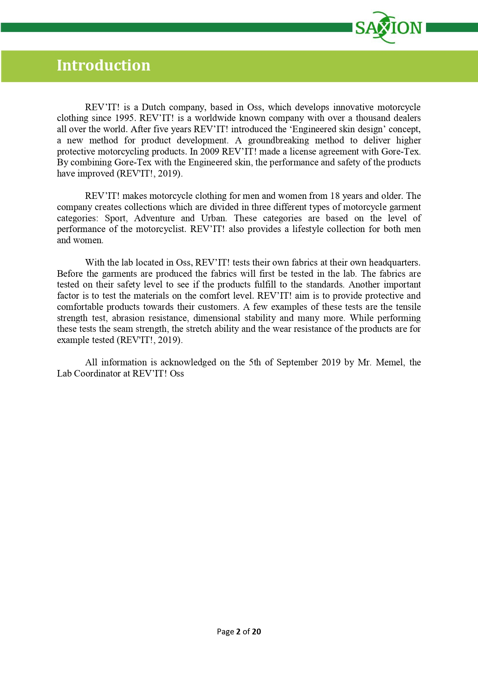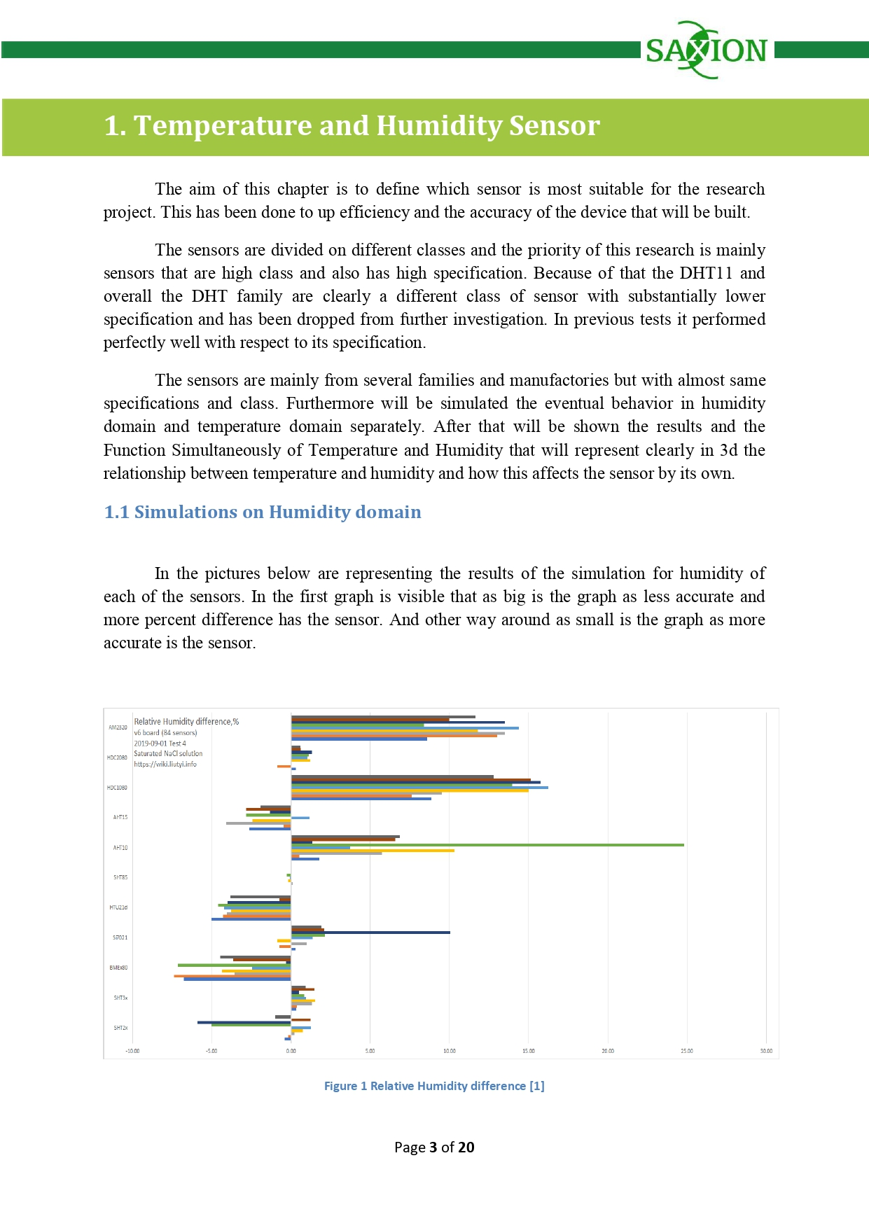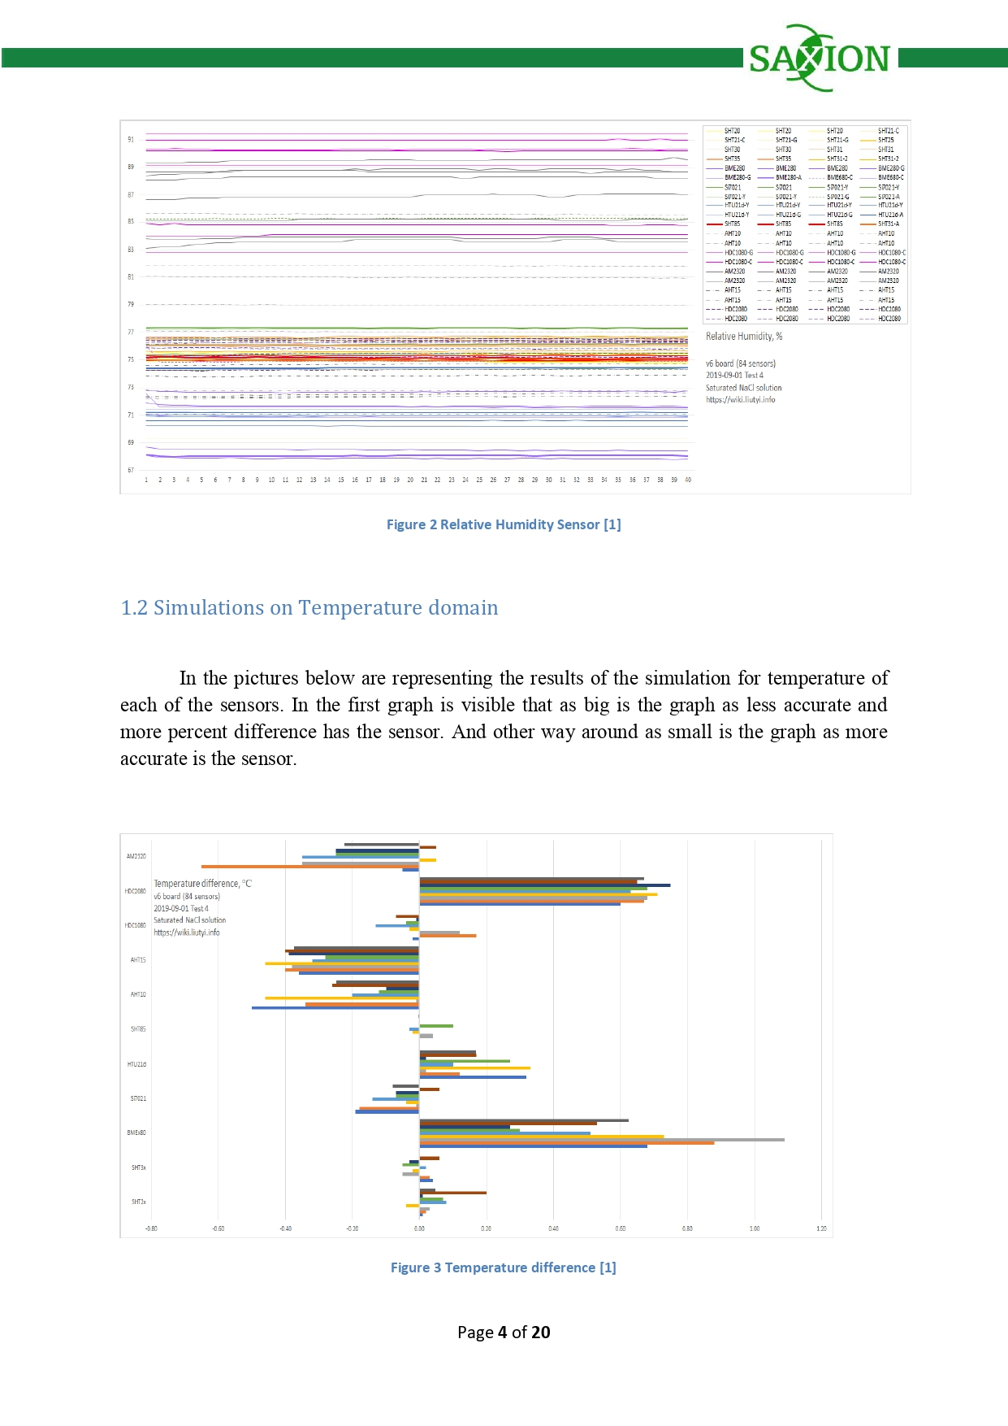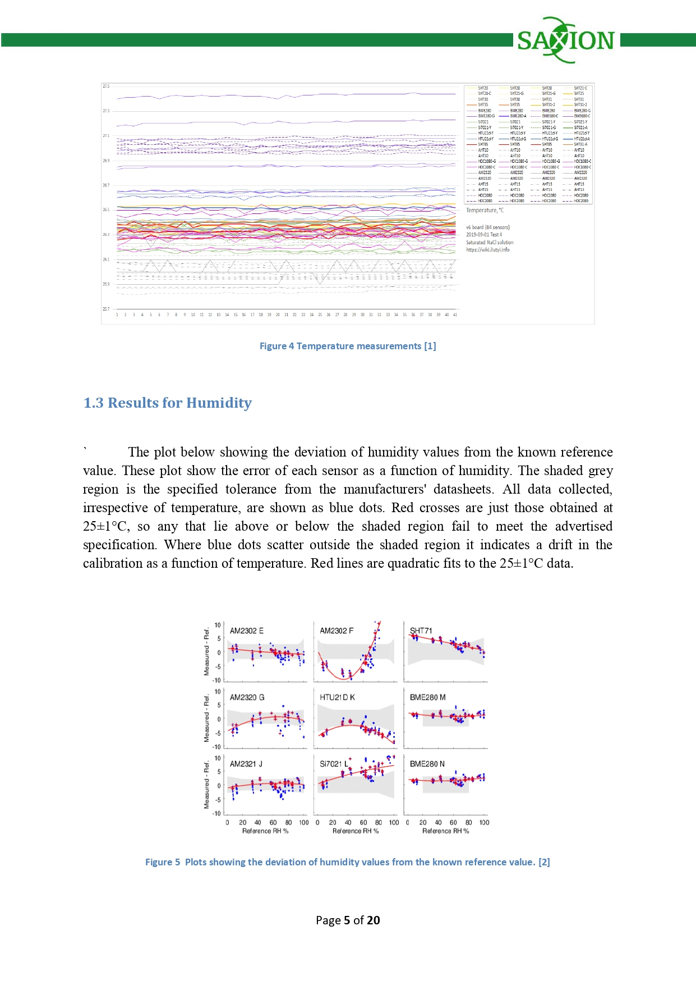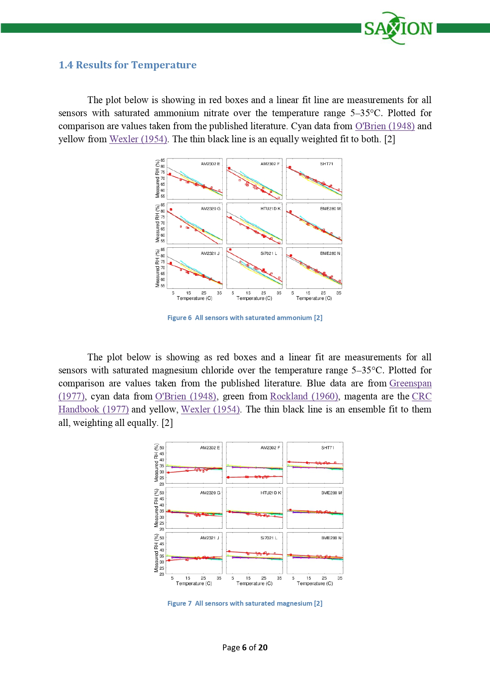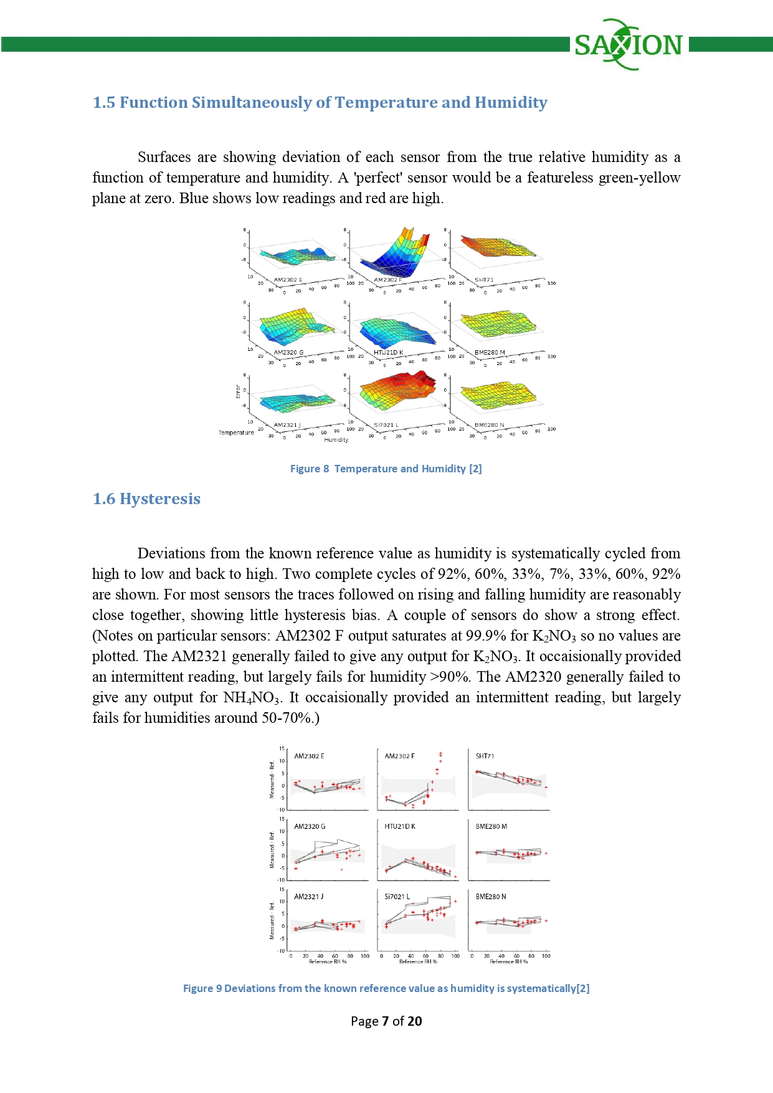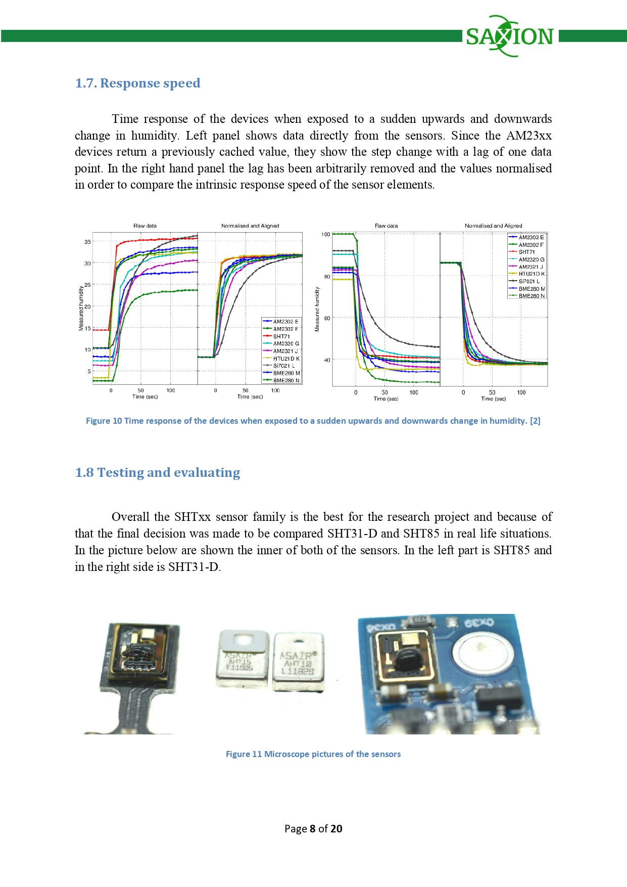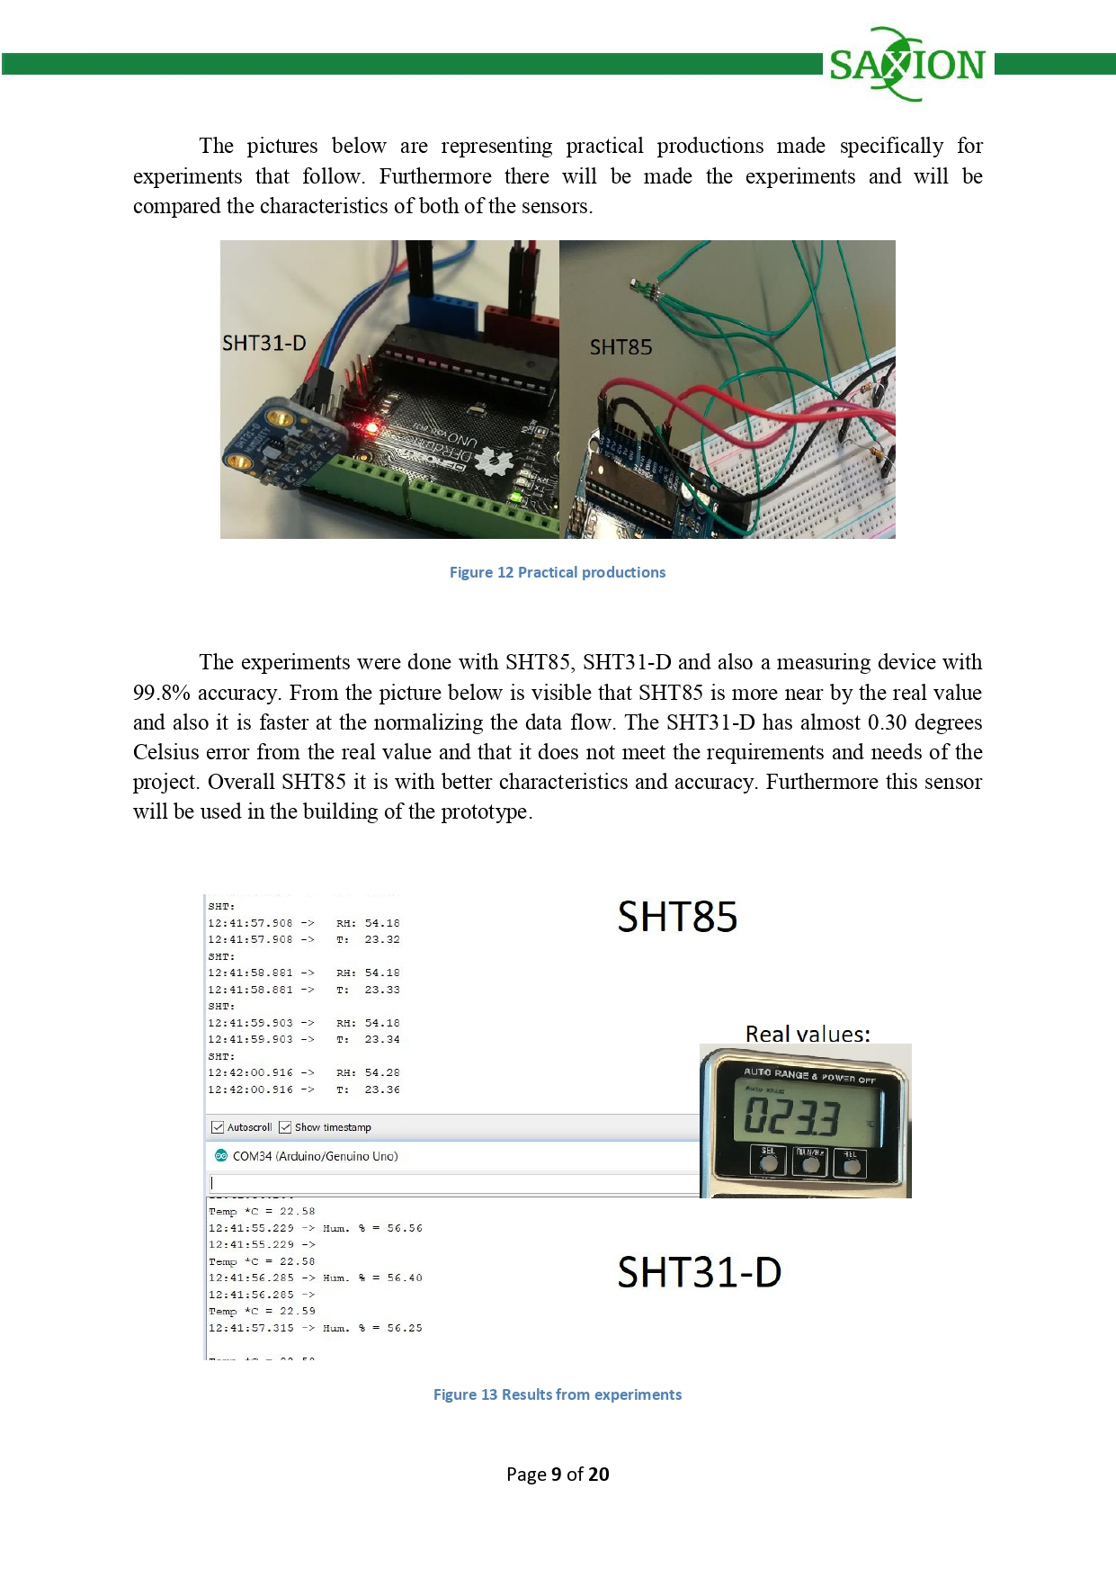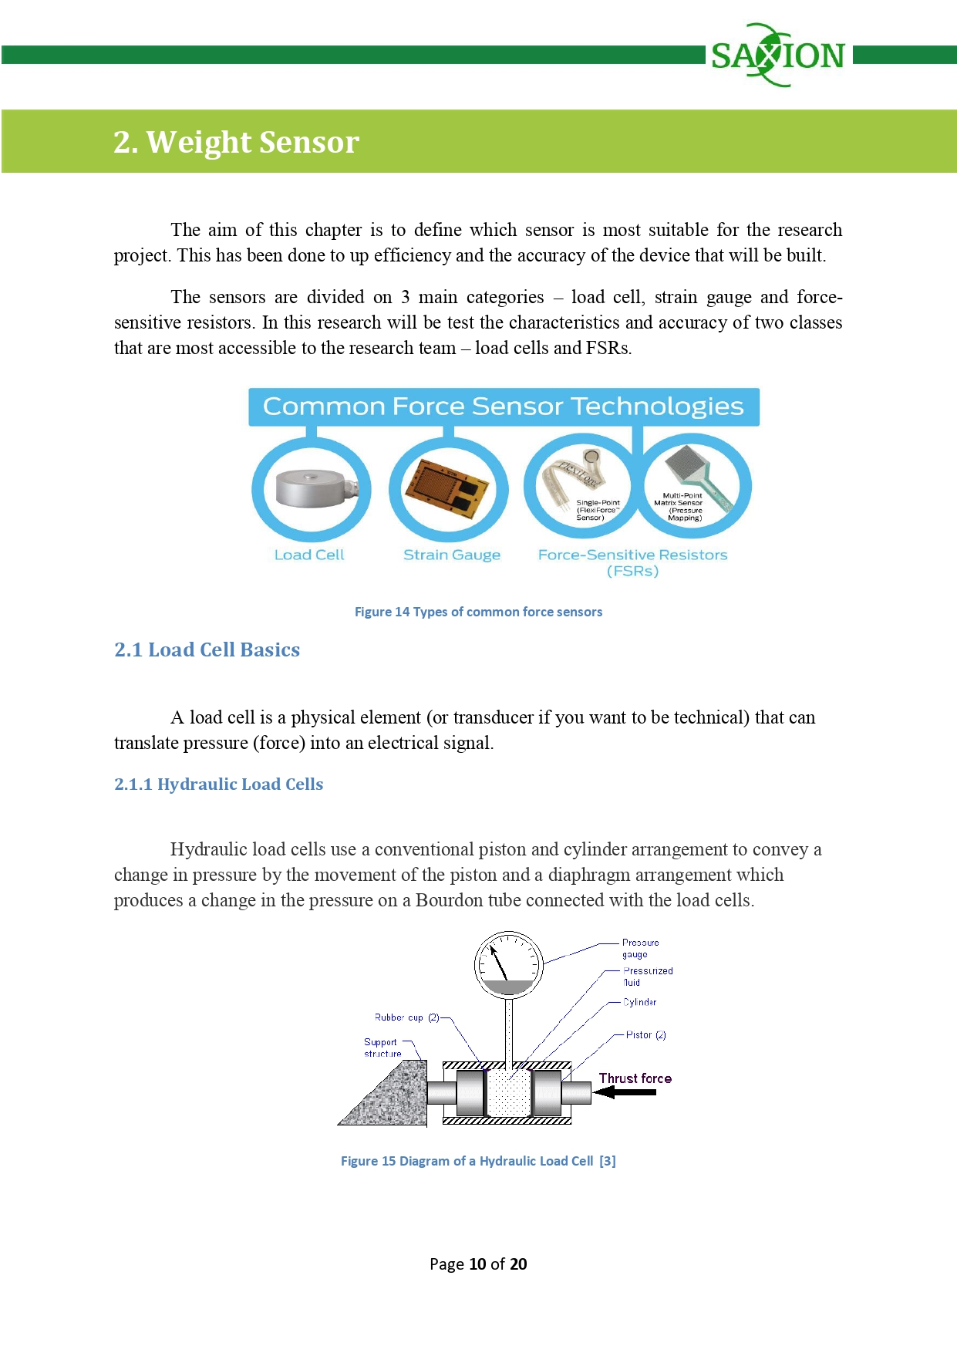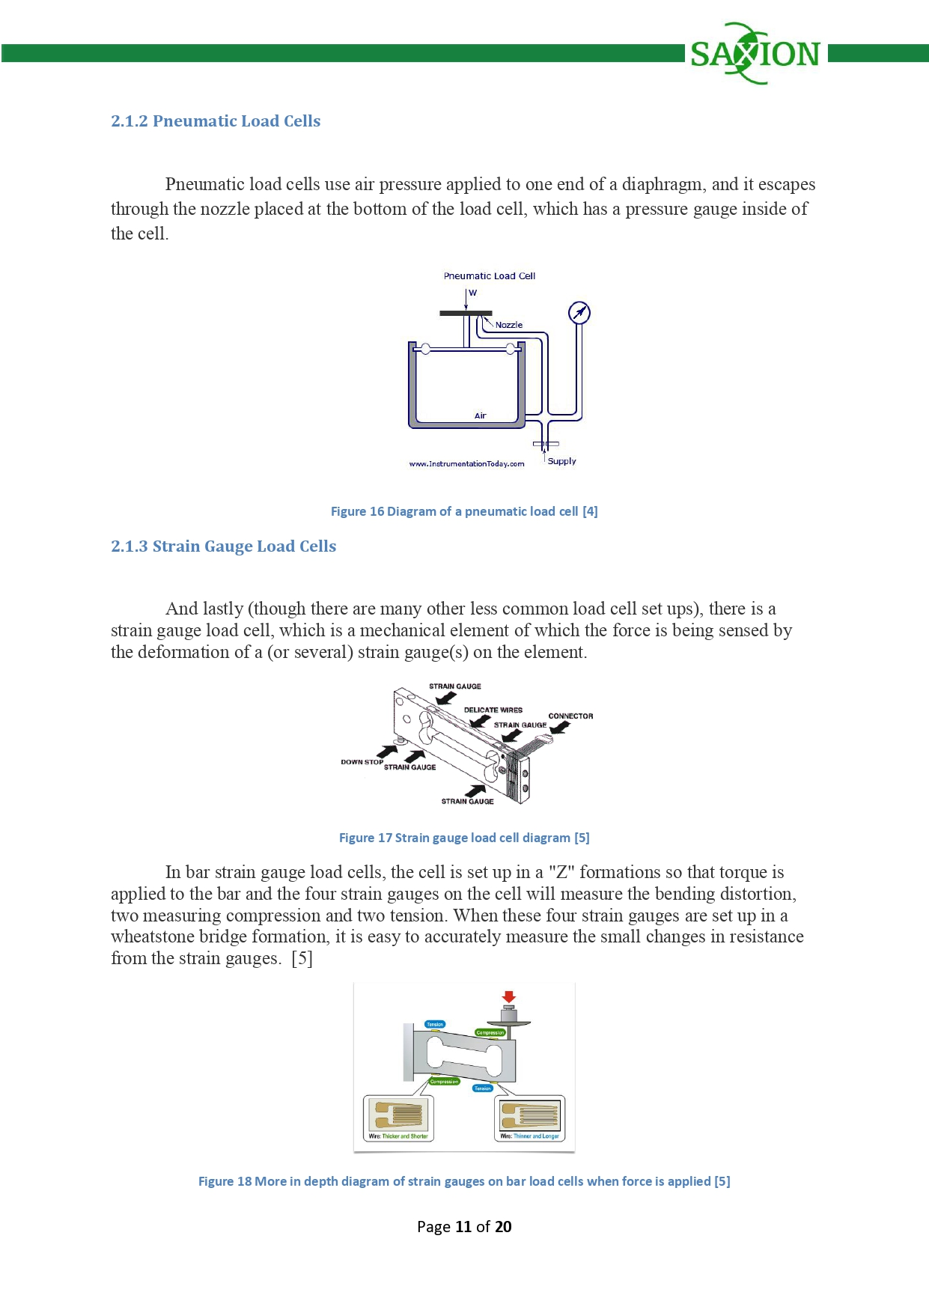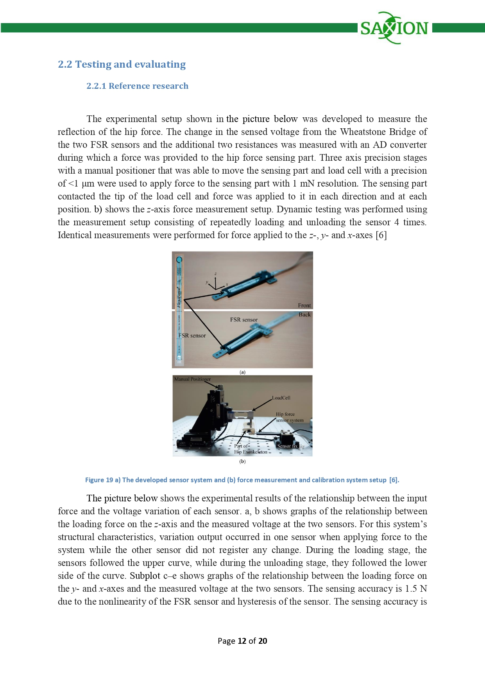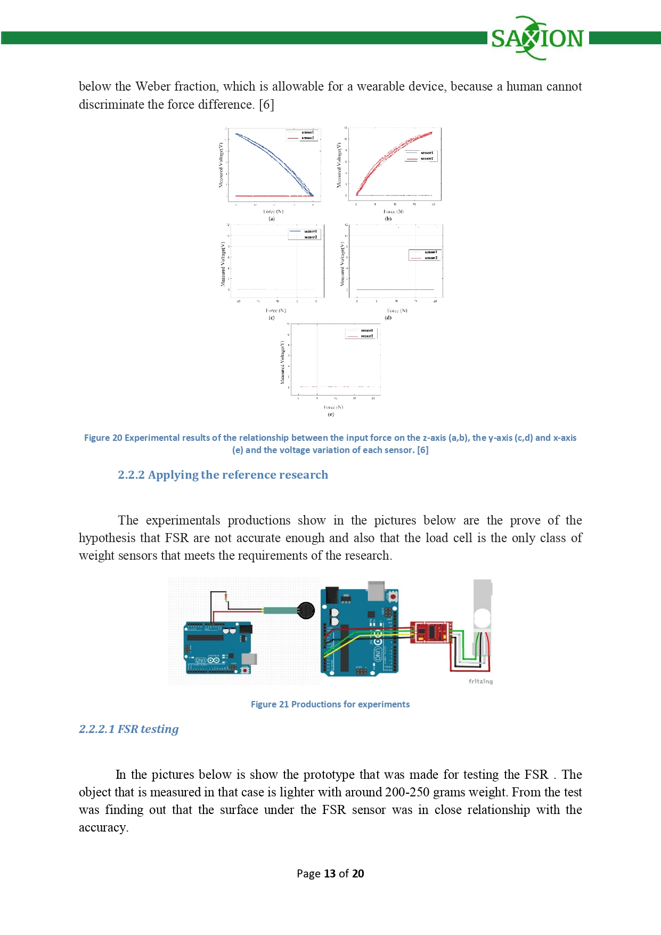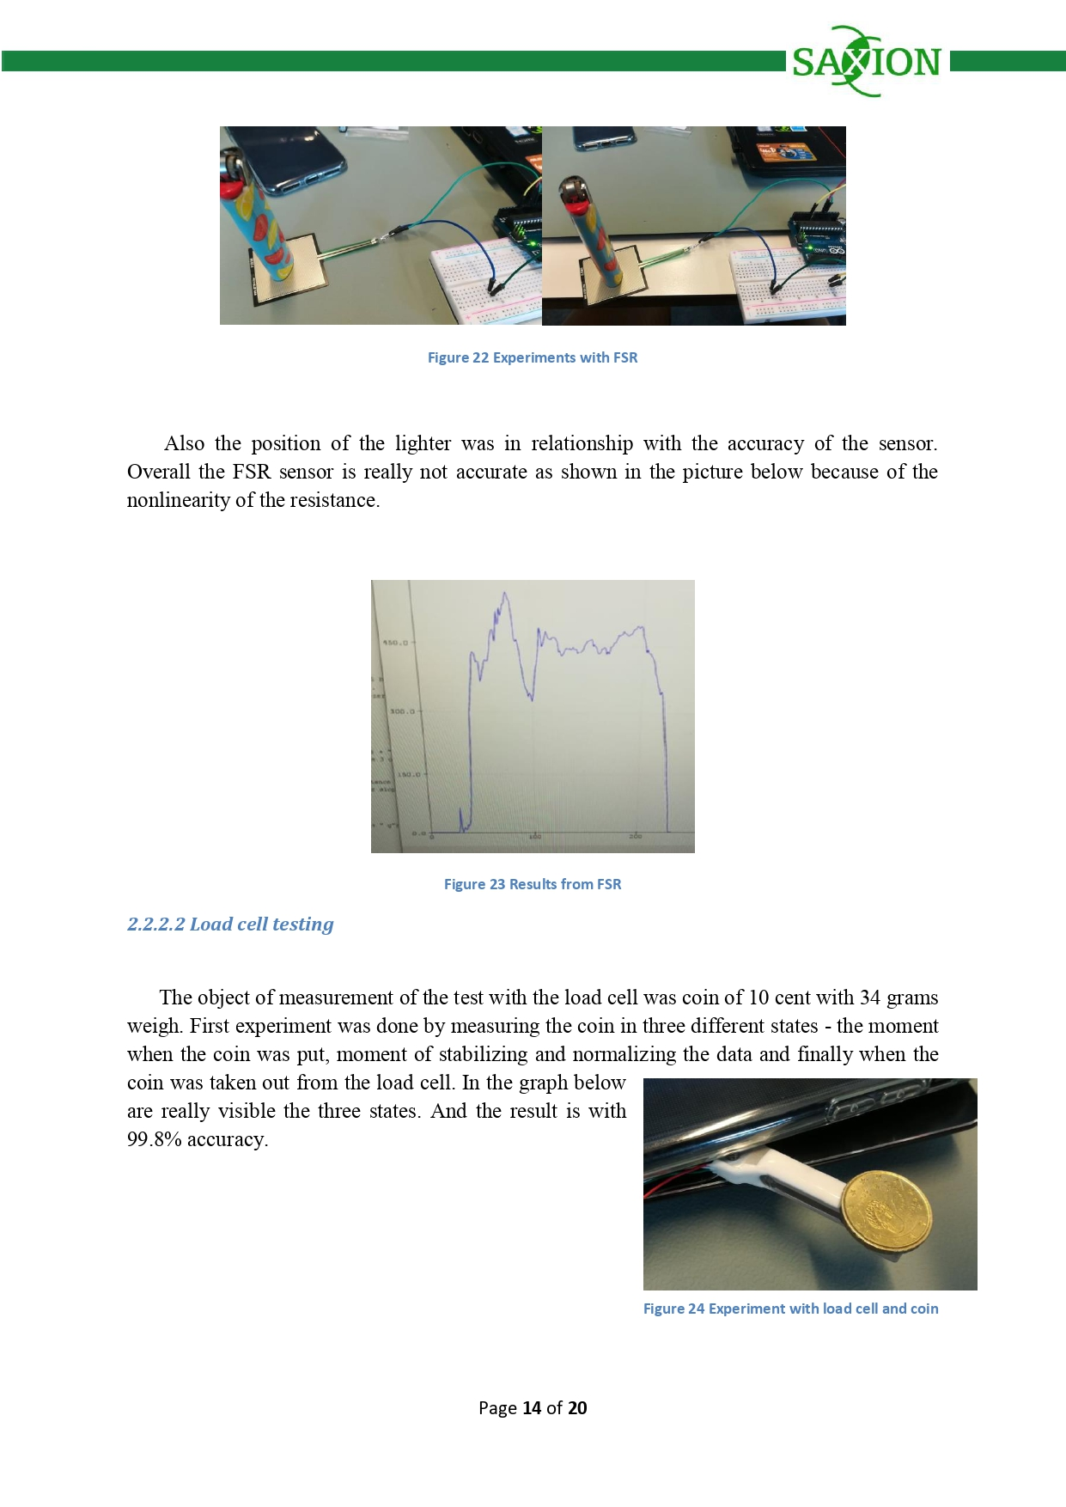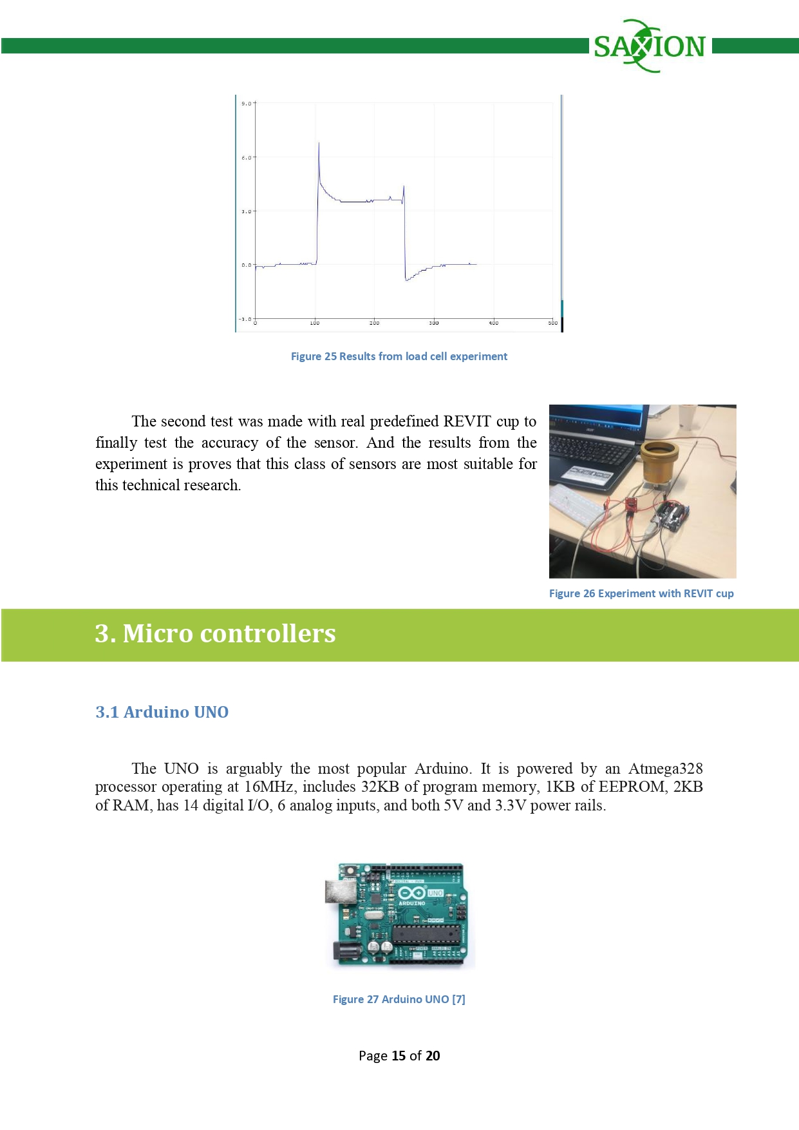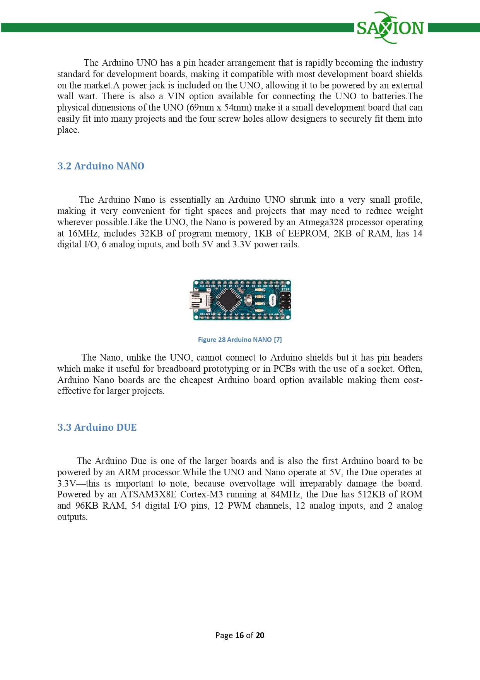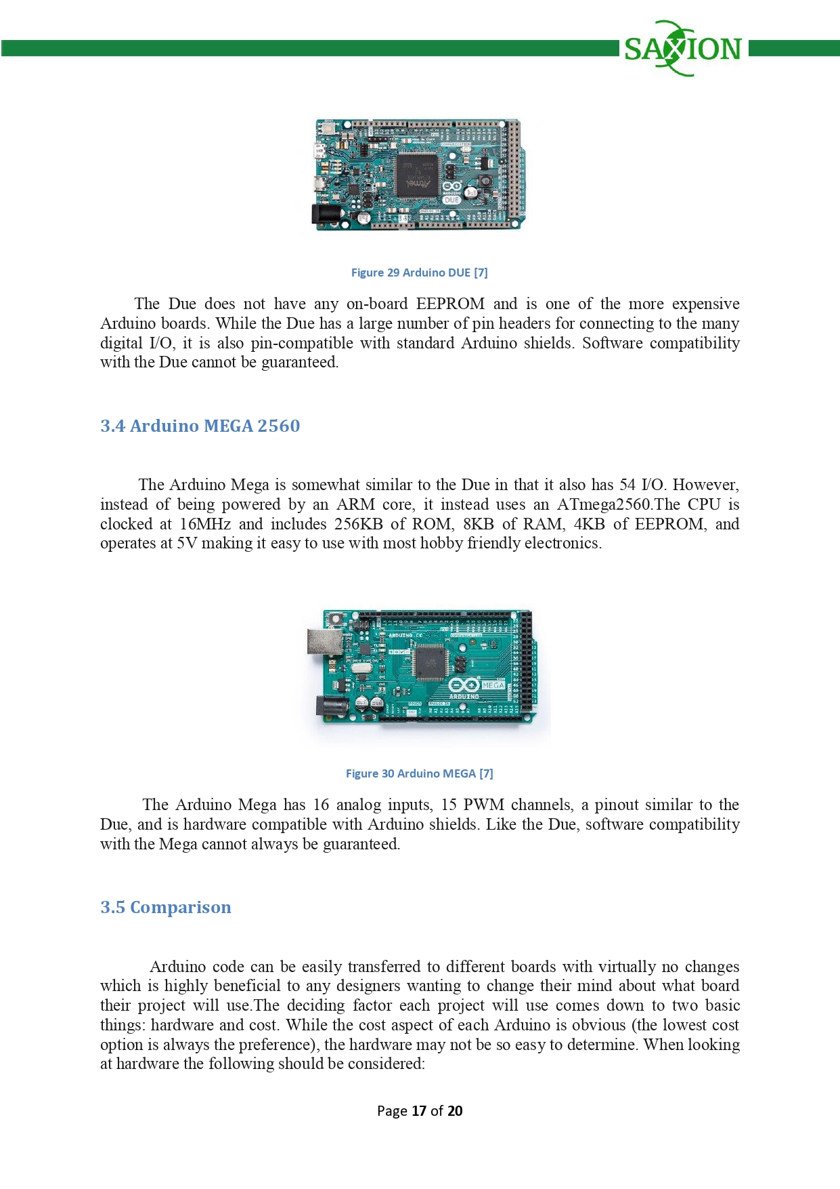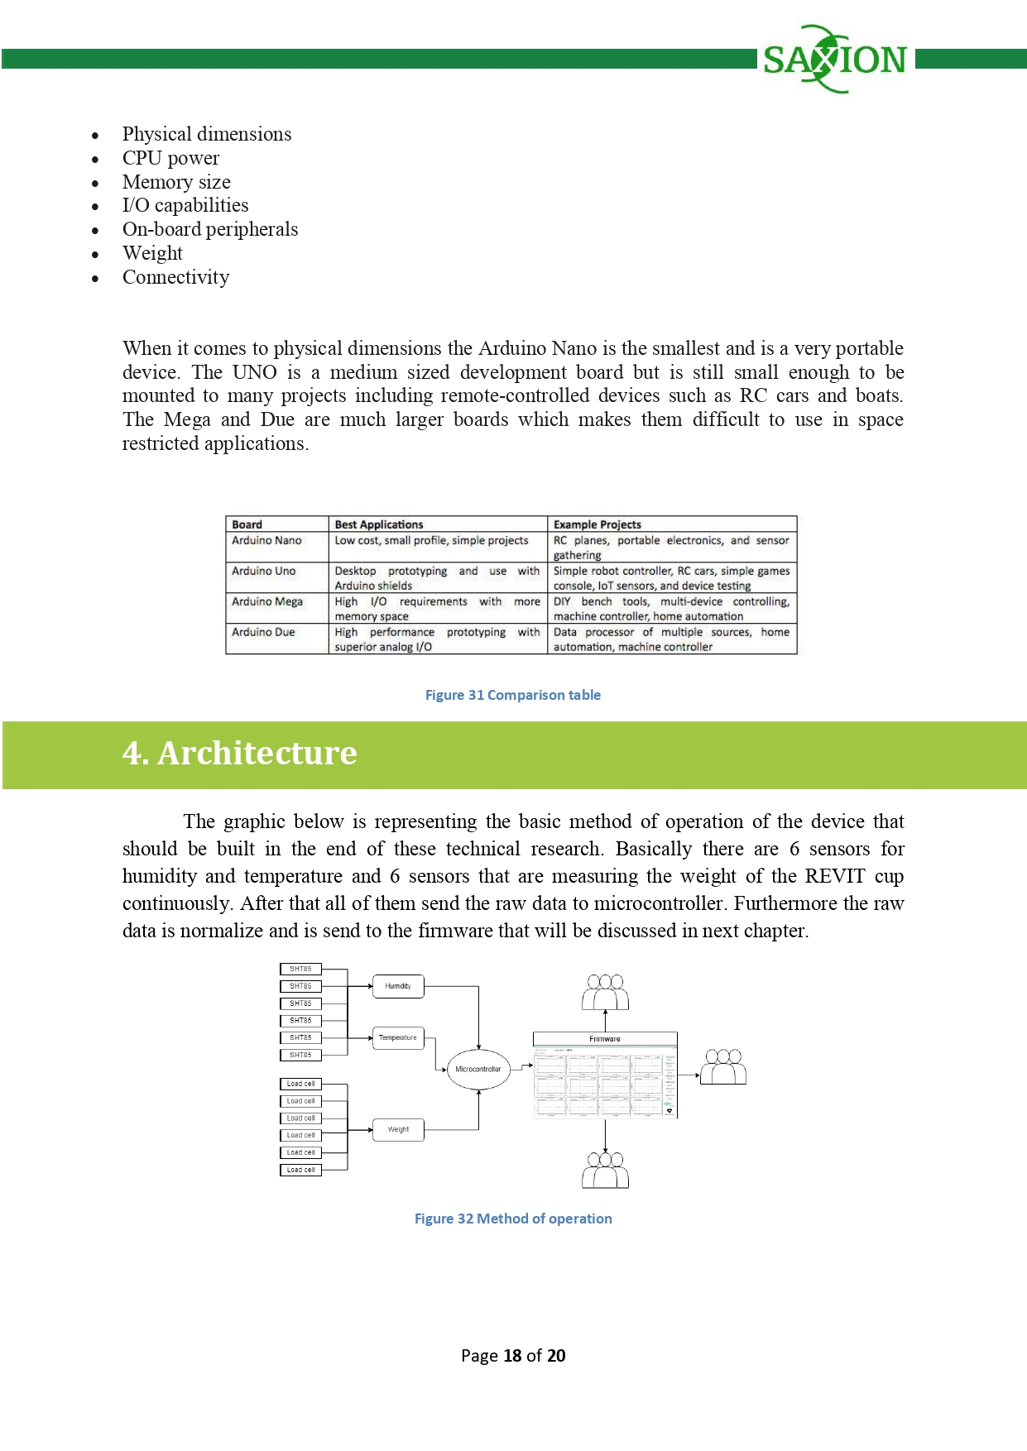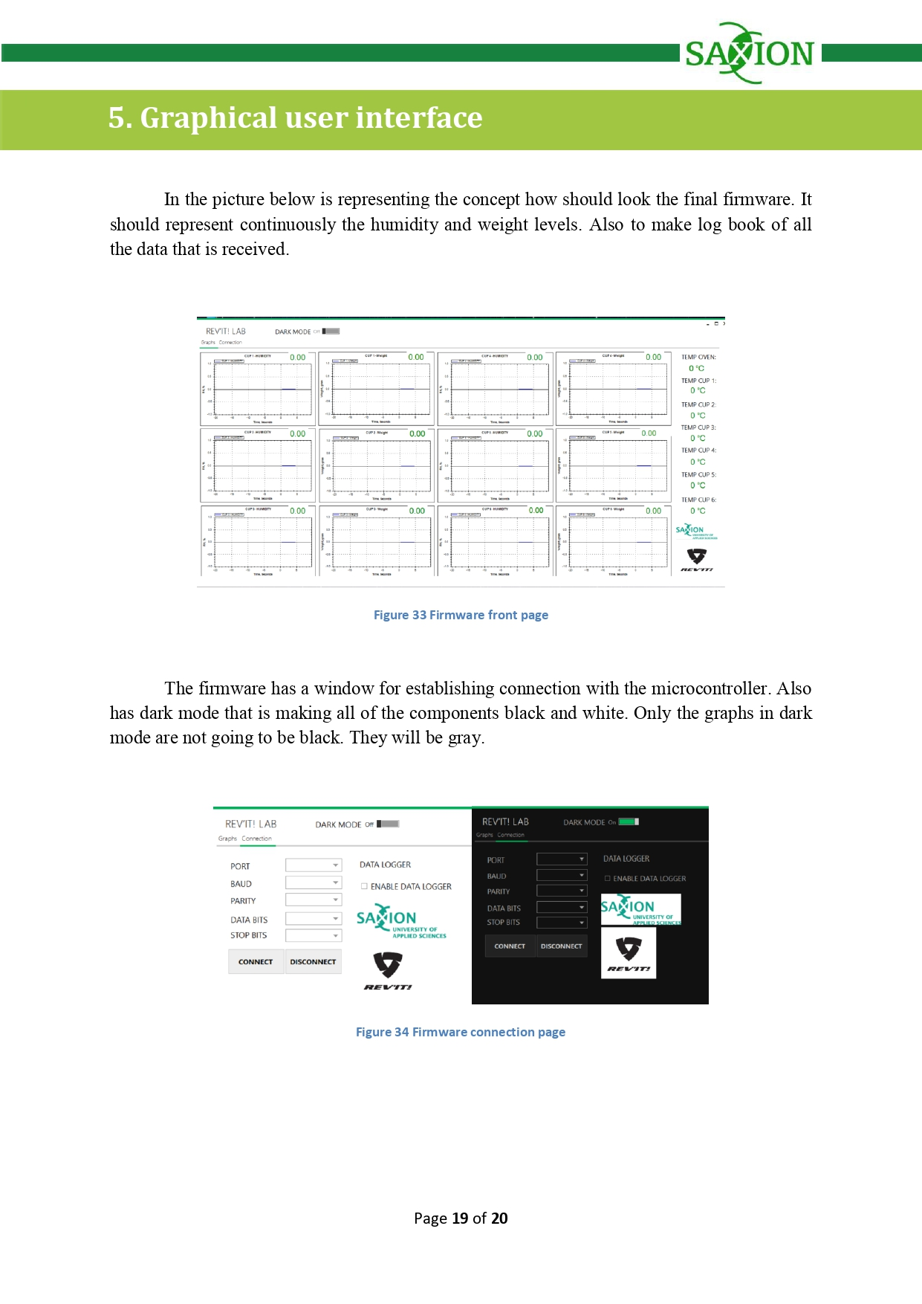

# 11.Drilling wholes

Because of the circumstances that one of our team members (Harold Kip) supposed to leave our team, we should finish his part of the work. His role was mainly mechanical, for example replicating the cups, drilling wholes, gluing cables and laser cutting. Anything raleted with his speciality. Because of this I supposed to drill all the holes in the cups. I was for first time in the Mechanical departument and was new experience for me.

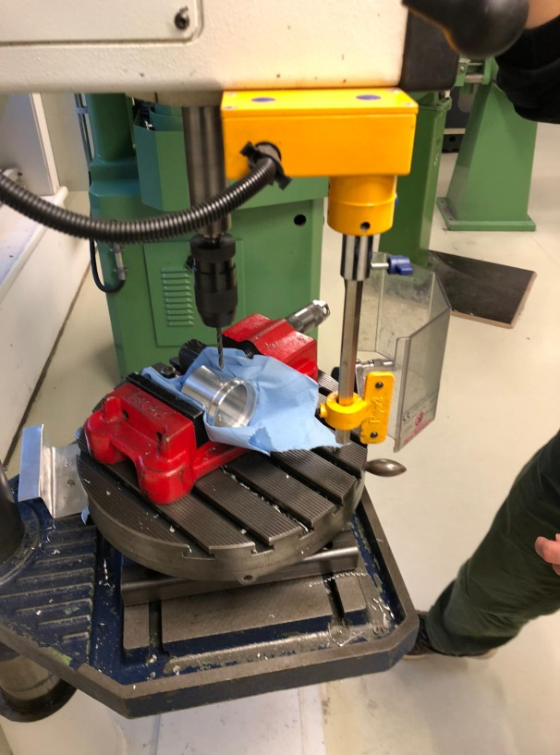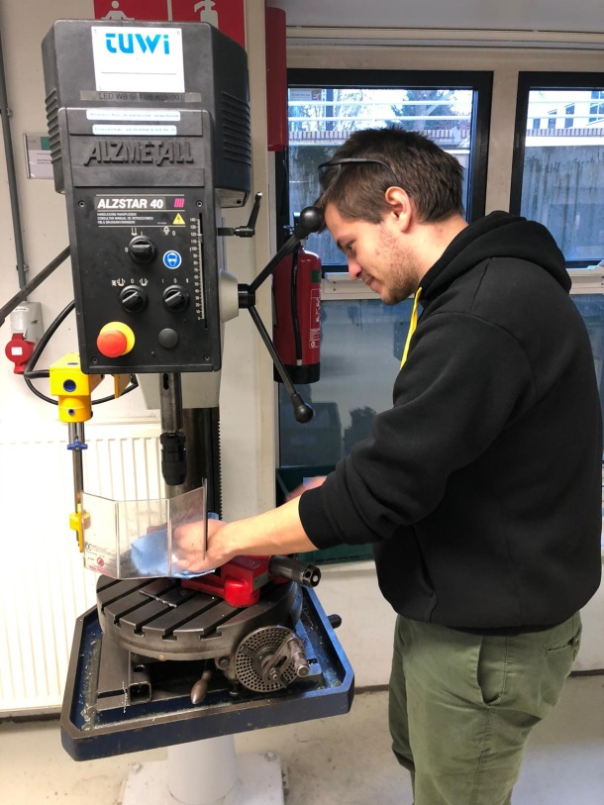

In the picture is visible where supposed to be drilled the holes and after that should be put a connectors for the SHT85 temperature humidity sensors.

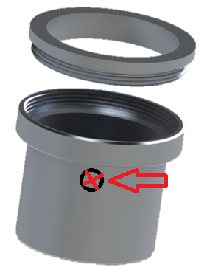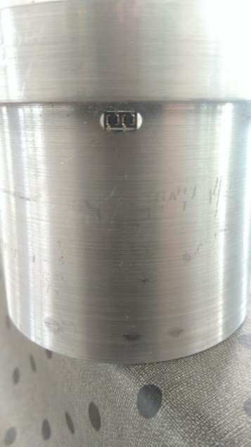

When the holes are done and connectors are placed I connected the cables and glue the hole with connector and cables. I tried to make it as good as possible to be sure that the water/steam won’t go out of the cup and to influence the whole experiment.

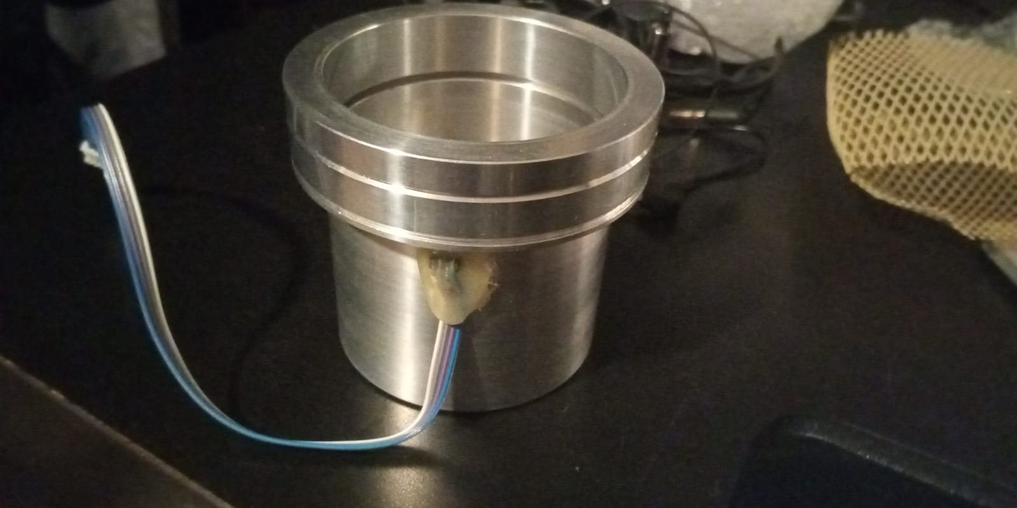

# 12.Software Development

The main device in the project is Arduino based and due to this fact are used Arduino IDE and the Arduino C to be programmed. The Arduino C is language developed especially for Atmel microcontroller and in the case of this project Arduino UNO. The language is mixture between C, C++ and some special libraries only for Arduino.

The black box below is representing the final version of the embedded software for the devices. In the code at the beginning are initialized all of weight sensors (LOADCELL-s) and also the SHT85 sensors. Also it is defining the calibration factor for the load cells that later on this will be define the accuracy of the device. The first rows are for implementing the libraries for the sensors.

However, in the loop part of the code firstly is collecting the data of the SHT85 sensors and if there is not data (NAN) that the code is defining the value as 0 and this means that the sensor is not responding. This can be caused from damage or disconnection from the main device. After that is collecting the data from the load cells and putting all of the data in one big sting that will be transfer via the COM port to the PC (to the Firmware).

In the end of the code are visible all of the functions for communicating and collecting data from the sensors. Also the function for using the I2C expander that is giving quince addresses to all of the SHT85 sensors. Otherwise all of them will have same address and they won’t work or if they work they will mix their data and won’t be possible to identify which data from which sensor it is.

#include <Wire.h>

#include "HX711.h"

#include "SHTSensor.h"

extern "C" {

  #include "utility/twi.h"}

#define TCAADDR 0x70

#define LOADCELL_DOUT_PIN_1 3

#define LOADCELL_SCK_PIN_1 2

#define LOADCELL_DOUT_PIN_2 5

#define LOADCELL_SCK_PIN_2 4

#define LOADCELL_DOUT_PIN_3 7

#define LOADCELL_SCK_PIN_3 6

#define LOADCELL_DOUT_PIN_4 9

#define LOADCELL_SCK_PIN_4 8

#define LOADCELL_DOUT_PIN_5 11

#define LOADCELL_SCK_PIN_5 10

#define LOADCELL_DOUT_PIN_6 13

#define LOADCELL_SCK_PIN_6 12

HX711 scale[6];

SHTSensor sht[7];

void tcaselect(uint8_t i);

int reading_loadcell(int number);

void setupsht85(int index);

int temp(int index);

int hum(int index);

void setupscales(int index,int out, int sck);

float calibration_factor = -7050; //-7050 worked for my 440lb max scale setup

long reading_cell[6];

float  temp_s[7];

float  hum_s[7];

long zero_factor[6];

void setup()

{

  Serial.begin(9600);

  Wire.begin();

  setupscales(0,LOADCELL_DOUT_PIN_1, LOADCELL_SCK_PIN_1);

  setupscales(1,LOADCELL_DOUT_PIN_2, LOADCELL_SCK_PIN_2);

  setupscales(2,LOADCELL_DOUT_PIN_3, LOADCELL_SCK_PIN_3);

  setupscales(3,LOADCELL_DOUT_PIN_4, LOADCELL_SCK_PIN_4);

  setupscales(4,LOADCELL_DOUT_PIN_5, LOADCELL_SCK_PIN_5);

  setupscales(5,LOADCELL_DOUT_PIN_6, LOADCELL_SCK_PIN_6);

  for (int i = 0; i <= 6; i++)

  {

    setupsht85(i);

  }

}

void loop() {

  for (int j = 0; j <= 6; j++)

  {

    hum_s[j] = hum(j);

    temp_s[j]= temp(j);

  }

  for (int k = 0; k <= 5; k++)

  {

    reading_cell[k] = reading_loadcell(k);

  }

  if(isnan(sht[0].getHumidity())){hum_s[0]=0;temp_s[0]=0;}

  else{hum_s[0]=sht[0].getHumidity();temp_s[0]=sht[0].getTemperature();}

  if(isnan(sht[1].getHumidity())){hum_s[1]=0;temp_s[1]=0;}

  else{hum_s[1]=sht[1].getHumidity();temp_s[1]=sht[1].getTemperature();}

  if(isnan(sht[2].getHumidity())){hum_s[2]=0;temp_s[2]=0;}

  else{hum_s[2]=sht[2].getHumidity();temp_s[2]=sht[2].getTemperature();}

  if(isnan(sht[3].getHumidity())){hum_s[3]=0;temp_s[3]=0;}

  else{hum_s[3]=sht[3].getHumidity();temp_s[3]=sht[3].getTemperature();}

  if(isnan(sht[4].getHumidity())){hum_s[4]=0;temp_s[4]=0;}

  else{hum_s[4]=sht[4].getHumidity();temp_s[4]=sht[4].getTemperature();}

  if(isnan(sht[5].getHumidity())){hum_s[5]=0;temp_s[5]=0;}

  else{hum_s[5]=sht[5].getHumidity();temp_s[5]=sht[5].getTemperature();}

  if(isnan(sht[6].getHumidity())){hum_s[6]=0;temp_s[6]=0;}

  else{hum_s[6]=sht[6].getHumidity();temp_s[6]=sht[6].getTemperature();}

  String H1 =  String(hum_s[0]); String W1 =  String(reading_cell[0]);String H2 =  String(hum_s[1]);

  String W2 =  String(reading_cell[1]);String H3 =  String(hum_s[2]);String W3 =  String(reading_cell[2]);

  String H4 =  String(hum_s[3]);String W4 =  String(reading_cell[3]);String H5 =  String(hum_s[4]);

  String W5 =  String(reading_cell[4]);String H6 =  String(hum_s[5]);String W6 =  String(reading_cell[5]);

  String TO =  String(temp_s[6]);

  String T1 =  String(temp_s[0]); String T2 =  String(temp_s[1]); String T3 =  String(temp_s[2]);

  String T4 =  String(temp_s[3]); String T5 =  String(temp_s[4]);String T6 =  String(temp_s[5]);

  Serial.println(H1+","+W1+","+H2+","+W2+","+H3+","+W3+","+H4+","+W4+","+H5+","+W5+","+H6+","+W6+","+TO+","+T1+","+T2+","+T3+","+T4+","+T5+","+T6);

  delay(300);

}

void tcaselect(uint8_t i)

{

  if (i > 7) return;

  Wire.beginTransmission(TCAADDR);

  Wire.write(1 << i);

  Wire.endTransmission();

  }

}

int reading_loadcell(int number)

{

  float value = 0;

  scale[number].set_scale(calibration_factor);

  value = (((scale[number].get_units()*4.5359237)/2));

  return value;

}

void setupscales(int index,int out, int sck)

{

  scale[index].begin(out, sck);

  scale[index].set_scale();

  scale[index].tare();

  zero_factor[index] = scale[index].read_average();

}

void setupsht85(int index)

{

  tcaselect(index);

  sht[index].setAccuracy(SHTSensor::SHT_ACCURACY_MEDIUM);

  if (sht[index].init())

  { //Serial.println(F("Yes it is connected"));

  }

  else

  { //Serial.println(F("No it is not connected"));

  }

}

int temp(int index)

{

  long value_temp;

  tcaselect(index);

  if (sht[index].readSample())

  {

    value_temp = sht[index].getTemperature();

  }

  return value_temp;

}

int hum(int index)

{

  long value_hum;

  tcaselect(index);

  if (sht[index].readSample())

  {

    value_hum = sht[index].getHumidity();

  }

  return value_hum;

}

# 13. Software for firmware

The picture below is the visual representation of the code for the firmware. The client in the end will see only this representation. There are 12 graphs for the 6 cups (6 for weight sensors and 6 for the humidity of each of the cups). Also in right there is a column with temperature for each of the cups and also for the temperature of the oven.

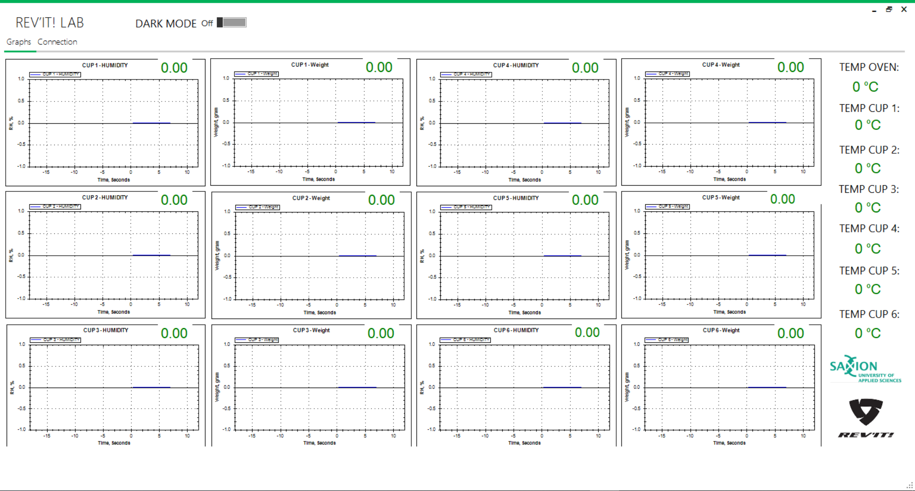

There is a second window that the client will establish the connection between the computer and the device. Also there is a feature that can log the data in a txt file. After that this txt file really easy can be transferred to excel or any other file format.

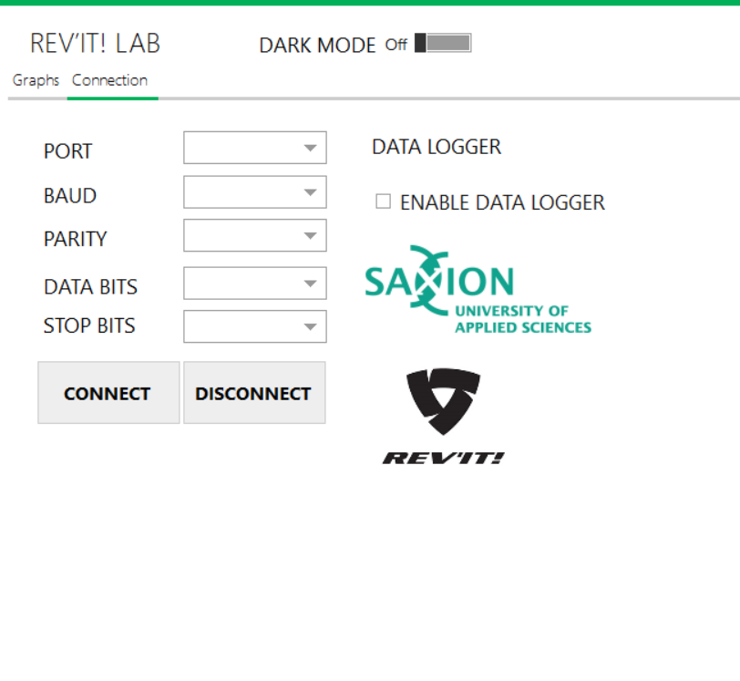

Also there is a dark mode for the graphs visualization. All of the components are going white and meanwhile the background is going black.

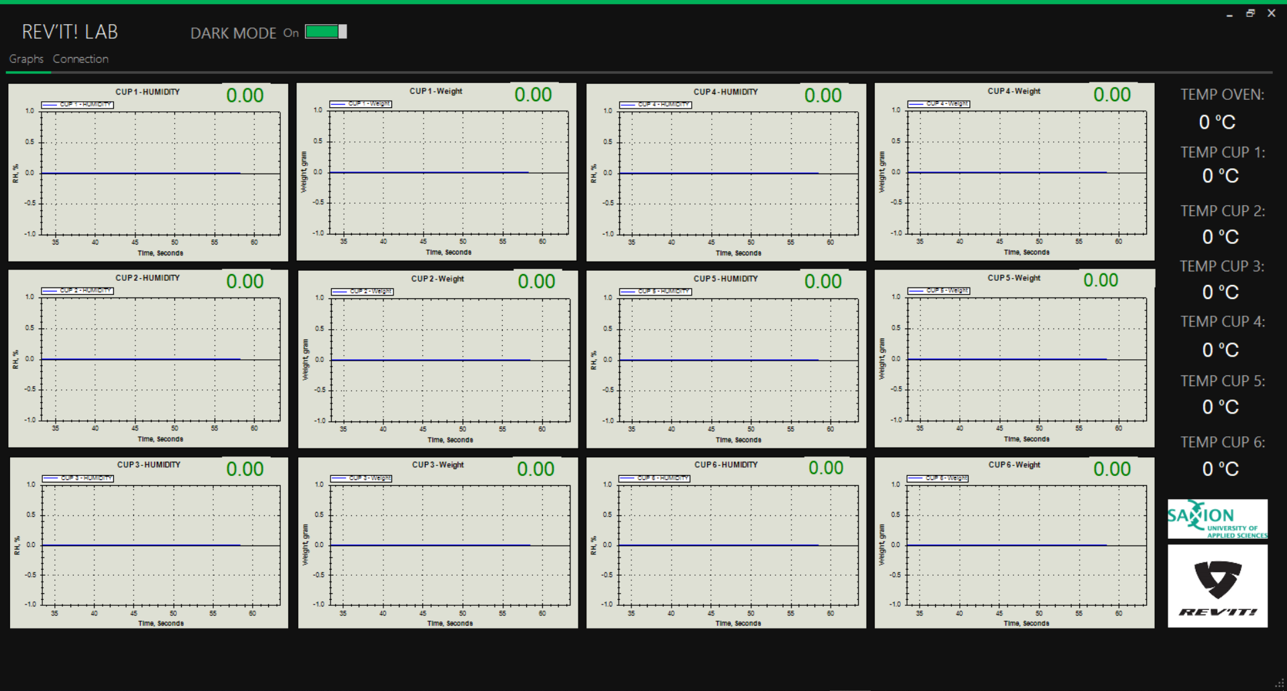

Also the dark mode is working in the connection windows. All of the components are change in black. Only the logos keep being white.

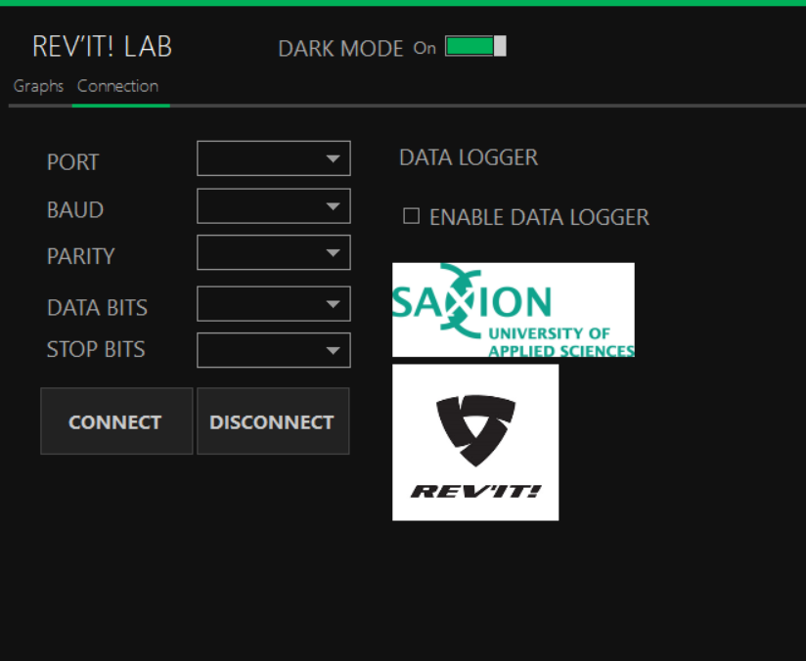

All of the functions described above are in the code below. The main logic of the code is following: the code is reading a string and separate it by special symbol in that case comma. And after that is representing the values in the graphs and the column for the temperature. Also there is a part that is establishing the connection between the computer and firmware.

using System;

using System.Collections.Generic;

using System.ComponentModel;

using System.Data;

using System.Drawing;

using System.Linq;

using System.Text;

using System.Threading.Tasks;

using System.Windows.Forms;

using System.IO.Ports;

using System.Diagnostics;

using System.Threading;

using System.Windows.Forms.DataVisualization.Charting;

using ZedGraph;

namespace FFD_GUI

{

    public partial class Main : MetroFramework.Forms.MetroForm

    {

        string[] arrList = new string[19];

        System.IO.StreamWriter out_file;

        class Settings

        {

            public string[] returndata = new string[65];

            public string[] Yaxis = new string[13];

            public string[] Xaxis = new string[13];

            public string[] Danger1 = new string[15];

            public string[] Danger2 = new string[15];

            public string[] Danger3 = new string[15];

            public string[] sensor_data = new string[13];

            public string[] calib = new string[13];

            public string[] calibbuff = new string[13];

        }

        class Datacon

        {

            public string[] rdata = new string[28];

            public string[] dataport_sensor = new string[28];

            public double[] data = new double[13];

        }

        Datacon d = new Datacon();

        Settings u = new Settings();

        //double temp = 0;

        //double humidity = 0;

        int TickStart1;

        int TickStart2;

        int TickStart3;

        int TickStart4;

        int TickStart5;

        int TickStart6;

        int TickStart7;

        int TickStart8;

        int TickStart9;

        int TickStart10;

        int TickStart11;

        int TickStart12;

        public Main()

        {

            InitializeComponent();

            openFileDialog1.Filter = "Text|*.txt";

            cbBaud.Items.Add(9600);

            cbBaud.Items.Add(14400);

            cbBaud.Items.Add(19200);

            cbBaud.Items.Add(38400);

            cbBaud.Items.Add(57600);

            cbBaud.Items.Add(74880);

            cbBaud.Items.Add(115200);

            cbBaud.Items.Add(230400);

            cbBaud.Items.Add(256000);

            cbBaud.Items.Add(460800);

            cbBaud.Items.Add(921600);

            cbDatabits.Items.Add(8);

            cbDatabits.Items.Add(7);

            cbDatabits.Items.Add(6);

            cbDatabits.Items.Add(5);

            cbStopbits.Items.Add("One");

            cbStopbits.Items.Add("OnePointFive");

            cbStopbits.Items.Add("Two");

            cbParity.Items.Add("None");

            cbParity.Items.Add("Even");

            cbParity.Items.Add("Odd");

            cbParity.Items.Add("Mark");

            cbParity.Items.Add("Space");

            lblsensor13.ForeColor = Color.Green;

            lblsensor14.ForeColor = Color.Green;

            lblsensor15.ForeColor = Color.Green;

            lblsensor16.ForeColor = Color.Green;

            lblsensor17.ForeColor = Color.Green;

            lblsensor18.ForeColor = Color.Green;

            lblsensor19.ForeColor = Color.Green;

            timer16.Tick += new EventHandler(DoUpdate); // Everytime timer ticks, timer_Tick will be called

            timer16.Enabled = true;

            timer15.Tick += new EventHandler(DoUpdate); // Everytime timer ticks, timer_Tick will be called

            timer15.Enabled = true;

            timer2.Tick += new EventHandler(DoUpdate); // Everytime timer ticks, timer_Tick will be called

            timer2.Enabled = true;                       // Enable the timer

            timer2.Start();                              // Start the timer

            timer1.Tick += new EventHandler(DoUpdate); // Everytime timer ticks, timer_Tick will be called

            timer1.Enabled = true;                       // Enable the timer

            timer1.Start();

            timer3.Tick += new EventHandler(DoUpdate); // Everytime timer ticks, timer_Tick will be called

            timer3.Enabled = true;                       // Enable the timer

            timer3.Start();                              // Start the timer

            timer4.Tick += new EventHandler(DoUpdate); // Everytime timer ticks, timer_Tick will be called

            timer4.Enabled = true;                       // Enable the timer

            timer4.Start();                              // Start the timer

            timer5.Tick += new EventHandler(DoUpdate); // Everytime timer ticks, timer_Tick will be called

            timer5.Enabled = true;                       // Enable the timer

            timer5.Start();                              // Start the timer

            timer6.Tick += new EventHandler(DoUpdate); // Everytime timer ticks, timer_Tick will be called

            timer6.Enabled = true;                       // Enable the timer

            timer6.Start();                              // Start the timer

            timer7.Tick += new EventHandler(DoUpdate); // Everytime timer ticks, timer_Tick will be called

            timer7.Enabled = true;                       // Enable the timer

            timer7.Start();                              // Start the timer

            timer8.Tick += new EventHandler(DoUpdate); // Everytime timer ticks, timer_Tick will be called

            timer8.Enabled = true;                       // Enable the timer

            timer8.Start();                              // Start the timer

            timer9.Tick += new EventHandler(DoUpdate); // Everytime timer ticks, timer_Tick will be called

            timer9.Enabled = true;                       // Enable the timer

            timer9.Start();                              // Start the timer

            timer10.Tick += new EventHandler(DoUpdate); // Everytime timer ticks, timer_Tick will be called

            timer10.Enabled = true;                       // Enable the timer

            timer10.Start();                              // Start the timer

            timer11.Tick += new EventHandler(DoUpdate); // Everytime timer ticks, timer_Tick will be called

            timer11.Enabled = true;                       // Enable the timer

            timer11.Start();                              // Start the timer

            timer11.Tick += new EventHandler(DoUpdate); // Everytime timer ticks, timer_Tick will be called

            timer11.Enabled = true;                       // Enable the timer

            timer11.Start();

            timer12.Tick += new EventHandler(DoUpdate); // Everytime timer ticks, timer_Tick will be called

            timer12.Enabled = true;                       // Enable the timer

            timer12.Start();

            timer13.Tick += new EventHandler(DoUpdate); // Everytime timer ticks, timer_Tick will be called

            timer13.Enabled = true;                       // Enable the timer

            timer13.Start();

            timer14.Tick += new EventHandler(DoUpdate); // Everytime timer ticks, timer_Tick will be called

            timer14.Enabled = true;                       // Enable the timer

            timer14.Start();

        }

        public void DoUpdate(object sender, EventArgs e)

        {

        }

        private void connectionToolStripMenuItem_Click(object sender, EventArgs e)

        {

        }

        private void optionsToolStripMenuItem_Click(object sender, EventArgs e)

        {

        }

        private void aboutToolStripMenuItem_Click(object sender, EventArgs e)

        {

        }

        //

        private void Main_Load(object sender, EventArgs e)

        {

            this.StyleManager = metroStyleManager1;

            GraphPane myPane1 = zedGraphControl1.GraphPane;

            myPane1.Title.Text = "CUP 1 - HUMIDITY";

            myPane1.XAxis.Title.Text = "Time, Seconds";

            myPane1.YAxis.Title.Text = "RH, %";

            RollingPointPairList list1 = new RollingPointPairList(60000);

            LineItem Curve1 = myPane1.AddCurve("CUP 1 - HUMIDITY", list1, Color.Blue, SymbolType.None);

            myPane1.YAxis.Scale.MaxAuto = true;

            myPane1.YAxis.Scale.MinAuto = true;

            myPane1.XAxis.Scale.MaxAuto = true;

            myPane1.XAxis.Scale.MinAuto = true;

            myPane1.XAxis.MajorGrid.IsVisible = true;

            myPane1.YAxis.MajorGrid.IsVisible = true;

            zedGraphControl1.AxisChange();

            TickStart1 = Environment.TickCount;

            GraphPane myPane2 = zedGraphControl2.GraphPane;

            myPane2.Title.Text = "CUP 1 - Weight";

            myPane2.XAxis.Title.Text = "Time, Seconds";

            myPane2.YAxis.Title.Text = "Weight, gram";

            myPane2.XAxis.MajorGrid.IsVisible = true;

            myPane2.YAxis.MajorGrid.IsVisible = true;

            RollingPointPairList list2 = new RollingPointPairList(60000);

            LineItem Curve2 = myPane2.AddCurve("CUP 1 - Weight", list2, Color.Blue, SymbolType.None);

            //

            myPane2.YAxis.Scale.MaxAuto = true;

            myPane2.YAxis.Scale.MinAuto = true;

            myPane2.XAxis.Scale.MaxAuto = true;

            myPane2.XAxis.Scale.MinAuto = true;

            zedGraphControl2.AxisChange();

            TickStart2 = Environment.TickCount;

            /*Display the graph 3 of contents*/

            //Theta graph//

            GraphPane myPane3 = zedGraphControl3.GraphPane;

            myPane3.Title.Text = "CUP 2 - HUMIDITY";

            myPane3.XAxis.Title.Text = "Time, Seconds";

            myPane3.YAxis.Title.Text = "RH, %";

            myPane3.XAxis.MajorGrid.IsVisible = true;

            myPane3.YAxis.MajorGrid.IsVisible = true;

            RollingPointPairList list3 = new RollingPointPairList(60000);

            LineItem Curve3 = myPane3.AddCurve("CUP 2 - HUMIDITY", list3, Color.Blue, SymbolType.None);

            myPane3.YAxis.Scale.MaxAuto = true;

            myPane3.YAxis.Scale.MinAuto = true;

            myPane3.XAxis.Scale.MaxAuto = true;

            myPane3.XAxis.Scale.MinAuto = true;

            zedGraphControl3.AxisChange();

            TickStart3 = Environment.TickCount;

            GraphPane myPane4 = zedGraphControl4.GraphPane;

            myPane4.Title.Text = "CUP 2 - Weight";

            myPane4.XAxis.Title.Text = "Time, Seconds";

            myPane4.YAxis.Title.Text = "Weight, gram";

            myPane4.XAxis.MajorGrid.IsVisible = true;

            myPane4.YAxis.MajorGrid.IsVisible = true;

            RollingPointPairList list4 = new RollingPointPairList(60000);

            LineItem Curve4 = myPane4.AddCurve("CUP 2 - Weight", list4, Color.Blue, SymbolType.None);

            myPane4.YAxis.Scale.MaxAuto = true;

            myPane4.YAxis.Scale.MinAuto = true;

            myPane4.XAxis.Scale.MaxAuto = true;

            myPane4.XAxis.Scale.MinAuto = true;

            zedGraphControl4.AxisChange();

            TickStart4 = Environment.TickCount;

            GraphPane myPane5 = zedGraphControl5.GraphPane;

            myPane5.Title.Text = "CUP 3 - HUMIDITY";

            myPane5.XAxis.Title.Text = "Time, Seconds";

            myPane5.YAxis.Title.Text = "RH, %";

            myPane5.XAxis.MajorGrid.IsVisible = true;

            myPane5.YAxis.MajorGrid.IsVisible = true;

            RollingPointPairList list5 = new RollingPointPairList(60000);

            LineItem Curve5 = myPane5.AddCurve("CUP 3 - HUMIDITY", list5, Color.Blue, SymbolType.None);

            myPane5.YAxis.Scale.MaxAuto = true;

            myPane5.YAxis.Scale.MinAuto = true;

            myPane5.XAxis.Scale.MaxAuto = true;

            myPane5.XAxis.Scale.MinAuto = true;

            zedGraphControl5.AxisChange();

            TickStart5 = Environment.TickCount;

            GraphPane myPane6 = zedGraphControl6.GraphPane;

            myPane6.Title.Text = "CUP 3 - Weight";

            myPane6.XAxis.Title.Text = "Time, Seconds";

            myPane6.YAxis.Title.Text = "Weight, gram";

            myPane6.XAxis.MajorGrid.IsVisible = true;

            myPane6.YAxis.MajorGrid.IsVisible = true;

            RollingPointPairList list6 = new RollingPointPairList(60000);

            LineItem Curve6 = myPane6.AddCurve("CUP 3 - Weight", list6, Color.Blue, SymbolType.None);

            myPane6.YAxis.Scale.MaxAuto = true;

            myPane6.YAxis.Scale.MinAuto = true;

            myPane6.XAxis.Scale.MaxAuto = true;

            myPane6.XAxis.Scale.MinAuto = true;

            zedGraphControl6.AxisChange();

            TickStart6 = Environment.TickCount;

            GraphPane myPane7 = zedGraphControl7.GraphPane;

            myPane7.Title.Text = "CUP 4 - HUMIDITY";

            myPane7.XAxis.Title.Text = "Time, Seconds";

            myPane7.YAxis.Title.Text = "RH, %";

            myPane7.XAxis.MajorGrid.IsVisible = true;

            myPane7.YAxis.MajorGrid.IsVisible = true;

            RollingPointPairList list7 = new RollingPointPairList(60000);

            LineItem Curve7 = myPane7.AddCurve("CUP 4 - HUMIDITY", list7, Color.Blue, SymbolType.None);

            myPane7.YAxis.Scale.MaxAuto = true;

            myPane7.YAxis.Scale.MinAuto = true;

            myPane7.XAxis.Scale.MaxAuto = true;

            myPane7.XAxis.Scale.MinAuto = true;

            zedGraphControl7.AxisChange();

            TickStart7 = Environment.TickCount;

            GraphPane myPane8 = zedGraphControl8.GraphPane;

            myPane8.Title.Text = "CUP 4 - Weight";

            myPane8.XAxis.Title.Text = "Time, Seconds";

            myPane8.YAxis.Title.Text = "Weight, gram";

            myPane8.XAxis.MajorGrid.IsVisible = true;

            myPane8.YAxis.MajorGrid.IsVisible = true;

            RollingPointPairList list8 = new RollingPointPairList(60000);

            LineItem Curve8 = myPane8.AddCurve("CUP 4 - Weight", list8, Color.Blue, SymbolType.None);

            myPane8.YAxis.Scale.MaxAuto = true;

            myPane8.YAxis.Scale.MinAuto = true;

            myPane8.XAxis.Scale.MaxAuto = true;

            myPane8.XAxis.Scale.MinAuto = true;

            zedGraphControl8.AxisChange();

            TickStart8 = Environment.TickCount;

            GraphPane myPane9 = zedGraphControl9.GraphPane;

            myPane9.Title.Text = "CUP 5 - HUMIDITY";

            myPane9.XAxis.Title.Text = "Time, Seconds";

            myPane9.YAxis.Title.Text = "RH, %";

            myPane9.XAxis.MajorGrid.IsVisible = true;

            myPane9.YAxis.MajorGrid.IsVisible = true;

            RollingPointPairList list9 = new RollingPointPairList(60000);

            LineItem Curve9 = myPane9.AddCurve("CUP 5 - HUMIDITY", list9, Color.Blue, SymbolType.None);

            myPane9.YAxis.Scale.MaxAuto = true;

            myPane9.YAxis.Scale.MinAuto = true;

            myPane9.XAxis.Scale.MaxAuto = true;

            myPane9.XAxis.Scale.MinAuto = true;

            zedGraphControl9.AxisChange();

            TickStart9 = Environment.TickCount;

            GraphPane myPane10 = zedGraphControl10.GraphPane;

            myPane10.Title.Text = "CUP 5 - Weight";

            myPane10.XAxis.Title.Text = "Time, Seconds";

            myPane10.YAxis.Title.Text = "Weight, gram";

            myPane10.XAxis.MajorGrid.IsVisible = true;

            myPane10.YAxis.MajorGrid.IsVisible = true;

            RollingPointPairList list10 = new RollingPointPairList(60000);

            LineItem Curve10 = myPane10.AddCurve("CUP 5 - Weight", list10, Color.Blue, SymbolType.None);

            myPane10.YAxis.Scale.MaxAuto = true;

            myPane10.YAxis.Scale.MinAuto = true;

            myPane10.XAxis.Scale.MaxAuto = true;

            myPane10.XAxis.Scale.MinAuto = true;

            zedGraphControl10.AxisChange();

            TickStart10 = Environment.TickCount;

            GraphPane myPane11 = zedGraphControl11.GraphPane;

            myPane11.Title.Text = "CUP 6 - HUMIDITY";

            myPane11.XAxis.Title.Text = "Time, Seconds";

            myPane11.YAxis.Title.Text = "RH, %";

            myPane11.XAxis.MajorGrid.IsVisible = true;

            myPane11.YAxis.MajorGrid.IsVisible = true;

            RollingPointPairList list11 = new RollingPointPairList(60000);

            LineItem Curve11 = myPane11.AddCurve("CUP 6 - HUMIDITY", list11, Color.Blue, SymbolType.None);

            myPane11.YAxis.Scale.MaxAuto = true;

            myPane11.YAxis.Scale.MinAuto = true;

            myPane11.XAxis.Scale.MaxAuto = true;

            myPane11.XAxis.Scale.MinAuto = true;

            zedGraphControl11.AxisChange();

            TickStart11 = Environment.TickCount;

            GraphPane myPane12 = zedGraphControl12.GraphPane;

            myPane12.Title.Text = "CUP 6 - Weight";

            myPane12.XAxis.Title.Text = "Time, Seconds";

            myPane12.YAxis.Title.Text = "Weight, gram";

            myPane12.XAxis.MajorGrid.IsVisible = true;

            myPane12.YAxis.MajorGrid.IsVisible = true;

            RollingPointPairList list12 = new RollingPointPairList(60000);

            LineItem Curve12 = myPane12.AddCurve("CUP 6 - Weight", list12, Color.Blue, SymbolType.None);

            myPane12.YAxis.Scale.MaxAuto = true;

            myPane12.YAxis.Scale.MinAuto = true;

            myPane12.XAxis.Scale.MaxAuto = true;

            myPane12.XAxis.Scale.MinAuto = true;

            zedGraphControl12.AxisChange();

            TickStart12 = Environment.TickCount;

        }

        private void Connection_Load(object sender, EventArgs e)

        {

            cbBaud.Enabled = true;

            cbPorts.Enabled = true;

            cbDatabits.Enabled = true;

            cbStopbits.Enabled = true;

            cbParity.Enabled = true;

            //Disable button control

            //Load value//

            cbBaud.Items.Add(9600);

            cbBaud.Items.Add(14400);

            cbBaud.Items.Add(19200);

            cbBaud.Items.Add(38400);

            cbBaud.Items.Add(57600);

            cbBaud.Items.Add(74880);

            cbBaud.Items.Add(115200);

            cbBaud.Items.Add(230400);

            cbBaud.Items.Add(256000);

            cbBaud.Items.Add(460800);

            cbBaud.Items.Add(921600);

            cbDatabits.Items.Add(8);

            cbDatabits.Items.Add(7);

            cbDatabits.Items.Add(6);

            cbDatabits.Items.Add(5);

            cbStopbits.Items.Add("One");

            cbStopbits.Items.Add("OnePointFive");

            cbStopbits.Items.Add("Two");

            cbParity.Items.Add("None");

            cbParity.Items.Add("Even");

            cbParity.Items.Add("Odd");

            cbParity.Items.Add("Mark");

            cbParity.Items.Add("Space");

            btnDisConn.Enabled = false;

        }

        private void serialPort1_DataReceived(object sender, SerialDataReceivedEventArgs e)

        {

            try

            {

                //split data receive from serialport

                arrList = serialPort1.ReadLine().Split(',');

            }

            catch

            {

                return;

            }

        }

        private void BtnConn_Click(object sender, EventArgs e)

        {

        }

        private void BtnDisConn_Click(object sender, EventArgs e)

        {

        }

        private void Datalogger_checkbox_CheckedChanged(object sender, EventArgs e)

        {

        }

        public void logger_saveinfo()

        {

            try

            {

                using (System.IO.StreamWriter file =

                new System.IO.StreamWriter(@datalogger_checkbox.Text, true))

                {

                    string year = DateTime.Now.Year.ToString("0000");

                    string month = DateTime.Now.Month.ToString("00");

                    string date = DateTime.Now.Day.ToString("00");

                    string hour = DateTime.Now.Hour.ToString("00");

                    string minute = DateTime.Now.Minute.ToString("00");

                    string second = DateTime.Now.Second.ToString("00");

                    string CurrentDate = date + "/"+month + "/"+year+" || "+hour+":" +minute  + ":" + second;

                    file.Write(CurrentDate + ","+arrList[0] + "," + arrList[1] + "," + arrList[2] + "," + arrList[3] + "," + arrList[4] + "," + arrList[5] + "," + arrList[6] + "," + arrList[7] + "," + arrList[8] + "," + arrList[9] + "," + arrList[10] + "," + arrList[11] + "," + arrList[12] + "," + arrList[13] + "," + arrList[14] + "," + arrList[15] + "," + arrList[16] + "," + arrList[17] + "," + arrList[18]+"\n");

                }

            }

            catch

            {

                return;

            }

        }

        int intlen = 0;

        private void Timer15_Tick(object sender, EventArgs e)

        {

            logger_saveinfo();

        }

        private void Timer16_Tick(object sender, EventArgs e)

        {

        }

        private void Chart1_Click(object sender, EventArgs e)

        {

        }

        private void Chart14_Click(object sender, EventArgs e)

        {

        }

        private void Lbl_Click(object sender, EventArgs e)

        {

        }

        private void Button2_Click(object sender, EventArgs e)

        {

        }

        private void ToolStripMenuItem2_Click(object sender, EventArgs e)

        {

        }

        private void MenuStrip2_ItemClicked(object sender, ToolStripItemClickedEventArgs e)

        {

        }

        private void CpuChart_Click(object sender, EventArgs e)

        {

        }

        private void Timer1_Tick(object sender, EventArgs e)

        {

            Draw();

            lblsensor1.ForeColor = Color.Green;

            lblsensor1.Text = String.Format("{0:0.00}", Convert.ToDouble(arrList[0]));

            lblsensor2.ForeColor = Color.Green;

            lblsensor2.Text = String.Format("{0:0.00}", Convert.ToDouble(arrList[1]));

            lblsensor3.ForeColor = Color.Green;

            lblsensor3.Text = String.Format("{0:0.00}", Convert.ToDouble(arrList[7]));

            lblsensor4.ForeColor = Color.Green;

            lblsensor4.Text = String.Format("{0:0.00}", Convert.ToDouble(arrList[3]));

            lblsensor5.ForeColor = Color.Green;

            lblsensor5.Text = String.Format("{0:0.00}", Convert.ToDouble(arrList[4]));

            lblsensor6.ForeColor = Color.Green;

            lblsensor6.Text = String.Format("{0:0.00}", Convert.ToDouble(arrList[5]));

            lblsensor7.ForeColor = Color.Green;

            lblsensor7.Text = String.Format("{0:0.00}", Convert.ToDouble(arrList[6]));

            lblsensor8.ForeColor = Color.Green;

            lblsensor8.Text = String.Format("{0:0.00}", Convert.ToDouble(arrList[2]));

            lblsensor9.ForeColor = Color.Green;

            lblsensor9.Text = String.Format("{0:0.00}", Convert.ToDouble(arrList[8]));

            lblsensor10.ForeColor = Color.Green;

            lblsensor10.Text = String.Format("{0:0.00}", Convert.ToDouble(arrList[9]));

            lblsensor11.ForeColor = Color.Green;

            lblsensor11.Text = String.Format("{0:0.00}", Convert.ToDouble(arrList[10]));

            lblsensor12.ForeColor = Color.Green;

            lblsensor12.Text = String.Format("{0:0.00}", Convert.ToDouble(arrList[11]));

            lblsensor13.Text = String.Format("{0} °C", Convert.ToDouble(arrList[12]));

            lblsensor14.Text = String.Format("{0} °C", Convert.ToDouble(arrList[13]));

            lblsensor15.Text = String.Format("{0} °C", Convert.ToDouble(arrList[14]));

            lblsensor16.Text = String.Format("{0} °C", Convert.ToDouble(arrList[15]));

            lblsensor17.Text = String.Format("{0} °C", Convert.ToDouble(arrList[16]));

            lblsensor18.Text = String.Format("{0} °C", Convert.ToDouble(arrList[17]));

            lblsensor19.Text = String.Format("{0} °C", Convert.ToDouble(arrList[18]));

        }

        private void ChartTest_Click(object sender, EventArgs e)

        {

        }

        private void Draw()

        {

            if (zedGraphControl1.GraphPane.CurveList.Count <= 0)

                return;

            if (zedGraphControl2.GraphPane.CurveList.Count <= 0)

                return;

            if (zedGraphControl3.GraphPane.CurveList.Count <= 0)

                return;

            if (zedGraphControl4.GraphPane.CurveList.Count <= 0)

                return;

            if (zedGraphControl5.GraphPane.CurveList.Count <= 0)

                return;

            if (zedGraphControl6.GraphPane.CurveList.Count <= 0)

                return;

            if (zedGraphControl7.GraphPane.CurveList.Count <= 0)

                return;

            if (zedGraphControl8.GraphPane.CurveList.Count <= 0)

                return;

            if (zedGraphControl9.GraphPane.CurveList.Count <= 0)

                return;

            if (zedGraphControl10.GraphPane.CurveList.Count <= 0)

                return;

            if (zedGraphControl11.GraphPane.CurveList.Count <= 0)

                return;

            if (zedGraphControl12.GraphPane.CurveList.Count <= 0)

                return;

            LineItem curve1 = zedGraphControl1.GraphPane.CurveList[0] as LineItem;

            LineItem curve2 = zedGraphControl2.GraphPane.CurveList[0] as LineItem;

            LineItem curve3 = zedGraphControl3.GraphPane.CurveList[0] as LineItem;

            LineItem curve4 = zedGraphControl4.GraphPane.CurveList[0] as LineItem;

            LineItem curve5 = zedGraphControl5.GraphPane.CurveList[0] as LineItem;

            LineItem curve6 = zedGraphControl6.GraphPane.CurveList[0] as LineItem;

            LineItem curve7 = zedGraphControl7.GraphPane.CurveList[0] as LineItem;

            LineItem curve8 = zedGraphControl8.GraphPane.CurveList[0] as LineItem;

            LineItem curve9 = zedGraphControl9.GraphPane.CurveList[0] as LineItem;

            LineItem curve10 = zedGraphControl10.GraphPane.CurveList[0] as LineItem;

            LineItem curve11 = zedGraphControl11.GraphPane.CurveList[0] as LineItem;

            LineItem curve12 = zedGraphControl12.GraphPane.CurveList[0] as LineItem;

            if (curve1 == null)

                return;

            if (curve2 == null)

                return;

            if (curve3 == null)

                return;

            if (curve4 == null)

                return;

            if (curve5 == null)

                return;

            if (curve6 == null)

                return;

            if (curve7 == null)

                return;

            if (curve8 == null)

                return;

            if (curve9 == null)

                return;

            if (curve10 == null)

                return;

            if (curve11 == null)

                return;

            if (curve12 == null)

                return;

            //

            IPointListEdit list1 = curve1.Points as IPointListEdit;

            IPointListEdit list2 = curve2.Points as IPointListEdit;

            IPointListEdit list3 = curve3.Points as IPointListEdit;

            IPointListEdit list4 = curve4.Points as IPointListEdit;

            IPointListEdit list5 = curve5.Points as IPointListEdit;

            IPointListEdit list6 = curve6.Points as IPointListEdit;

            IPointListEdit list7 = curve7.Points as IPointListEdit;

            IPointListEdit list8 = curve8.Points as IPointListEdit;

            IPointListEdit list9 = curve9.Points as IPointListEdit;

            IPointListEdit list10 = curve10.Points as IPointListEdit;

            IPointListEdit list11 = curve11.Points as IPointListEdit;

            IPointListEdit list12 = curve12.Points as IPointListEdit;

            //

            if (list1 == null)

                return;

            if (list2 == null)

                return;

            if (list3 == null)

                return;

            if (list4 == null)

                return;

            if (list5 == null)

                return;

            if (list6 == null)

                return;

            if (list7 == null)

                return;

            if (list8 == null)

                return;

            if (list9 == null)

                return;

            if (list10 == null)

                return;

            if (list11 == null)

                return;

            if (list12 == null)

                return;

            //

            double time1 = (Environment.TickCount - TickStart1) / 1000.0;

            double time2 = (Environment.TickCount - TickStart2) / 1000.0;

            double time3 = (Environment.TickCount - TickStart3) / 1000.0;

            double time4 = (Environment.TickCount - TickStart4) / 1000.0;

            double time5 = (Environment.TickCount - TickStart5) / 1000.0;

            double time6 = (Environment.TickCount - TickStart6) / 1000.0;

            double time7 = (Environment.TickCount - TickStart7) / 1000.0;

            double time8 = (Environment.TickCount - TickStart8) / 1000.0;

            double time9 = (Environment.TickCount - TickStart9) / 1000.0;

            double time10 = (Environment.TickCount - TickStart10) / 1000.0;

            double time11 = (Environment.TickCount - TickStart11) / 1000.0;

            double time12 = (Environment.TickCount - TickStart12) / 1000.0;

            //

            list1.Add(time1, Convert.ToDouble(arrList[0]));

            list2.Add(time2, Convert.ToDouble(arrList[1]));

            list3.Add(time3, Convert.ToDouble(arrList[2]));

            list4.Add(time4, Convert.ToDouble(arrList[3]));

            list5.Add(time5, Convert.ToDouble(arrList[4]));

            list6.Add(time6, Convert.ToDouble(arrList[5]));

            list7.Add(time7, Convert.ToDouble(arrList[6]));

            list8.Add(time8, Convert.ToDouble(arrList[7]));

            list9.Add(time9, Convert.ToDouble(arrList[8]));

            list10.Add(time10, Convert.ToDouble(arrList[9]));

            list11.Add(time11, Convert.ToDouble(arrList[10]));

            list12.Add(time12, Convert.ToDouble(arrList[11]));

            Scale xScale1 = zedGraphControl1.GraphPane.XAxis.Scale;

            Scale xScale2 = zedGraphControl2.GraphPane.XAxis.Scale;

            Scale xScale3 = zedGraphControl3.GraphPane.XAxis.Scale;

            Scale xScale4 = zedGraphControl4.GraphPane.XAxis.Scale;

            Scale xScale5 = zedGraphControl5.GraphPane.XAxis.Scale;

            Scale xScale6 = zedGraphControl6.GraphPane.XAxis.Scale;

            Scale xScale7 = zedGraphControl7.GraphPane.XAxis.Scale;

            Scale xScale8 = zedGraphControl8.GraphPane.XAxis.Scale;

            Scale xScale9 = zedGraphControl9.GraphPane.XAxis.Scale;

            Scale xScale10 = zedGraphControl10.GraphPane.XAxis.Scale;

            Scale xScale11 = zedGraphControl11.GraphPane.XAxis.Scale;

            Scale xScale12 = zedGraphControl12.GraphPane.XAxis.Scale;

            //

            Scale yScale1 = zedGraphControl1.GraphPane.YAxis.Scale;

            Scale yScale2 = zedGraphControl2.GraphPane.YAxis.Scale;

            Scale yScale3 = zedGraphControl3.GraphPane.YAxis.Scale;

            Scale yScale4 = zedGraphControl4.GraphPane.YAxis.Scale;

            Scale yScale5 = zedGraphControl5.GraphPane.YAxis.Scale;

            Scale yScale6 = zedGraphControl6.GraphPane.YAxis.Scale;

            Scale yScale7 = zedGraphControl7.GraphPane.YAxis.Scale;

            Scale yScale8 = zedGraphControl8.GraphPane.YAxis.Scale;

            Scale yScale9 = zedGraphControl9.GraphPane.YAxis.Scale;

            Scale yScale10 = zedGraphControl10.GraphPane.YAxis.Scale;

            Scale yScale11 = zedGraphControl11.GraphPane.YAxis.Scale;

            Scale yScale12 = zedGraphControl12.GraphPane.YAxis.Scale;

            //

            if (time1 > xScale1.Max - xScale1.MajorStep)

            {

                xScale1.Max = time1 + xScale1.MajorStep;

                xScale1.Min = xScale1.Max - 30;//Auto scale x axis in limit tim

            }

            if (time2 > xScale2.Max - xScale2.MajorStep)

            {

                xScale2.Max = time2 + xScale2.MajorStep;

                xScale2.Min = xScale2.Max - 30;

            }

            if (time3 > xScale3.Max - xScale3.MajorStep)

            {

                xScale3.Max = time3 + xScale3.MajorStep;

                xScale3.Min = xScale3.Max - 30;

            }

            if (time4 > xScale4.Max - xScale4.MajorStep)

            {

                xScale4.Max = time4 + xScale4.MajorStep;

                xScale4.Min = xScale4.Max - 30;

            }

            if (time5 > xScale5.Max - xScale5.MajorStep)

            {

                xScale5.Max = time5 + xScale5.MajorStep;

                xScale5.Min = xScale5.Max - 30;

            }

            if (time6 > xScale6.Max - xScale6.MajorStep)

            {

                xScale6.Max = time6 + xScale6.MajorStep;

                xScale6.Min = xScale6.Max - 30;

            }

            if (time7 > xScale7.Max - xScale7.MajorStep)

            {

                xScale7.Max = time7 + xScale7.MajorStep;

                xScale7.Min = xScale7.Max - 30;

            }

            if (time8 > xScale8.Max - xScale8.MajorStep)

            {

                xScale8.Max = time8 + xScale8.MajorStep;

                xScale8.Min = xScale8.Max - 30;

            }

            if (time9 > xScale9.Max - xScale9.MajorStep)

            {

                xScale9.Max = time9 + xScale9.MajorStep;

                xScale9.Min = xScale9.Max - 30;

            }

            if (time10 > xScale10.Max - xScale10.MajorStep)

            {

                xScale10.Max = time10 + xScale10.MajorStep;

                xScale10.Min = xScale10.Max - 30;

            }

            if (time11 > xScale11.Max - xScale11.MajorStep)

            {

                xScale11.Max = time11 + xScale11.MajorStep;

                xScale11.Min = xScale11.Max - 30;

            }

            if (time12 > xScale12.Max - xScale12.MajorStep)

            {

                xScale12.Max = time12 + xScale12.MajorStep;

                xScale12.Min = xScale12.Max - 30;

            }

            //

            zedGraphControl1.AxisChange();

            zedGraphControl2.AxisChange();

            zedGraphControl3.AxisChange();

            zedGraphControl4.AxisChange();

            zedGraphControl5.AxisChange();

            zedGraphControl6.AxisChange();

            zedGraphControl7.AxisChange();

            zedGraphControl8.AxisChange();

            zedGraphControl9.AxisChange();

            zedGraphControl10.AxisChange();

            zedGraphControl11.AxisChange();

            zedGraphControl12.AxisChange();

            //

            zedGraphControl1.Invalidate();

            zedGraphControl2.Invalidate();

            zedGraphControl3.Invalidate();

            zedGraphControl4.Invalidate();

            zedGraphControl5.Invalidate();

            zedGraphControl6.Invalidate();

            zedGraphControl7.Invalidate();

            zedGraphControl8.Invalidate();

            zedGraphControl9.Invalidate();

            zedGraphControl10.Invalidate();

            zedGraphControl11.Invalidate();

            zedGraphControl12.Invalidate();

        }

        private void ZedGraphControl1_Load(object sender, EventArgs e)

        {

        }

        private void Lblsensor13_Click(object sender, EventArgs e)

        {

        }

        private void Timer2_Tick(object sender, EventArgs e)

        {

        }

        private void PictureBox3_Click(object sender, EventArgs e)

        {

            System.Diagnostics.Process.Start("https://www.saxion.nl/onderzoek/smart-industry/advanced-forensic-technology");

        }

        private void Label63_Click(object sender, EventArgs e)

        {

        }

        private void Label1_Click(object sender, EventArgs e)

        {

        }

        private void Lblsensor15_Click(object sender, EventArgs e)

        {

        }

        private void Timer3_Tick(object sender, EventArgs e)

        {

            GraphPane myPane1 = zedGraphControl1.GraphPane;

        }

        private void Timer4_Tick(object sender, EventArgs e)

        {

            GraphPane myPane2 = zedGraphControl2.GraphPane;

        }

        private void Timer5_Tick(object sender, EventArgs e)

        {

            GraphPane myPane3 = zedGraphControl3.GraphPane;

        }

        private void Timer6_Tick(object sender, EventArgs e)

        {

            GraphPane myPane4 = zedGraphControl4.GraphPane;

        }

        private void Timer7_Tick(object sender, EventArgs e)

        {

            GraphPane myPane5 = zedGraphControl5.GraphPane;

        }

        private void Timer8_Tick(object sender, EventArgs e)

        {

            GraphPane myPane6 = zedGraphControl6.GraphPane;

        }

        private void Timer9_Tick(object sender, EventArgs e)

        {

            GraphPane myPane7 = zedGraphControl7.GraphPane;

        }

        private void Timer10_Tick(object sender, EventArgs e)

        {

            GraphPane myPane8 = zedGraphControl8.GraphPane;

        }

        private void Timer11_Tick(object sender, EventArgs e)

        {

            GraphPane myPane9 = zedGraphControl9.GraphPane;

        }

        private void Timer12_Tick(object sender, EventArgs e)

        {

            GraphPane myPane10 = zedGraphControl10.GraphPane;

        }

        private void Timer13_Tick(object sender, EventArgs e)

        {

            GraphPane myPane11 = zedGraphControl11.GraphPane;

        }

        private void Timer14_Tick(object sender, EventArgs e)

        {

            GraphPane myPane12 = zedGraphControl12.GraphPane;

        }

        private void ZedGraphControl5_Load(object sender, EventArgs e)

        {

        }

        private void MetroProgressBar1_Click(object sender, EventArgs e)

        {

        }

        bool drum;

        private void MetroToggle1_CheckedChanged(object sender, EventArgs e)

        {

            if(drum == true)

            {

                metroStyleManager1.Theme = MetroFramework.MetroThemeStyle.Light;

                zedGraphControl1.GraphPane.Fill = new Fill(Color.FromArgb(255,255,255));

                zedGraphControl1.GraphPane.Chart.Fill = new Fill(Color.FromArgb(255,255,255));

                zedGraphControl2.GraphPane.Fill = new Fill(Color.FromArgb(255, 255, 255));

                zedGraphControl2.GraphPane.Chart.Fill = new Fill(Color.FromArgb(255, 255, 255));

                zedGraphControl3.GraphPane.Fill = new Fill(Color.FromArgb(255, 255, 255));

                zedGraphControl3.GraphPane.Chart.Fill = new Fill(Color.FromArgb(255, 255, 255));

                zedGraphControl4.GraphPane.Fill = new Fill(Color.FromArgb(255, 255, 255));

                zedGraphControl4.GraphPane.Chart.Fill = new Fill(Color.FromArgb(255, 255, 255));

                zedGraphControl5.GraphPane.Fill = new Fill(Color.FromArgb(255, 255, 255));

                zedGraphControl5.GraphPane.Chart.Fill = new Fill(Color.FromArgb(255, 255, 255));

                zedGraphControl6.GraphPane.Fill = new Fill(Color.FromArgb(255, 255, 255));

                zedGraphControl6.GraphPane.Chart.Fill = new Fill(Color.FromArgb(255, 255, 255));

                zedGraphControl7.GraphPane.Fill = new Fill(Color.FromArgb(255, 255, 255));

                zedGraphControl7.GraphPane.Chart.Fill = new Fill(Color.FromArgb(255, 255, 255));

                zedGraphControl8.GraphPane.Fill = new Fill(Color.FromArgb(255, 255, 255));

                zedGraphControl8.GraphPane.Chart.Fill = new Fill(Color.FromArgb(255, 255, 255));

                zedGraphControl9.GraphPane.Fill = new Fill(Color.FromArgb(255, 255, 255));

                zedGraphControl9.GraphPane.Chart.Fill = new Fill(Color.FromArgb(255, 255, 255));

                zedGraphControl10.GraphPane.Fill = new Fill(Color.FromArgb(255, 255, 255));

                zedGraphControl10.GraphPane.Chart.Fill = new Fill(Color.FromArgb(255, 255, 255));

                zedGraphControl11.GraphPane.Fill = new Fill(Color.FromArgb(255, 255, 255));

                zedGraphControl11.GraphPane.Chart.Fill = new Fill(Color.FromArgb(255, 255, 255));

                zedGraphControl12.GraphPane.Fill = new Fill(Color.FromArgb(255, 255, 255));

                zedGraphControl12.GraphPane.Chart.Fill = new Fill(Color.FromArgb(255, 255, 255));

                lblsensor1.BackColor = Color.FromArgb(255, 255, 255);

                lblsensor2.BackColor = Color.FromArgb(255, 255, 255);

                lblsensor3.BackColor = Color.FromArgb(255, 255, 255);

                lblsensor4.BackColor = Color.FromArgb(255, 255, 255);

                lblsensor5.BackColor = Color.FromArgb(255, 255, 255);

                lblsensor6.BackColor = Color.FromArgb(255, 255, 255);

                lblsensor7.BackColor = Color.FromArgb(255, 255, 255);

                lblsensor8.BackColor = Color.FromArgb(255, 255, 255);

                lblsensor9.BackColor = Color.FromArgb(255, 255, 255);

                lblsensor10.BackColor = Color.FromArgb(255, 255, 255);

                lblsensor11.BackColor = Color.FromArgb(255, 255, 255);

                lblsensor12.BackColor = Color.FromArgb(255, 255, 255);

                lblsensor13.ForeColor = Color.Green;

                lblsensor14.ForeColor = Color.Green;

                lblsensor15.ForeColor = Color.Green;

                lblsensor16.ForeColor = Color.Green;

                lblsensor17.ForeColor = Color.Green;

                lblsensor18.ForeColor = Color.Green;

                lblsensor19.ForeColor = Color.Green;

                drum = false;

            }

            else if(drum ==false)

            {

                metroStyleManager1.Theme = MetroFramework.MetroThemeStyle.Dark;

                zedGraphControl1.GraphPane.Fill = new Fill(Color.FromArgb(222, 224, 212));

                zedGraphControl1.GraphPane.Chart.Fill = new Fill(Color.FromArgb(222, 224, 212));

                zedGraphControl2.GraphPane.Fill = new Fill(Color.FromArgb(222, 224, 212));

                zedGraphControl2.GraphPane.Chart.Fill = new Fill(Color.FromArgb(222, 224, 212));

                zedGraphControl3.GraphPane.Fill = new Fill(Color.FromArgb(222, 224, 212));

                zedGraphControl3.GraphPane.Chart.Fill = new Fill(Color.FromArgb(222, 224, 212));

                zedGraphControl4.GraphPane.Fill = new Fill(Color.FromArgb(222, 224, 212));

                zedGraphControl4.GraphPane.Chart.Fill = new Fill(Color.FromArgb(222, 224, 212));

                zedGraphControl5.GraphPane.Fill = new Fill(Color.FromArgb(222, 224, 212));

                zedGraphControl5.GraphPane.Chart.Fill = new Fill(Color.FromArgb(222, 224, 212));

                zedGraphControl6.GraphPane.Fill = new Fill(Color.FromArgb(222, 224, 212));

                zedGraphControl6.GraphPane.Chart.Fill = new Fill(Color.FromArgb(222, 224, 212));

                zedGraphControl7.GraphPane.Fill = new Fill(Color.FromArgb(222, 224, 212));

                zedGraphControl7.GraphPane.Chart.Fill = new Fill(Color.FromArgb(222, 224, 212));

                zedGraphControl8.GraphPane.Fill = new Fill(Color.FromArgb(222, 224, 212));

                zedGraphControl8.GraphPane.Chart.Fill = new Fill(Color.FromArgb(222, 224, 212));

                zedGraphControl9.GraphPane.Fill = new Fill(Color.FromArgb(222, 224, 212));

                zedGraphControl9.GraphPane.Chart.Fill = new Fill(Color.FromArgb(222, 224, 212));

                zedGraphControl10.GraphPane.Fill = new Fill(Color.FromArgb(222, 224, 212));

                zedGraphControl10.GraphPane.Chart.Fill = new Fill(Color.FromArgb(222, 224, 212));

                zedGraphControl11.GraphPane.Fill = new Fill(Color.FromArgb(222, 224, 212));

                zedGraphControl11.GraphPane.Chart.Fill = new Fill(Color.FromArgb(222, 224, 212));

                zedGraphControl12.GraphPane.Fill = new Fill(Color.FromArgb(222, 224, 212));

                zedGraphControl12.GraphPane.Chart.Fill = new Fill(Color.FromArgb(222, 224, 212));

                lblsensor1.BackColor = Color.FromArgb(222, 224, 212);

                lblsensor2.BackColor = Color.FromArgb(222, 224, 212);

                lblsensor3.BackColor = Color.FromArgb(222, 224, 212);

                lblsensor4.BackColor = Color.FromArgb(222, 224, 212);

                lblsensor5.BackColor = Color.FromArgb(222, 224, 212);

                lblsensor6.BackColor = Color.FromArgb(222, 224, 212);

                lblsensor7.BackColor = Color.FromArgb(222, 224, 212);

                lblsensor8.BackColor = Color.FromArgb(222, 224, 212);

                lblsensor9.BackColor = Color.FromArgb(222, 224, 212);

                lblsensor10.BackColor = Color.FromArgb(222, 224, 212);

                lblsensor11.BackColor = Color.FromArgb(222, 224, 212);

                lblsensor12.BackColor = Color.FromArgb(222, 224, 212);

                lblsensor13.ForeColor = Color.White;

                lblsensor14.ForeColor = Color.White;

                lblsensor15.ForeColor = Color.White;

                lblsensor16.ForeColor = Color.White;

                lblsensor17.ForeColor = Color.White;

                lblsensor18.ForeColor = Color.White;

                lblsensor19.ForeColor = Color.White;

                drum = true;

            }

        }

        private void MetroTabPage1_Click(object sender, EventArgs e)

        {

        }

        private void MetroTabPage2_Click(object sender, EventArgs e)

        {

        }

        private void HtmlPanel1_Click(object sender, EventArgs e)

        {

        }

        private void MetroLabel7_Click(object sender, EventArgs e)

        {

        }

        private void CbDatabits_SelectedIndexChanged(object sender, EventArgs e)

        {

        }

        private void BtnConn_Click_1(object sender, EventArgs e)

        {

            try

            {

                if (cbPorts.Text != "")

                {

                    if (cbBaud.Text != "")

                    {

                        serialPort1.PortName = cbPorts.Text;

                        serialPort1.BaudRate = Convert.ToInt32(cbBaud.Text);

                        serialPort1.Parity = (Parity)Enum.Parse(typeof(Parity), cbParity.Text);

                        serialPort1.StopBits = (StopBits)Enum.Parse(typeof(StopBits), cbStopbits.Text);

                        serialPort1.DataBits = Convert.ToInt32(cbDatabits.Text);

                        serialPort1.Handshake = Handshake.None;

                        serialPort1.RtsEnable = true;

                        serialPort1.DataReceived += new SerialDataReceivedEventHandler(serialPort1_DataReceived);

                        if (serialPort1.IsOpen) return;

                        serialPort1.Open();

                        btnConn.Enabled = false;

                        btnDisConn.Enabled = true;

                        //

                        cbBaud.Enabled = false;

                        cbPorts.Enabled = false;

                        cbDatabits.Enabled = false;

                        cbStopbits.Enabled = false;

                        cbParity.Enabled = false;

                        if (datalogger_checkbox.Checked)

                            try { out_file.Dispose(); }

                            catch {/*ignore*/ }

                    }

                    else

                        return;

                }

                else

                    return;

            }

            catch

            {

                return;

            }

        }

        private void BtnDisConn_Click_1(object sender, EventArgs e)

        {

            try

            {

                if (serialPort1.IsOpen == false) return;

                serialPort1.Close();

                btnConn.Enabled = true;

                btnDisConn.Enabled = false;

                //

                cbBaud.Enabled = true;

                cbPorts.Enabled = true;

                cbDatabits.Enabled = true;

                cbStopbits.Enabled = true;

                cbParity.Enabled = true;

            }

            catch

            {

                return;

            }

        }

        private void Datalogger_checkbox_CheckedChanged_1(object sender, EventArgs e)

        {

            if (datalogger_checkbox.Checked)

            {

                if (openFileDialog1.ShowDialog() == DialogResult.OK)

                {

                    datalogger_checkbox.Text = openFileDialog1.FileName;

                    string text = "Time,H1,W1,H2,W2,H3,W3,H4,W4,H5,W5,H6,W6,TO,T1,T2,T3,T4,T5,T6";

                    System.IO.File.WriteAllText(@datalogger_checkbox.Text, text);

                }

                else

                {

                    datalogger_checkbox.Checked = false;

                }

            }

            else

            {

                datalogger_checkbox.Text = "Enable Data logger";

            }

        }

        private void Lblsensor3_Click(object sender, EventArgs e)

        {

        }

        private void Timer16_Tick_1(object sender, EventArgs e)

        {

            string[] ports = SerialPort.GetPortNames();

            if (intlen != ports.Length)

            {

                intlen = ports.Length;

                cbPorts.Items.Clear();

                for (int j = 0; j < intlen; j++)

                {

                    cbPorts.Items.Add(ports[j]);

                }

            }

        }

    }

}

# 14.Device

## 14.1 First Prototype

The picture below is representing the first prototype. It is consisting of one chip HX711, one bread board, SHT85 temperature/humidity sensor, arduino, load cell, cup, rings and metal plates. The first prototype was with so many cabels and was really unstable with so many errors. But the main aim of it was to prove that the research beforehand is right and accurate. Also to check if this setup is good for next step of prototyping.

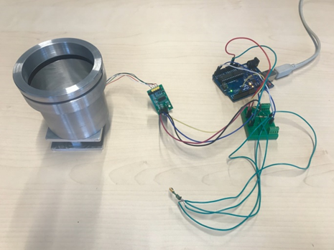

## 14.2 Second Prototype

Next developing step was the second prototype. The second prototype is consisting of same components as the first one but this time there is not that many bugs and errors. Also there is no that many cables. The sensors started to be plug and play. Also everything began to be easy replaceable. The second prototype is visible in the picture below.

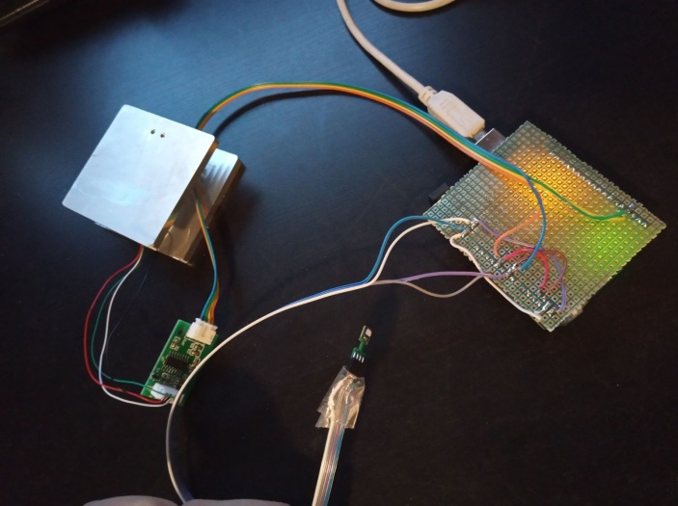

## 14.3 Final Prototype / Final Device

The figure below is representing the PCB (Printed circuit board) of the final prototype. This is a pseudo representation of it. In real the PCB won’t look like that. The PCB is containing only female 4 pin connector for all of the sensors and everything will be really easily to be disconnected or connected. In center there is socket for the I2C extender.



The figure below is representing a pseudo schematic of the final prototype. The schematic is prepared especially for non-engineering people and is representing all of the components and connection in really easy and accessible way. The top part of it they are six HX711 chips that are connected to 500g load cells bridges. In the bottom of the schematic there are seven SHT85 temperature/humidity sensors. Six of them are for the six cups and one for measuring the environment of the oven. They are connected directly to I2C extender which is connected to the microcontroller.



The final product consist from 6 packs of cup, SHT85 (temperature/humidity sensors), 2 x foam rings, 1 x plastic rings and also a metal plate that has on it one motherboard with 6 chips and 6 load cells that are measuring the weight of the cups. Everything is with hotspot connection and really easy changeable.

 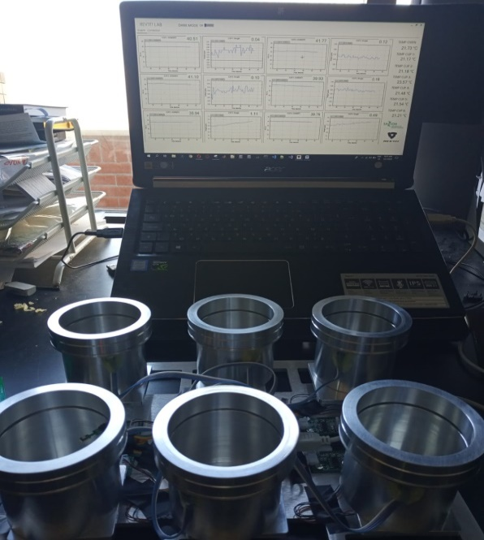

# 15. Laser

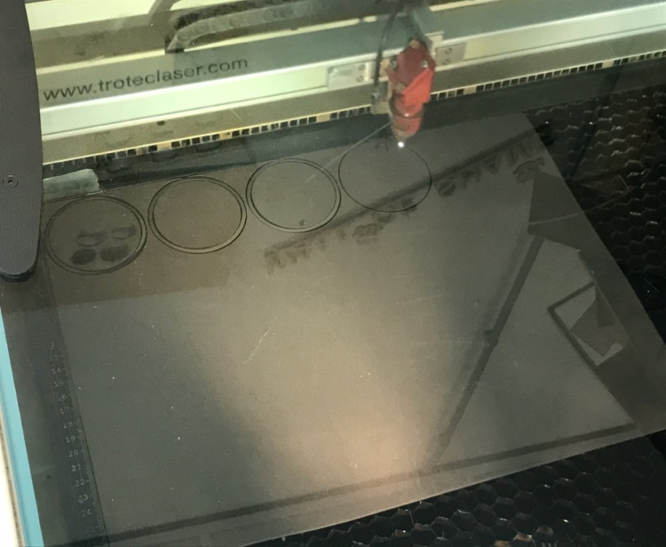Because of the circumstances that one of our team members (Harold Kip) supposed to leave our team, we should finish his part of the work. His role was mainly mechanical, for example replicating the cups, drilling wholes, gluing cables and laser cutting. Anything raleted with his speciality. Because of this we supposed to laser cut the foam and plastic rings for the cups. None of the team members did not know how to work with the laser. But we asked first in FabLab with unfortunaly we did not have the materials. That was the first problem. We supposed to find from somewhere foam and plastic material. In the end we find the materials in the Product Design departument and also we asked them for help for laser cutting. We figure out that they have laser cutter. Because of the Product Design departument and all of the nice people there we were able to have this result. They gave us the material and also help us to lase cut the rings. The whole process is visible in the picture around the text.

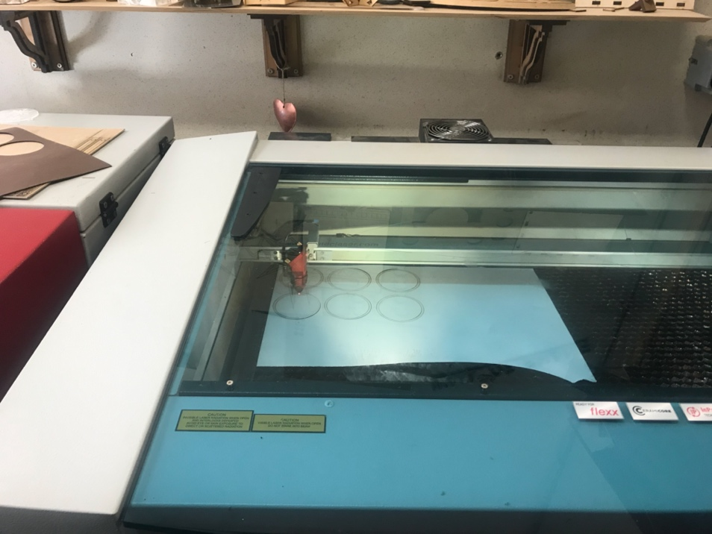

# 16.Interview

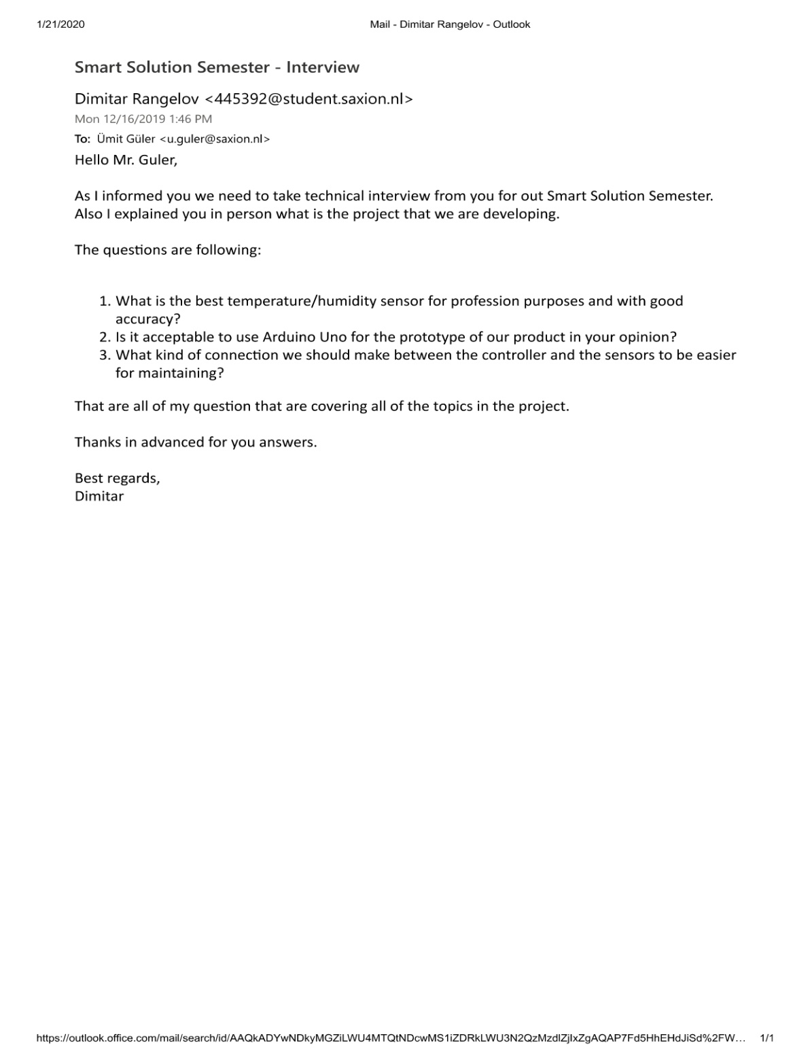

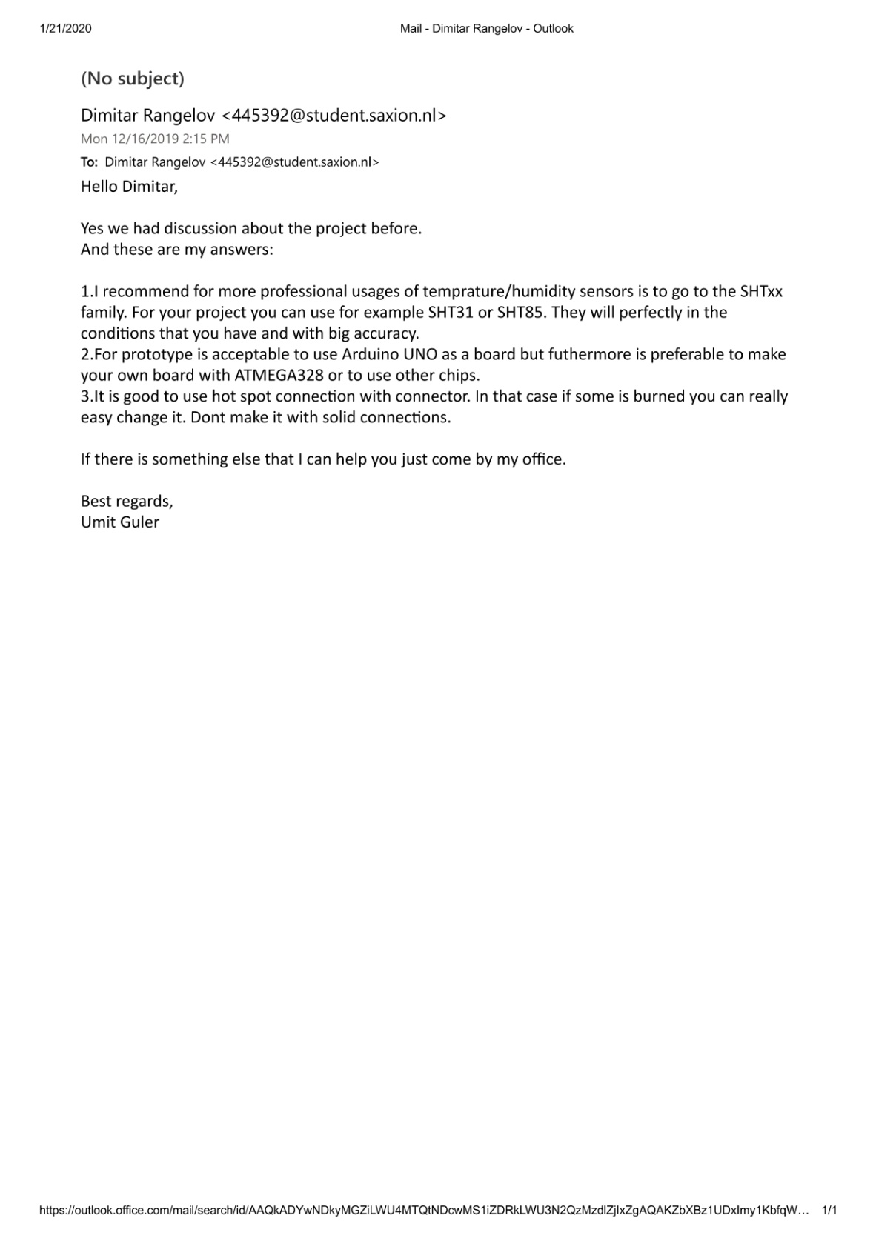

# 17.Midterm presentation



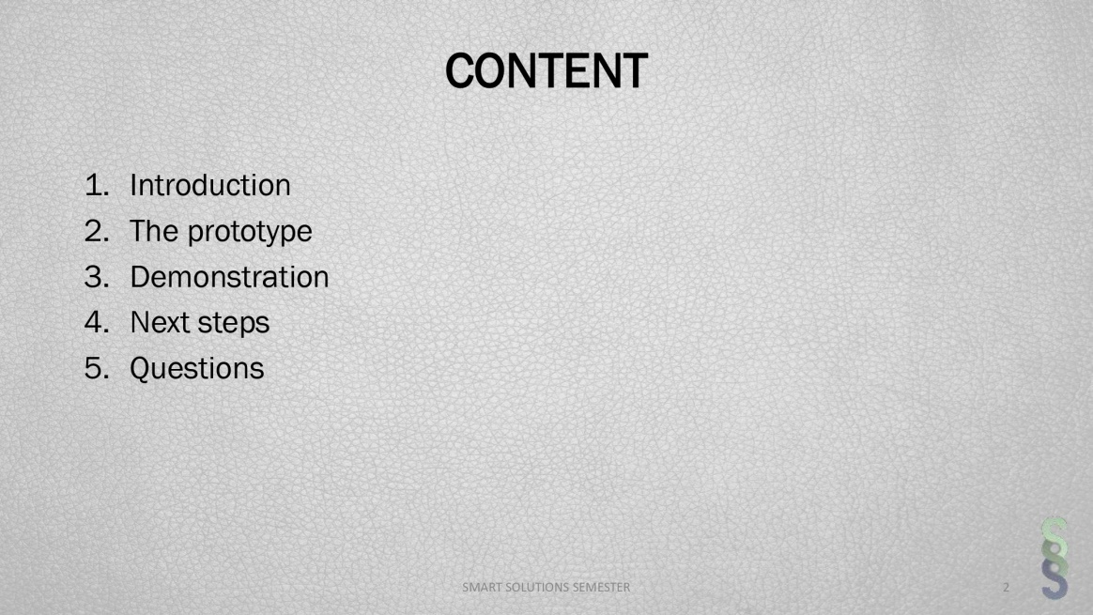

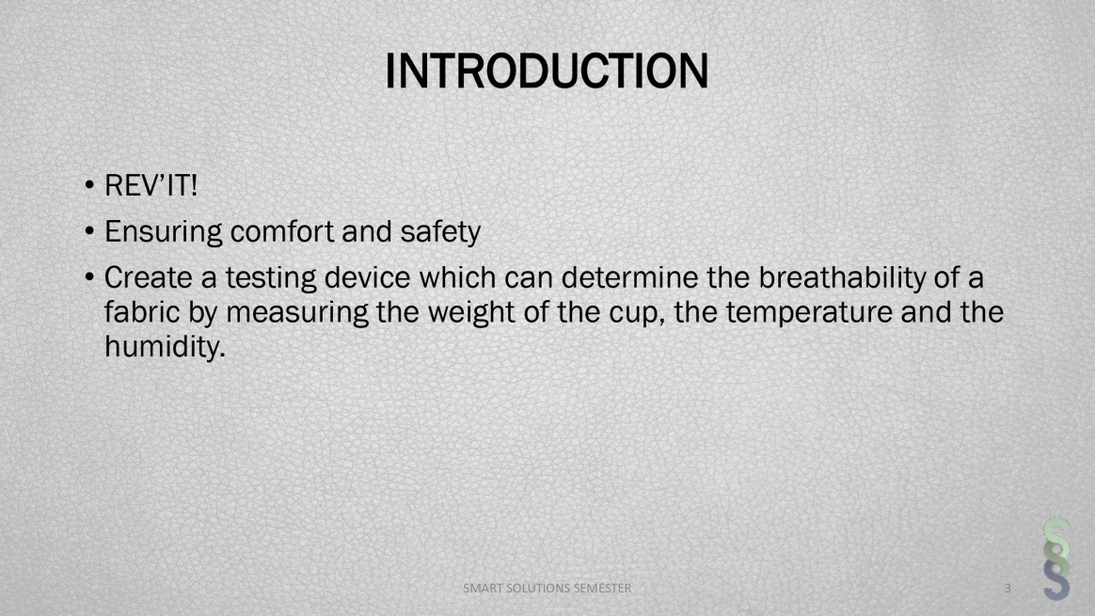

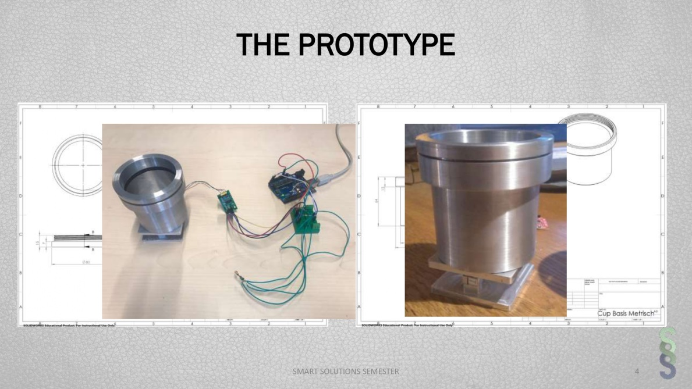

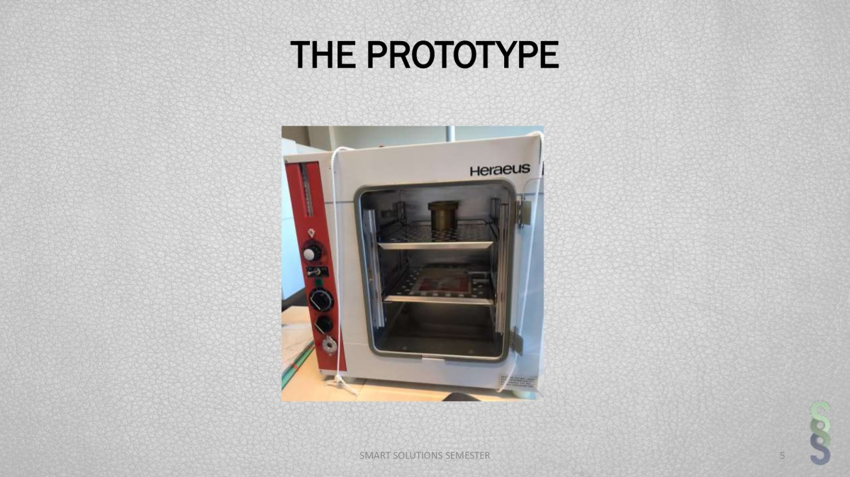

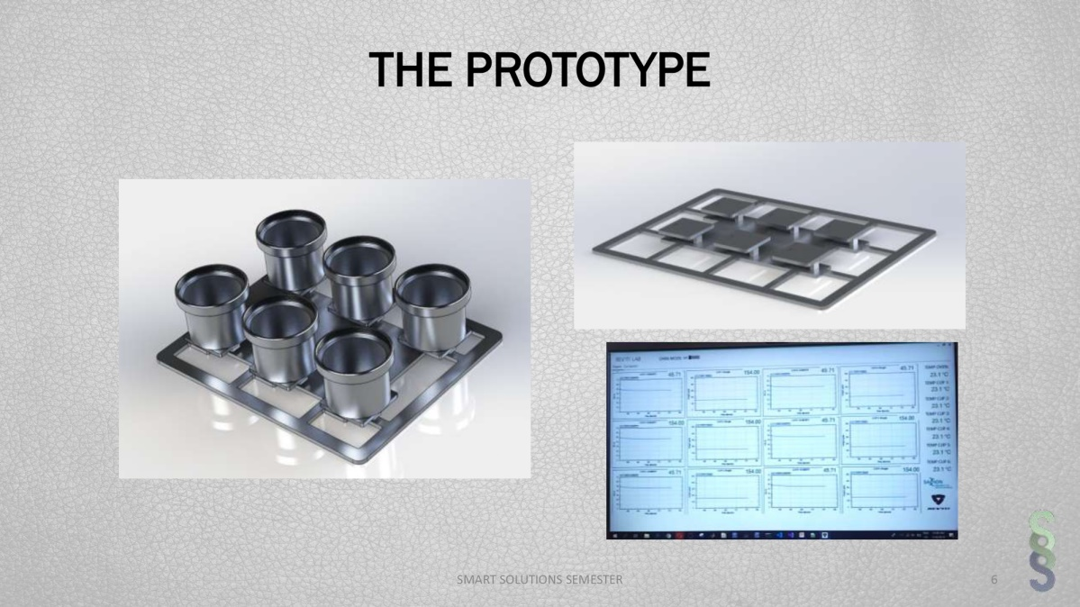

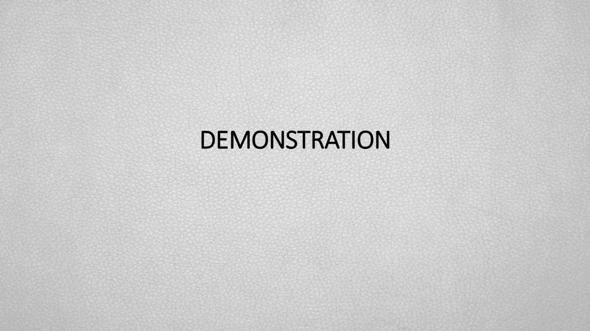

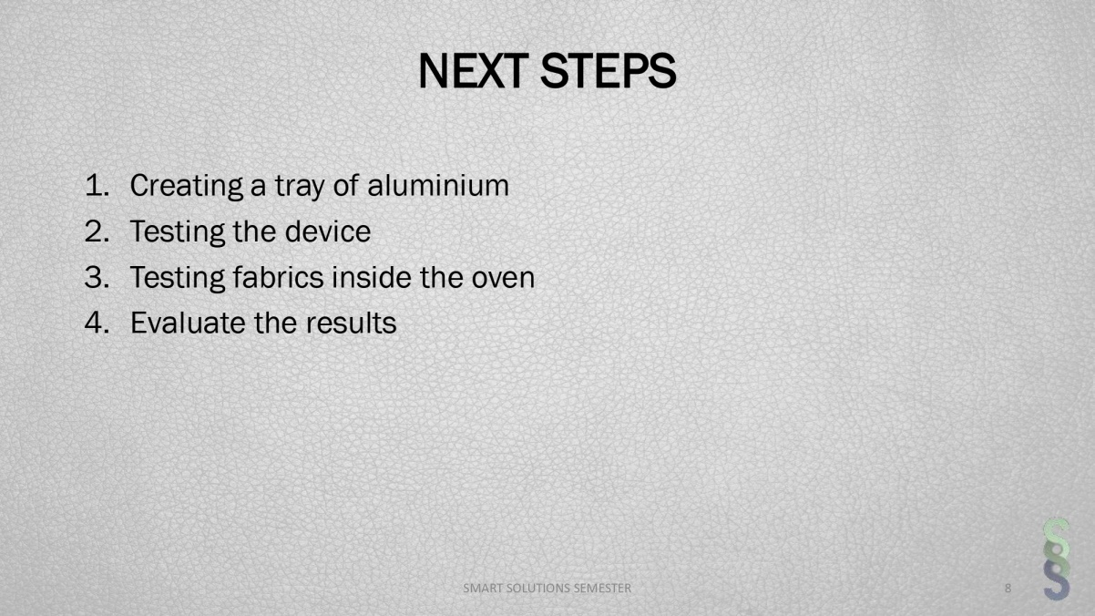



# 18.Last Presentation REVIT

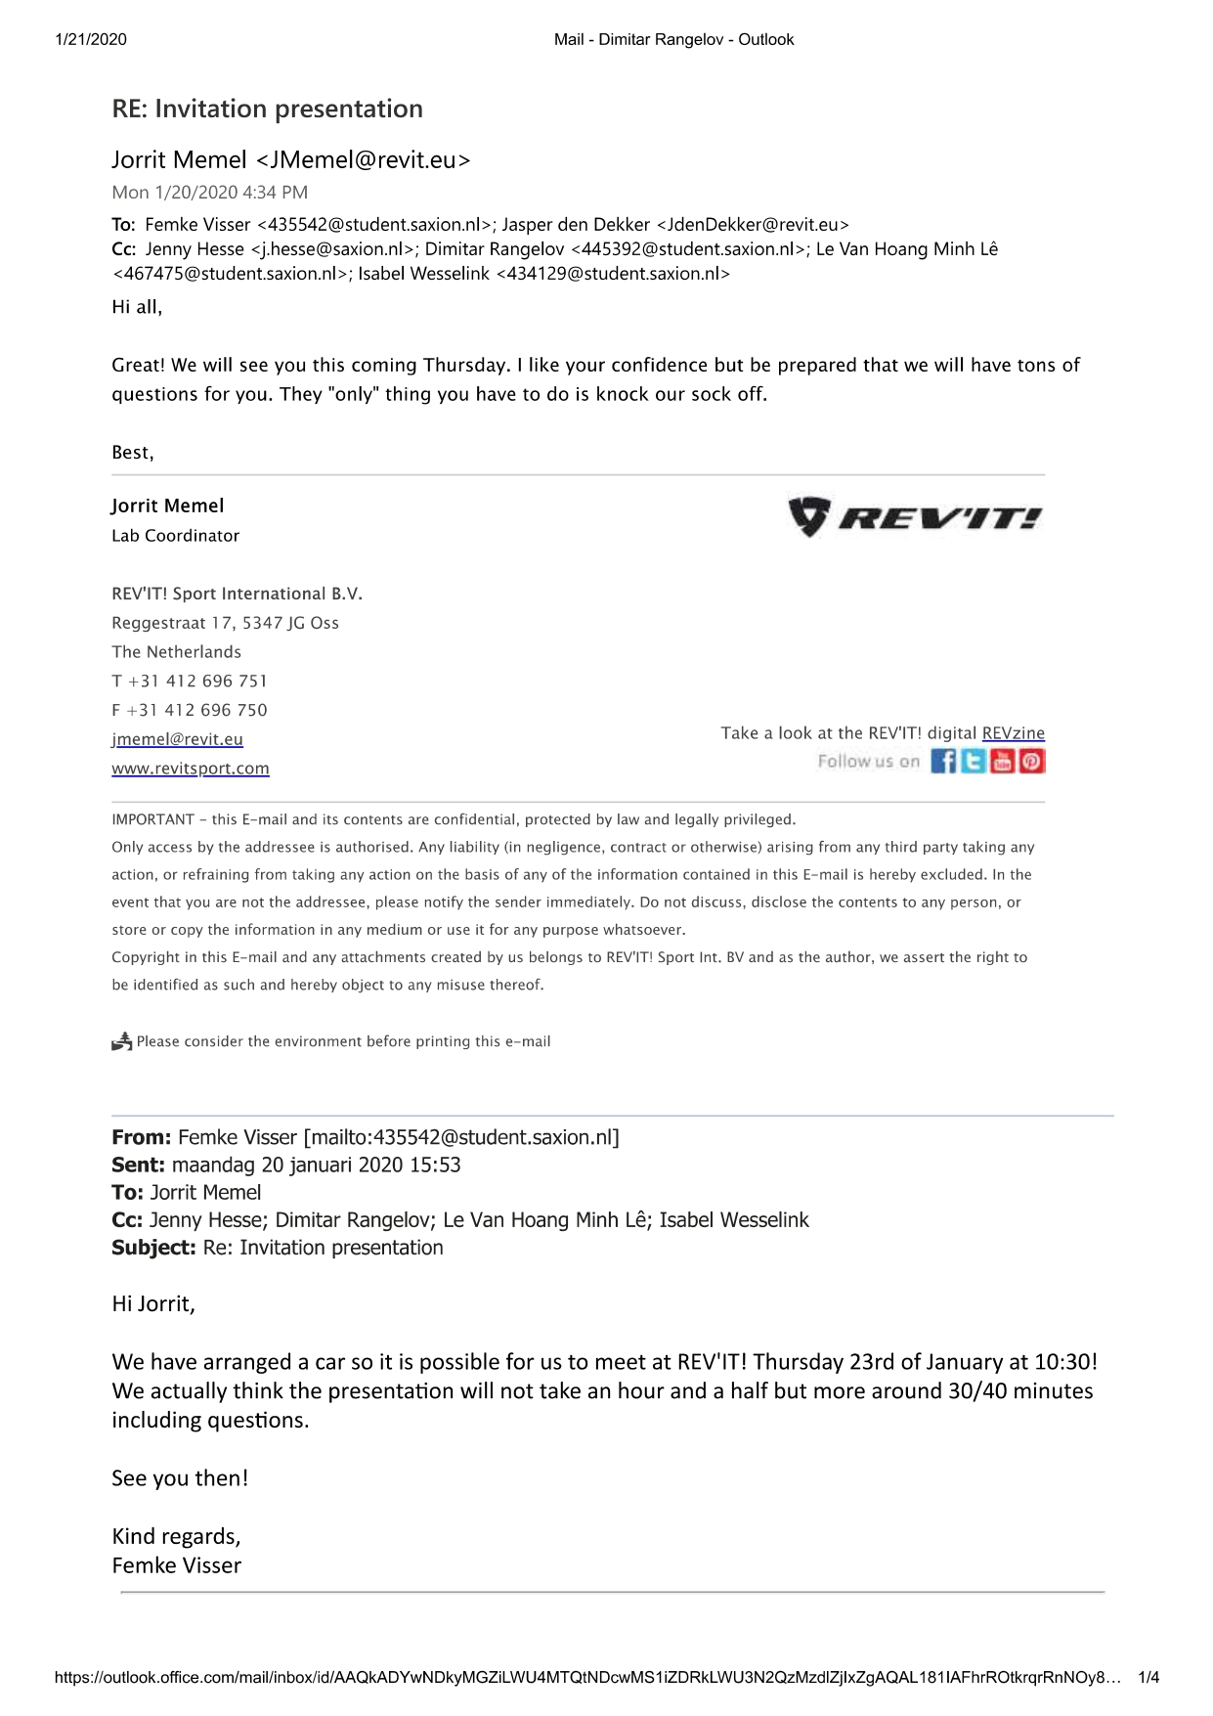





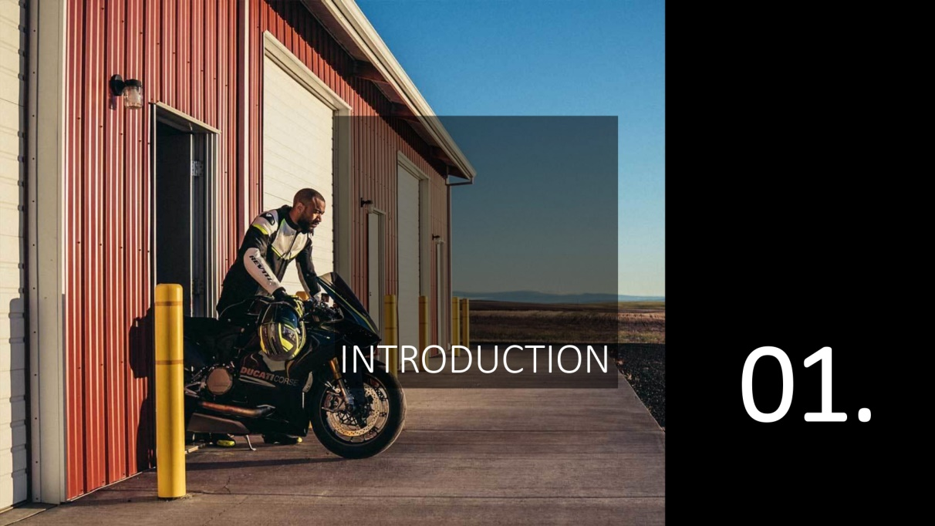



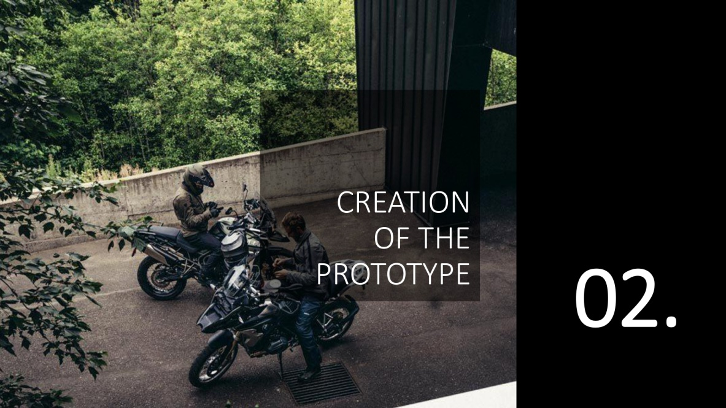

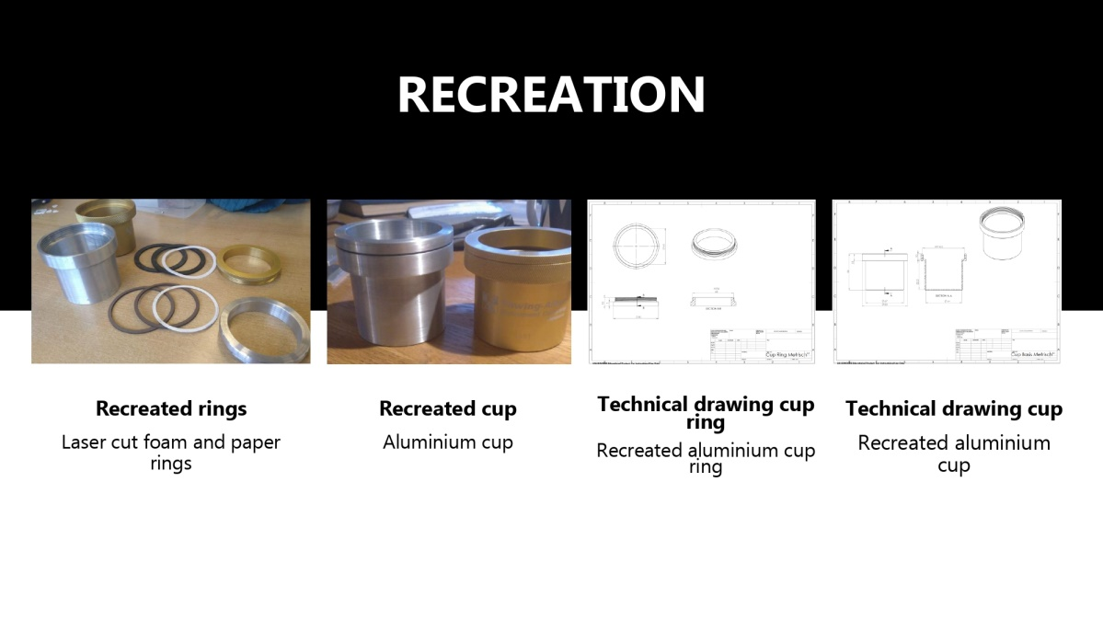

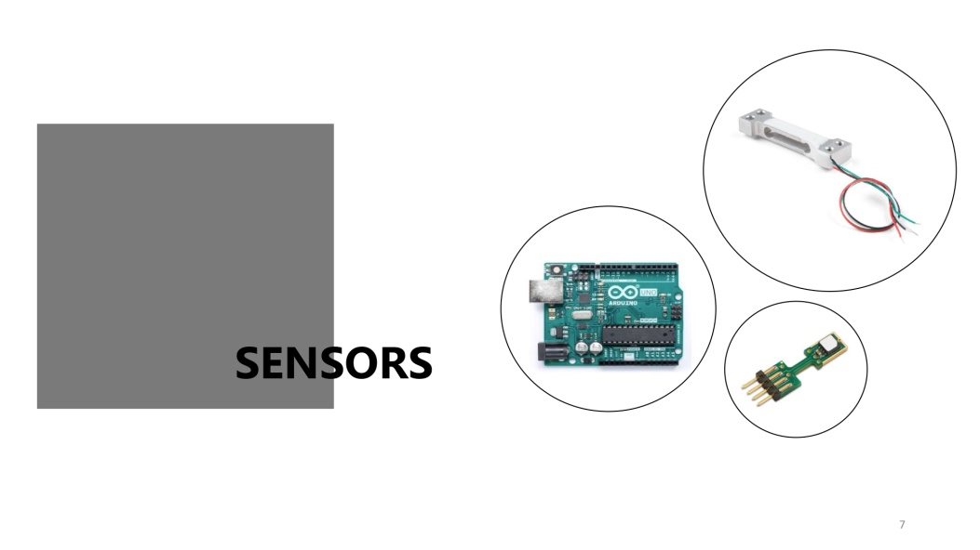

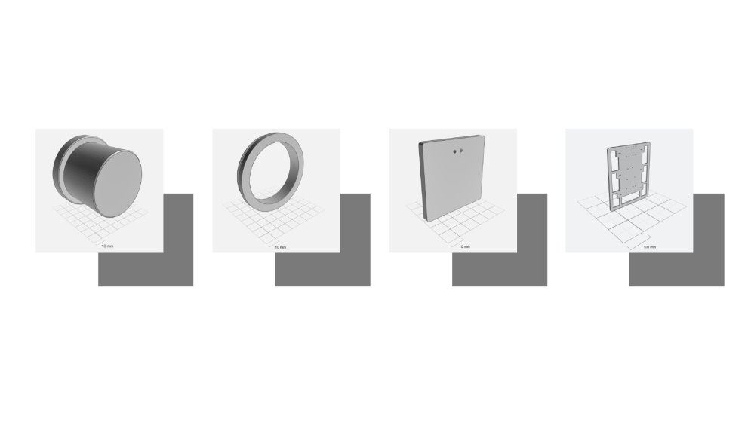

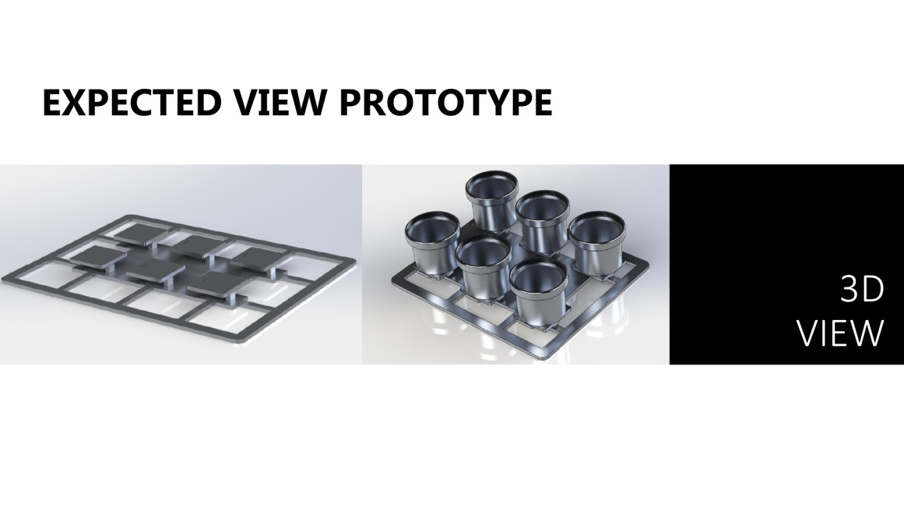

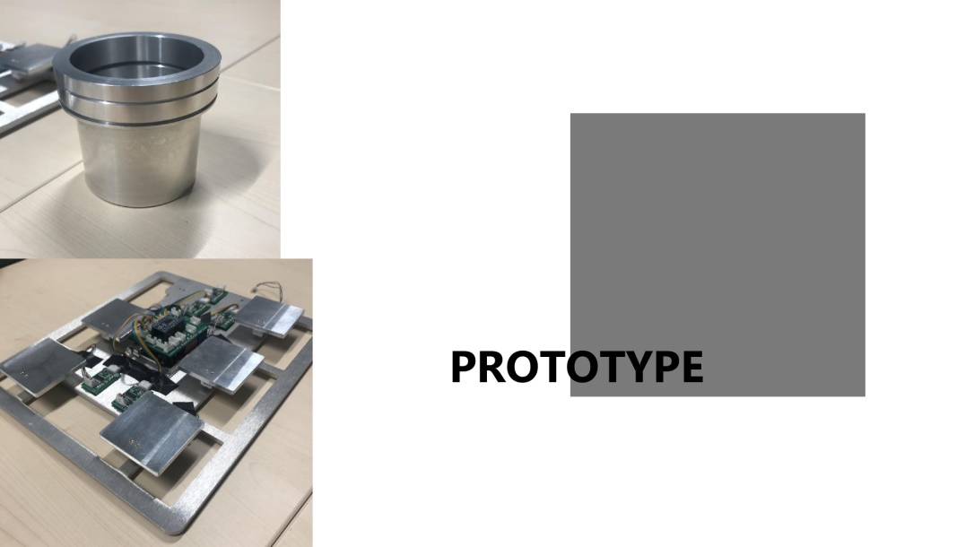

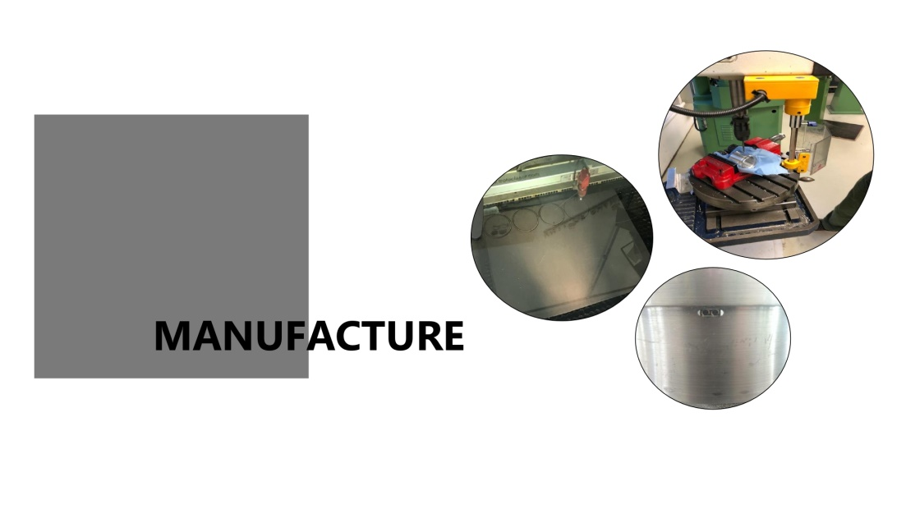

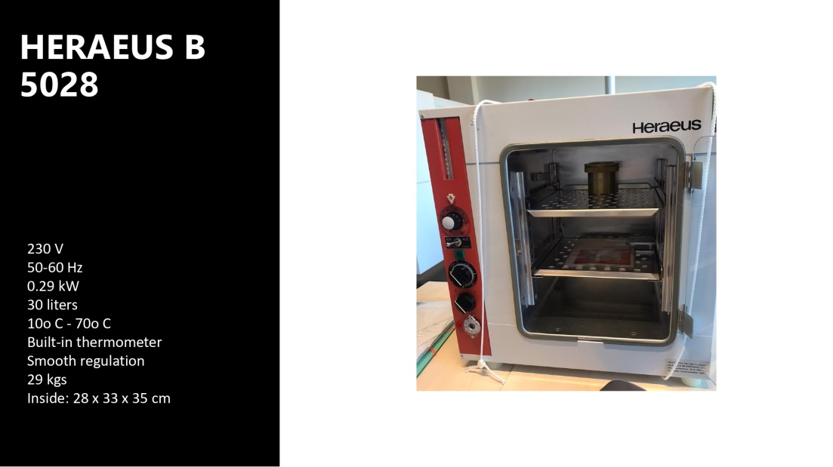

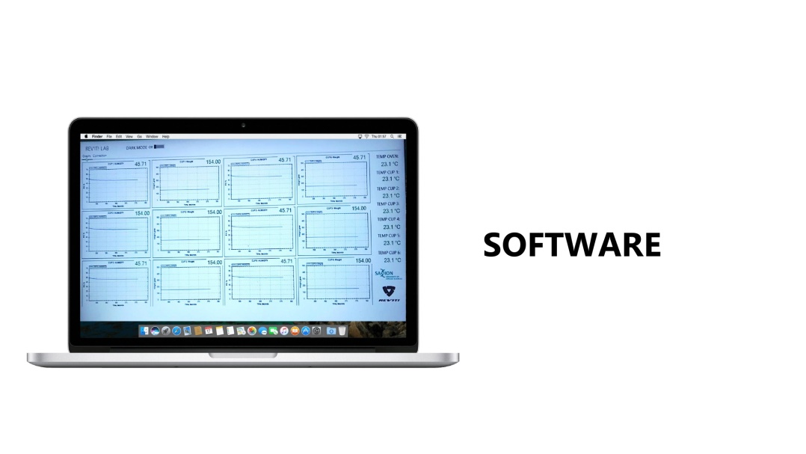

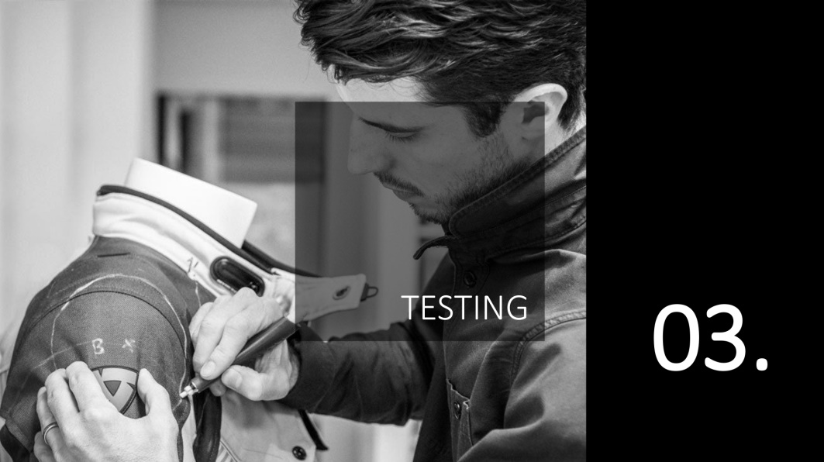



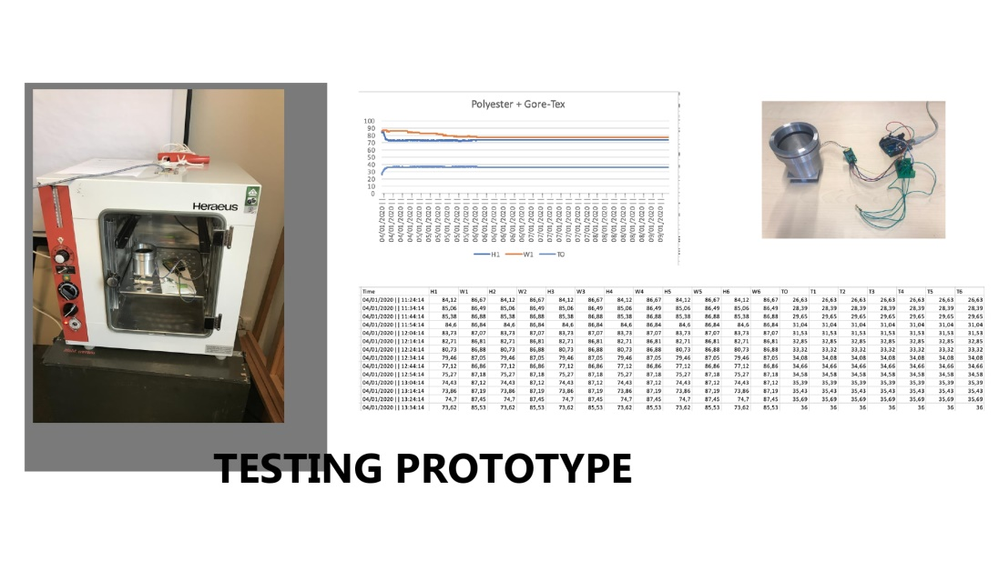



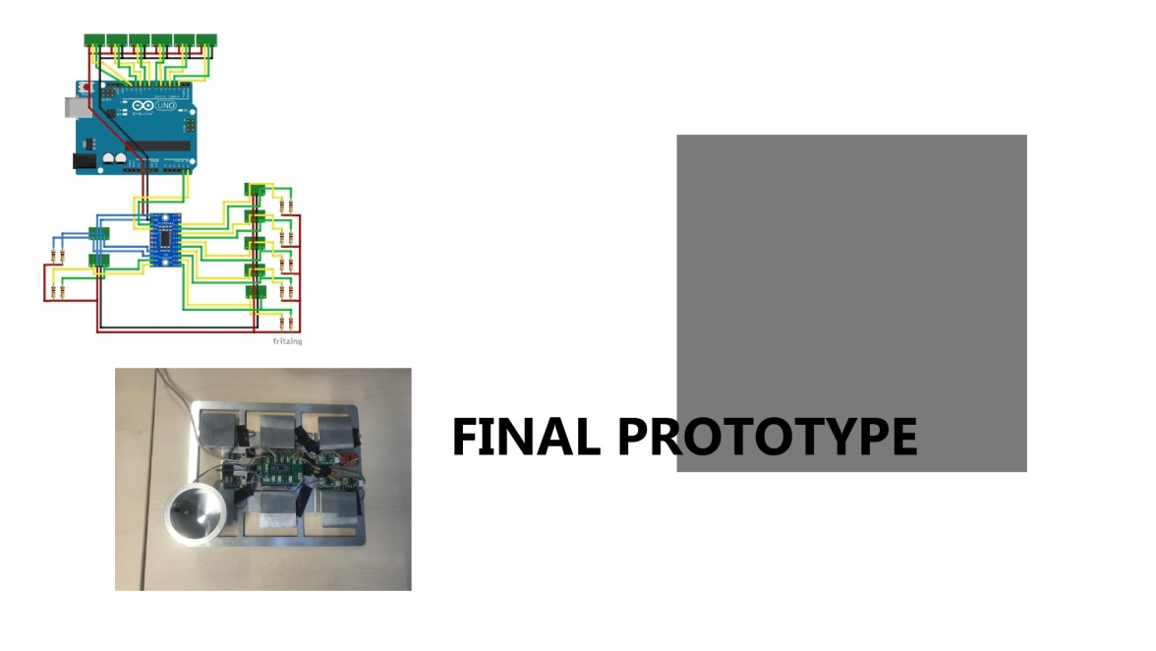



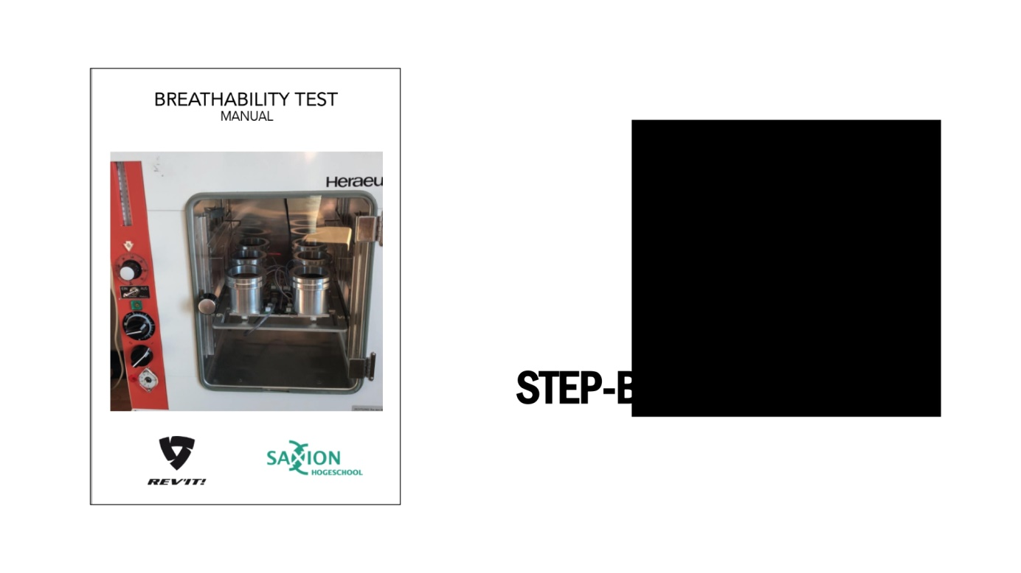

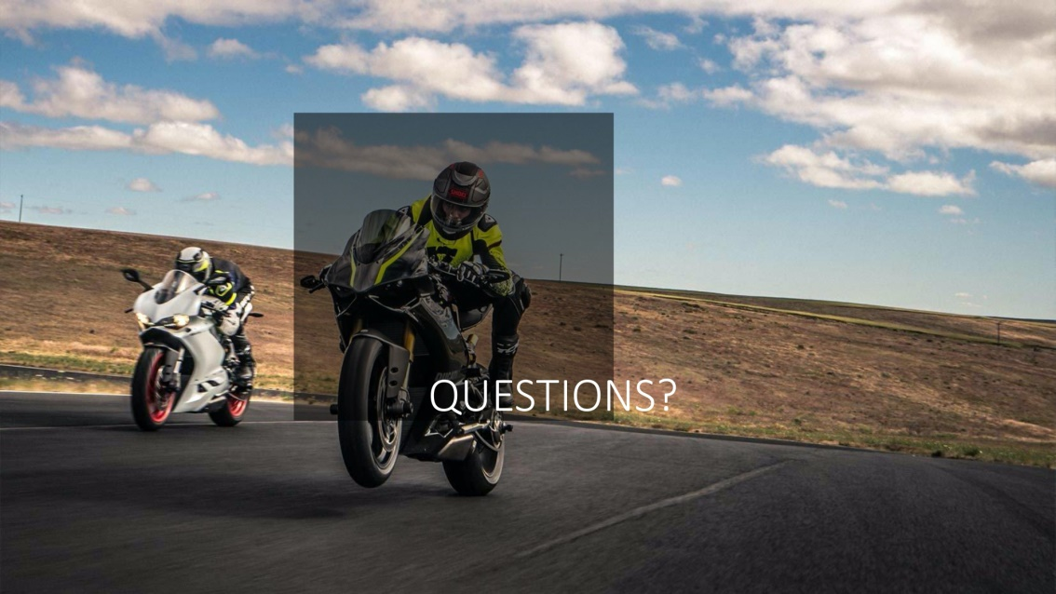

The picture below is from the final presentation of the project in the REVI’Ts Labs. We present the presentation in the pictures above and after that we demonstrate the final prototype. Our team provided the user manual to Jorrit from REVI’T and explained each of the steps.

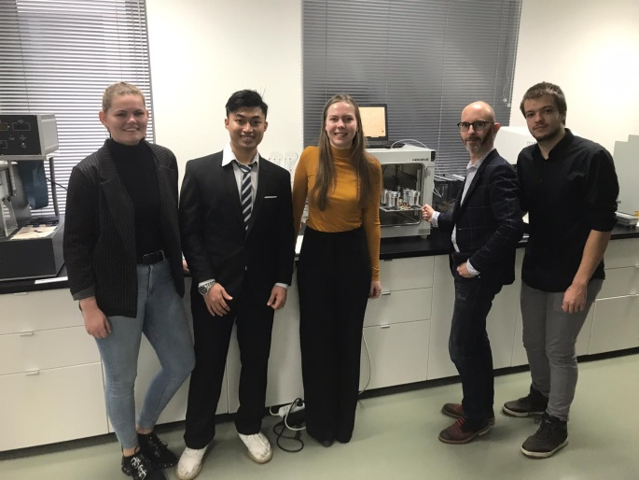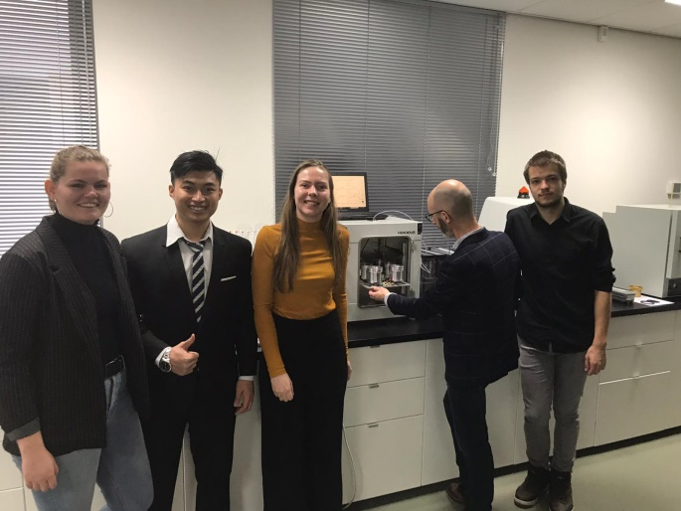

# 19. Product Manual

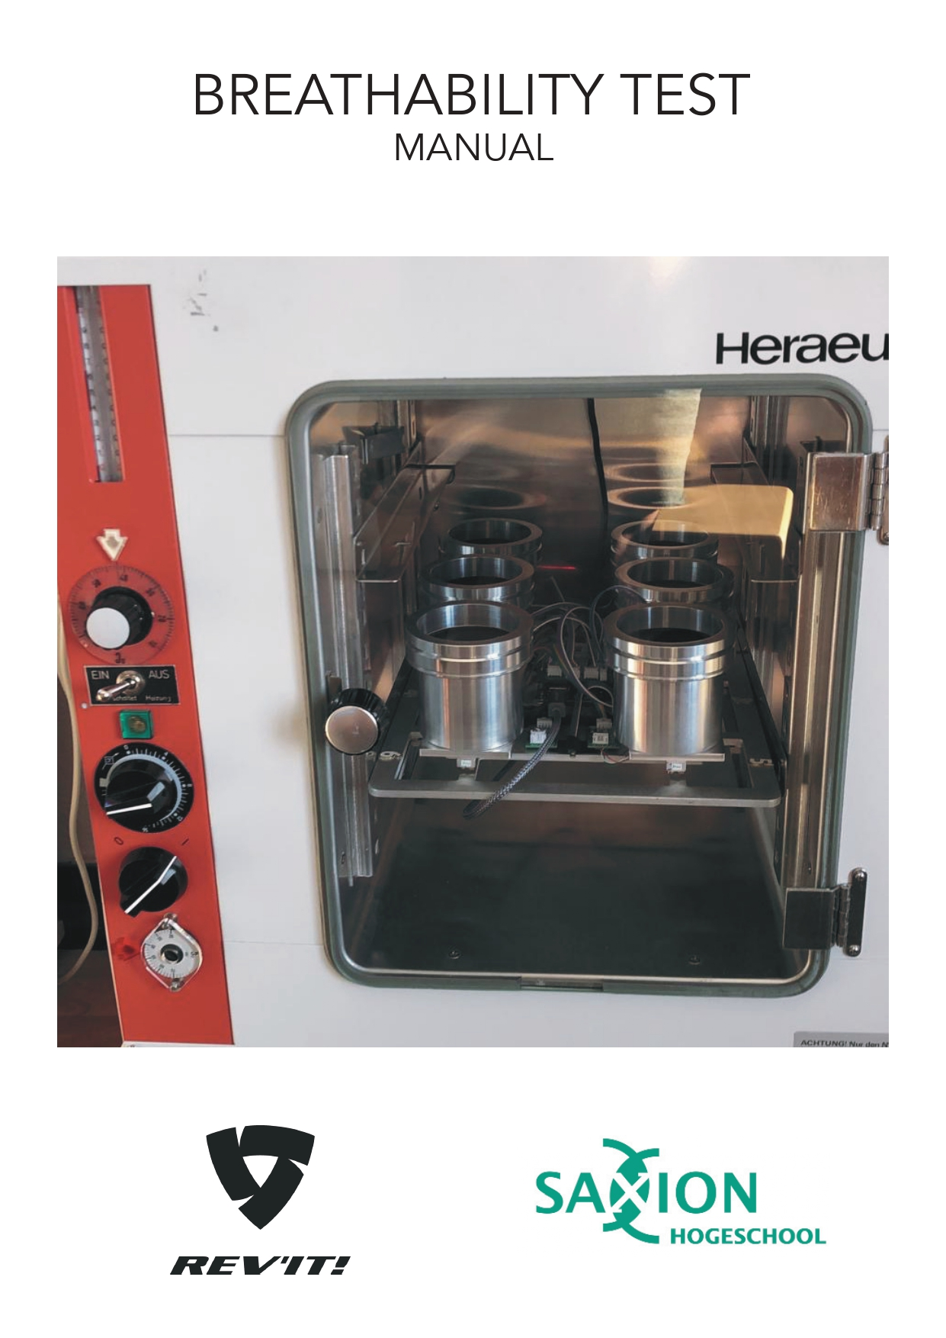

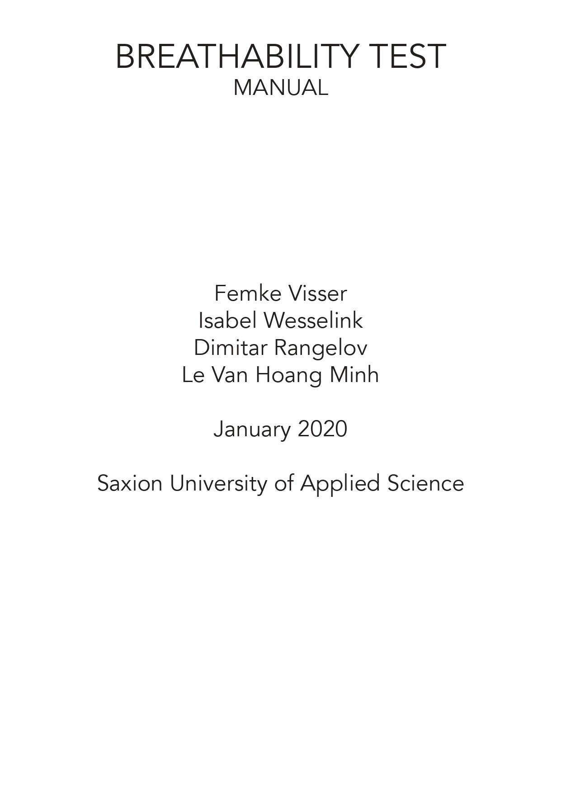

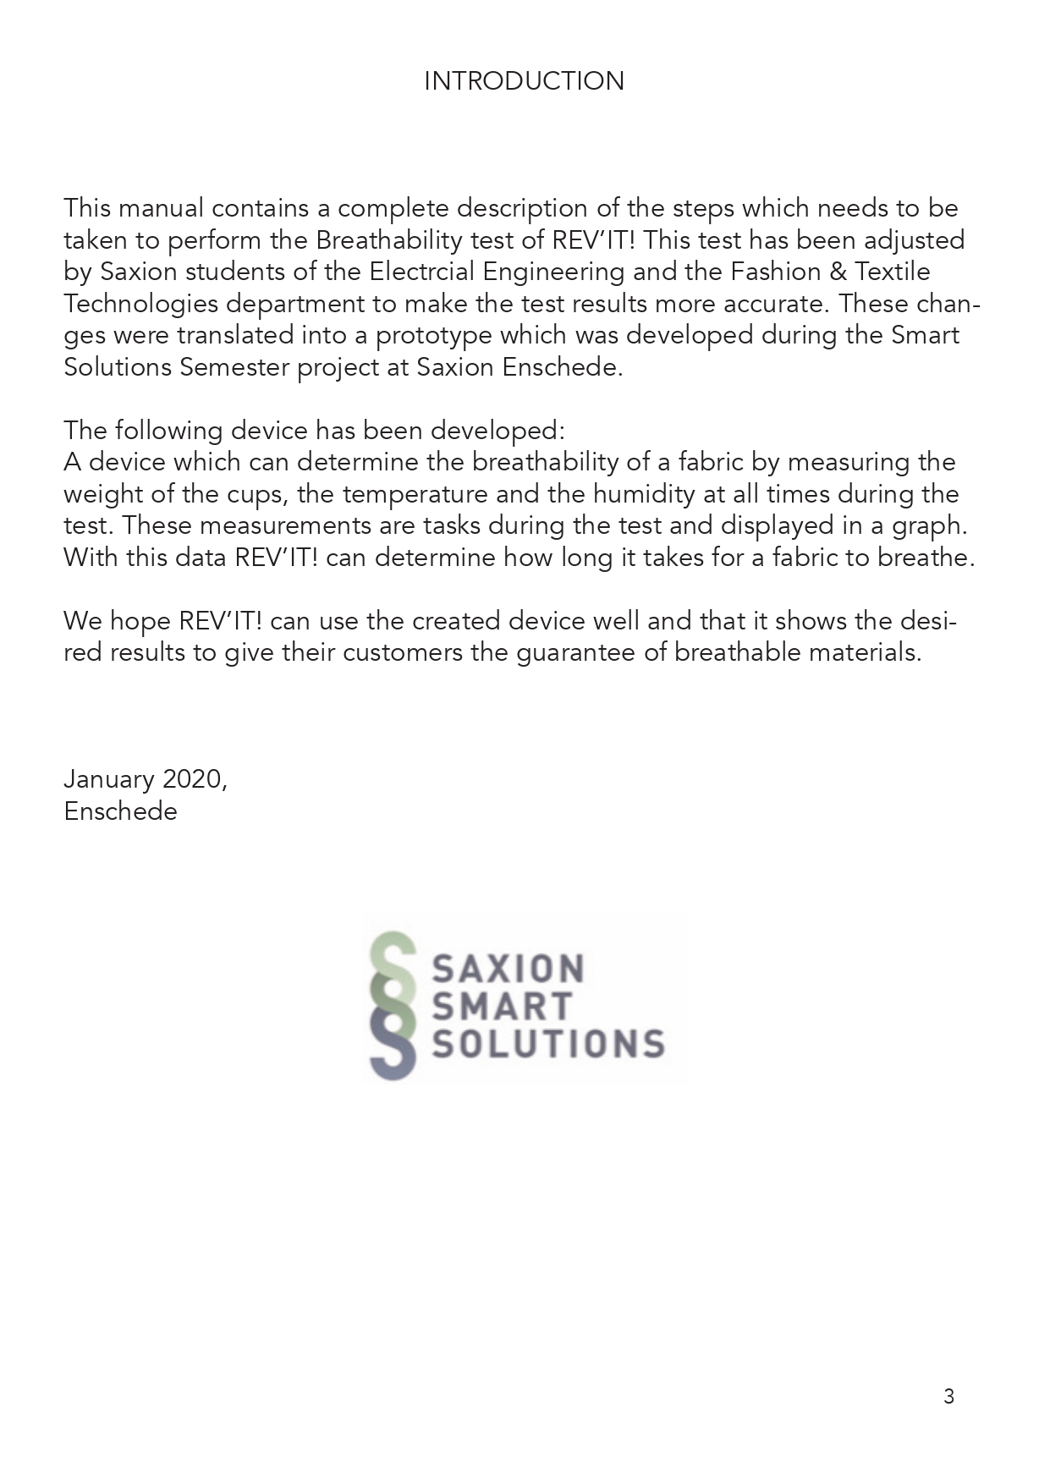

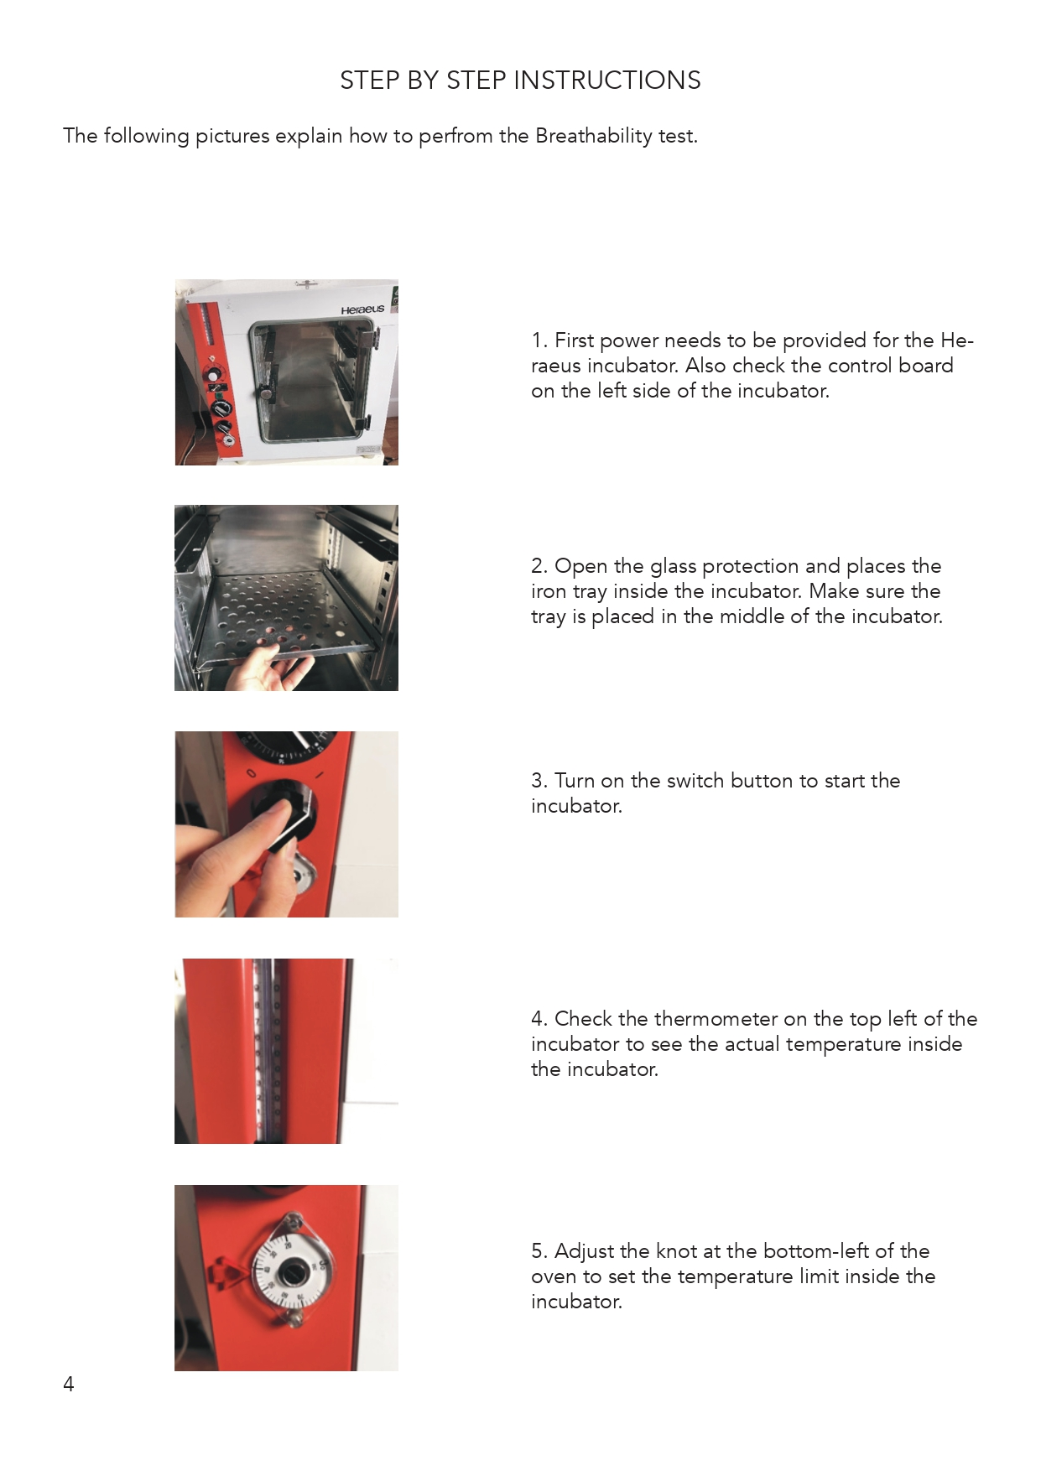

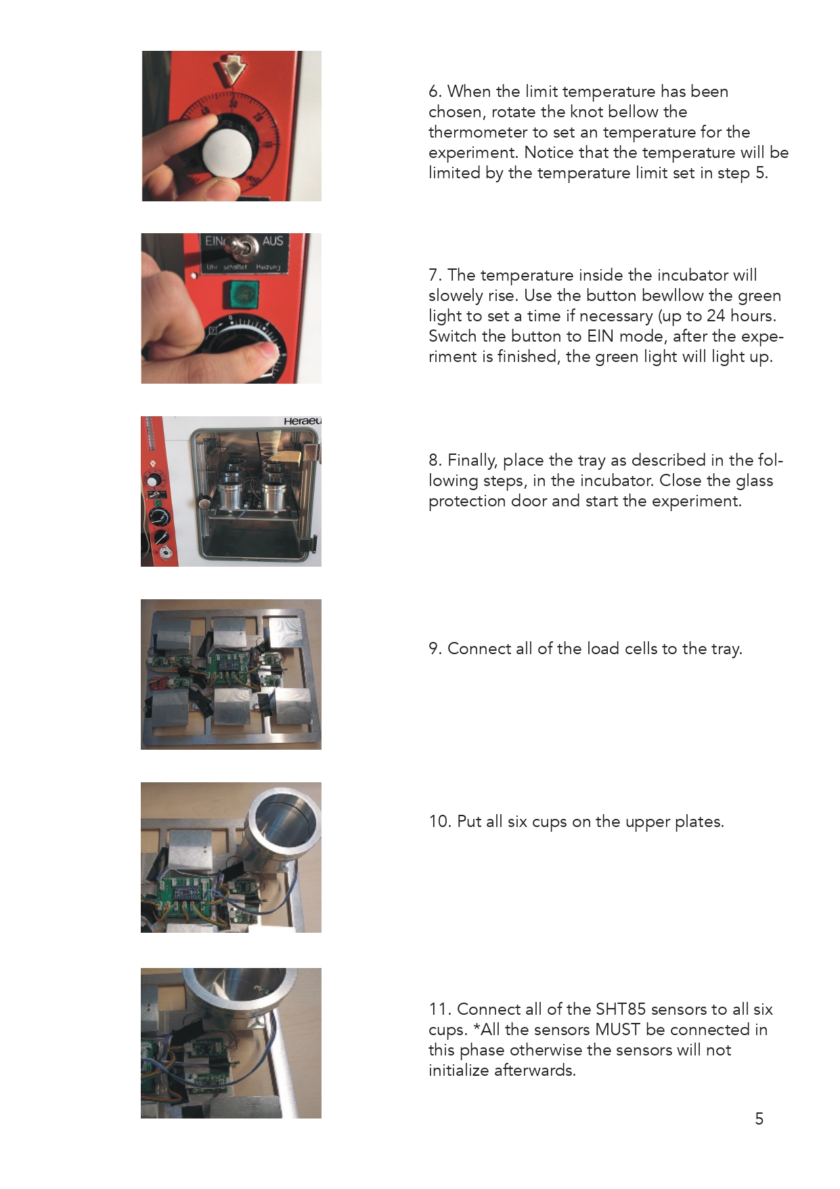

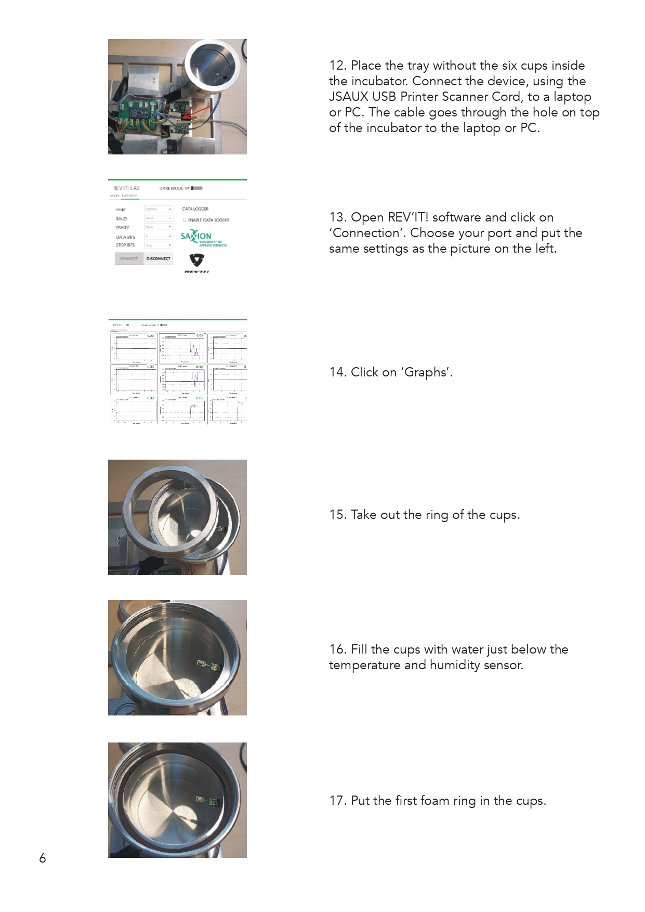

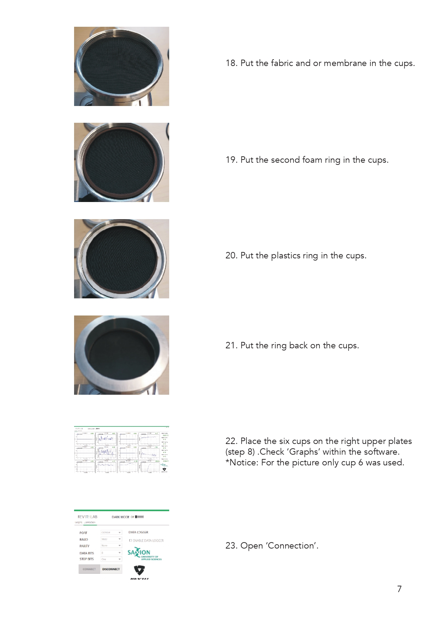

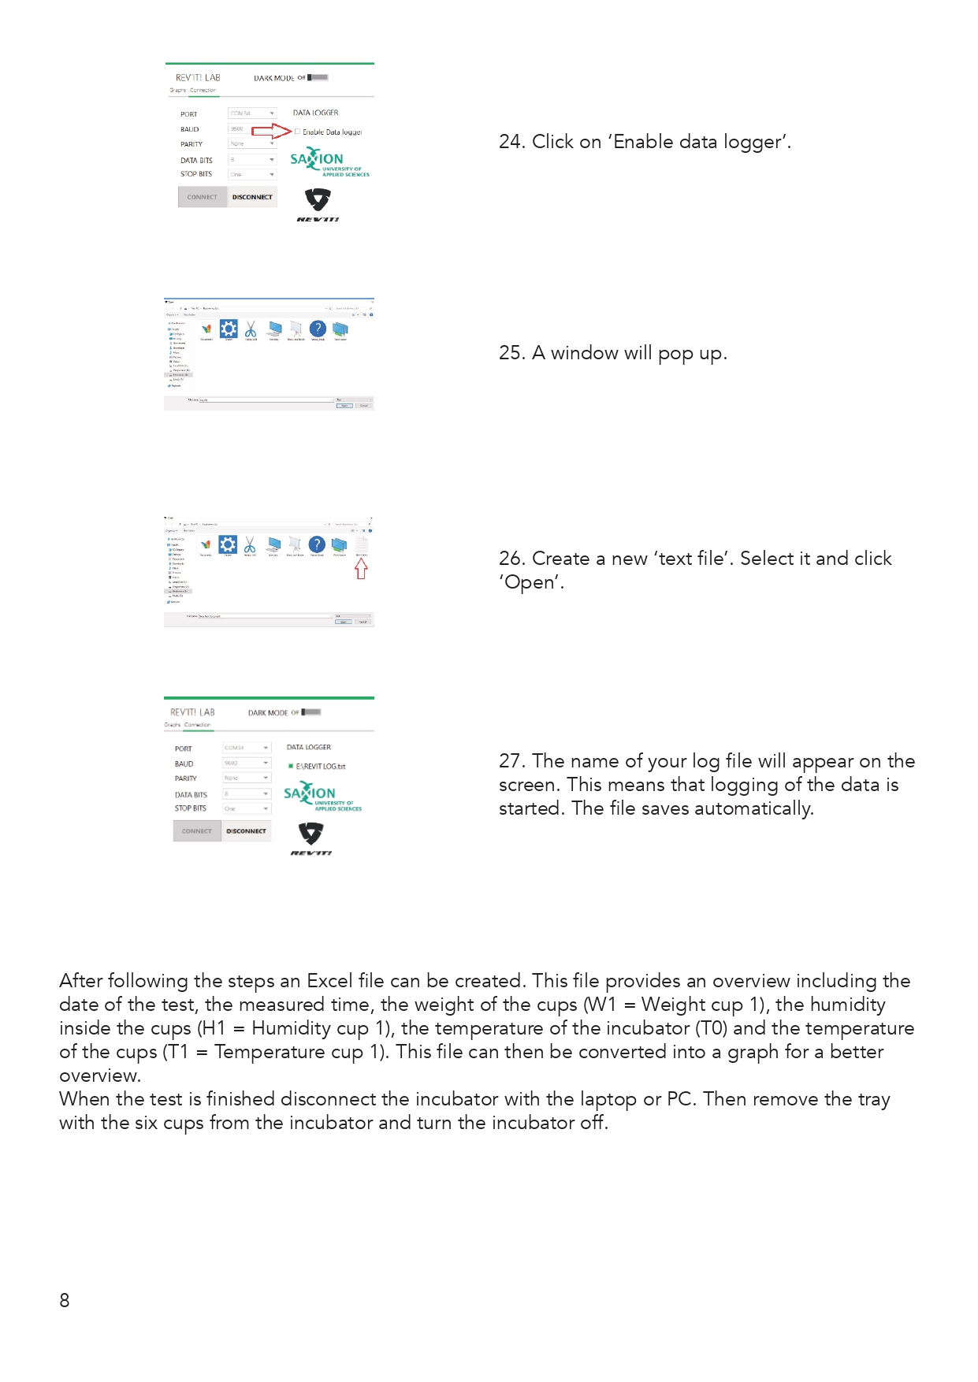

# 20. Testing

The picture below is repesenting the first testing/experiment setup that was located in one of the working smart solution rooms in Saxion.

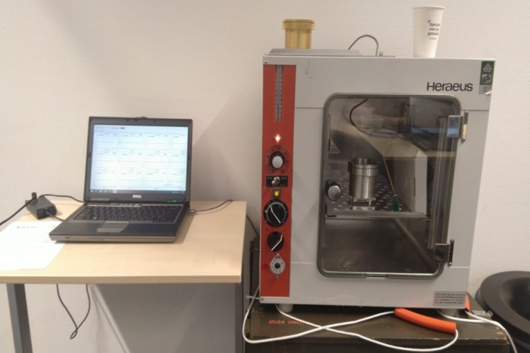

We work together on every of the first experiments. Also we analyze and discuss each of the experimetns.

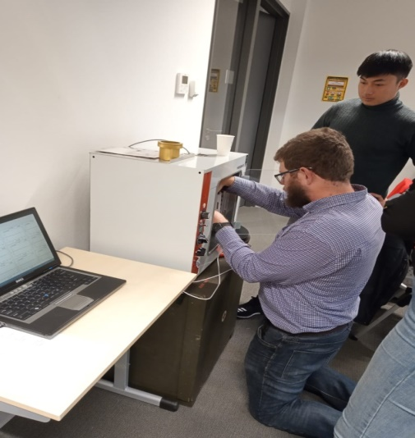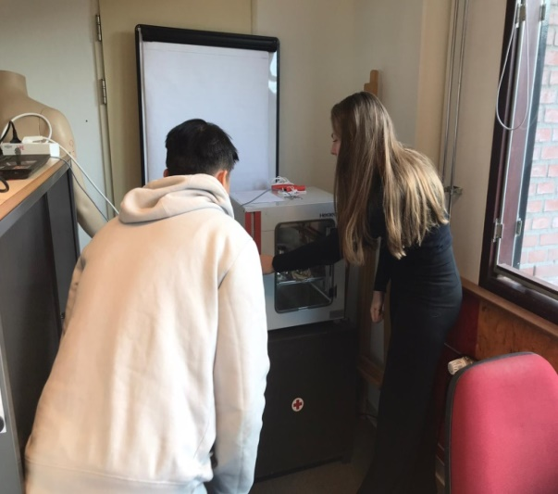

The pictures below are representing the final prototype setup that was located in my place. And the first test that was indicating that the final device is working properly.

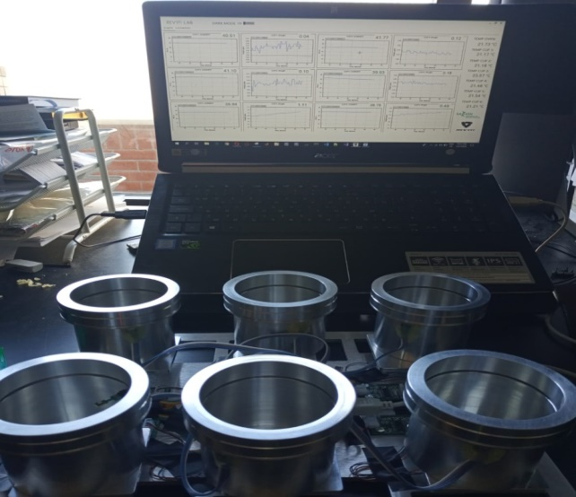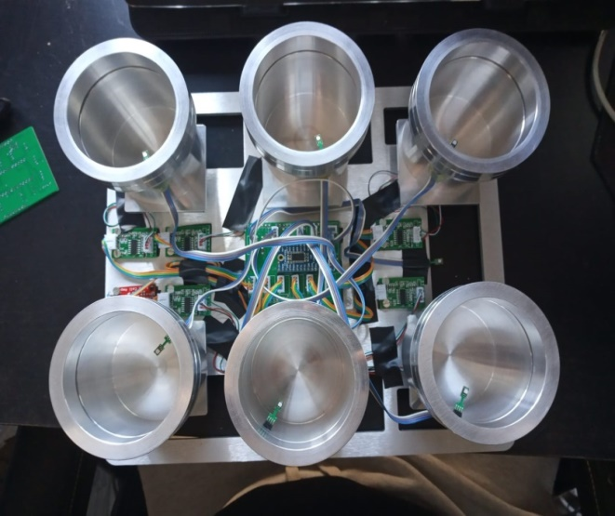

The picture below is from the last experiment. For more information about it is visible at Testing final prototype – REV’IT! & Intrepid (21/01/2020 – 22/01/2020).

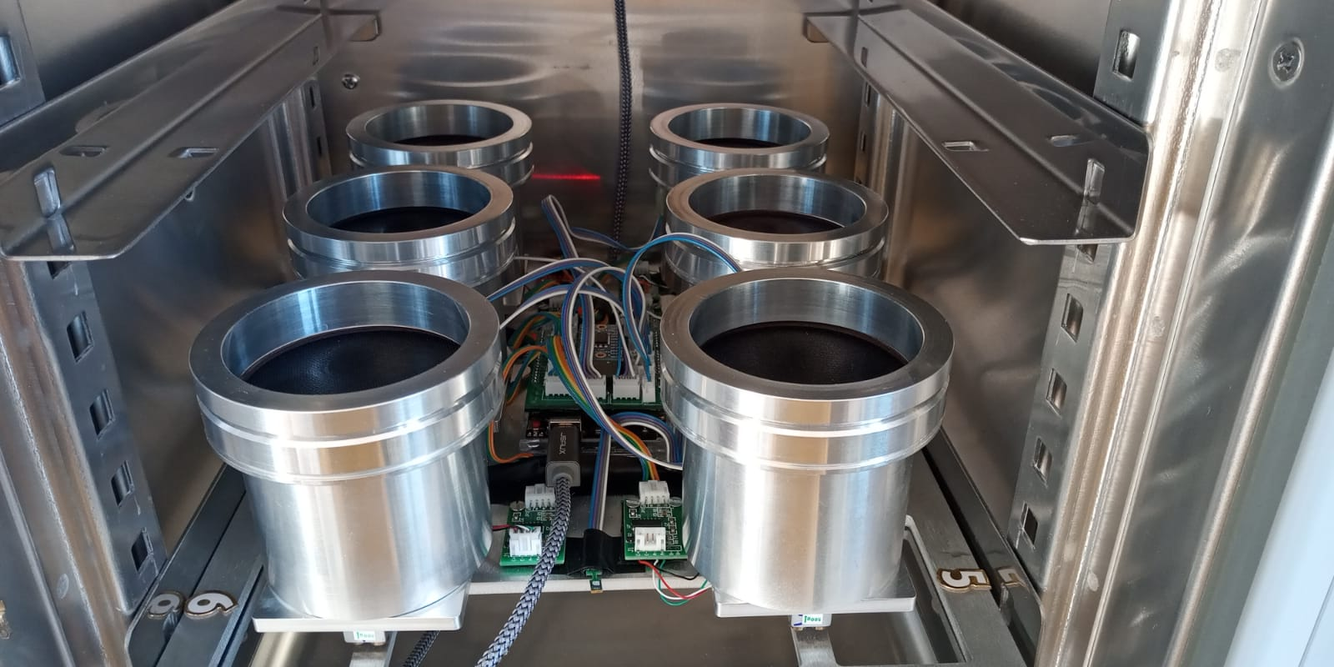

There are more pictures below from the last experiment that is proving that the final prototype is able to work with 6 cups for first time. Also in the right picture is visible my help to the experiment.

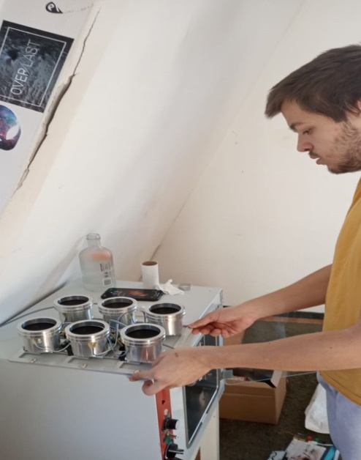

## 20.1 Testing final prototype – REV’IT! & Intrepid (21/01/2020 – 22/01/2020)

|  |  |  |  |  |  |  |  |  |  |  |  |
| --- | --- | --- | --- | --- | --- | --- | --- | --- | --- | --- | --- |
| Time | H1 | W1 | H2 | W2 | H3 | W3 | H4 | W4 | H5 | W5 | H6 |
| 21/01/2020 || 12:44:34 | 78.25 | 105.5 | 80.86 | 100.43 | 78.74 | 101.4 | 85.74 | 117.75 | 86.88 | 105.29 | 84.34 |
| 21/01/2020 || 12:54:34 | 79.37 | 105.5 | 82.54 | 100.4 | 80.29 | 101.36 | 86.63 | 117.45 | 87.78 | 105.37 | 85.38 |
| 21/01/2020 || 13:04:34 | 80.48 | 105.6 | 83.81 | 100.42 | 80.8 | 101.41 | 87.36 | 117.35 | 88.46 | 105.42 | 86.28 |
| 21/01/2020 || 13:14:34 | 80.6 | 105.7 | 84.82 | 100.43 | 82.11 | 101.49 | 87.84 | 117.27 | 89.1 | 105.46 | 87.09 |
| 21/01/2020 || 13:24:34 | 82.04 | 105.8 | 85.86 | 100.42 | 82.18 | 101.53 | 88.08 | 117.25 | 89.57 | 105.53 | 87.62 |
| 21/01/2020 || 13:34:34 | 83.15 | 106 | 86.36 | 100.4 | 82.83 | 101.66 | 88.29 | 117.25 | 90.01 | 105.59 | 88.05 |
| 21/01/2020 || 13:44:34 | 84.25 | 106.1 | 86.32 | 100.39 | 85.88 | 101.77 | 88.68 | 117.23 | 90.35 | 105.58 | 88.36 |
| 21/01/2020 || 13:54:34 | 83.88 | 106.3 | 85.93 | 100.36 | 86.38 | 101.88 | 89.03 | 117.26 | 90.7 | 105.59 | 88.54 |
| 21/01/2020 || 14:04:34 | 83.62 | 106.4 | 85.68 | 100.27 | 86.33 | 101.92 | 89.25 | 117.17 | 90.72 | 105.71 | 88.53 |
| 21/01/2020 || 14:14:34 | 83.81 | 106.5 | 85.38 | 100.24 | 85.84 | 102.09 | 89.6 | 117.18 | 91.24 | 105.77 | 89.16 |
| 21/01/2020 || 14:24:34 | 84.74 | 106.6 | 85.34 | -202.77 | 86.33 | 102.26 | 89.74 | 117.23 | 91.5 | 105.79 | 89.63 |
| 21/01/2020 || 14:34:34 | 85.18 | 106.7 | 85.89 | 100.21 | 86.9 | 102.42 | 90.14 | 117.32 | 91.84 | 105.81 | 89.79 |
| 21/01/2020 || 14:44:34 | 85.69 | 106.9 | 86.24 | 100.22 | 86.98 | 102.58 | 90.39 | 117.39 | 92.11 | 105.81 | 90.08 |
| 21/01/2020 || 14:54:34 | 86.23 | 107 | 86.81 | 100.18 | 87.41 | 102.73 | 90.68 | 117.48 | 92.42 | 105.82 | 90.33 |
| 21/01/2020 || 15:04:34 | 86.73 | 107.1 | 87.31 | 100.15 | 88.28 | 102.86 | 90.94 | 117.57 | 92.57 | 105.87 | 90.56 |
| 21/01/2020 || 15:14:34 | 86.91 | 107.1 | 87.38 | 100.08 | 88.24 | 102.98 | 91.06 | 117.64 | 92.8 | 105.87 | 90.71 |
| 21/01/2020 || 15:24:34 | 87.04 | 107.1 | 88 | 100.04 | 88.81 | 103.08 | 91.35 | 117.7 | 92.9 | 105.91 | 90.95 |
| 21/01/2020 || 15:34:34 | 87.49 | 107.2 | 88.32 | 100.02 | 88.76 | 103.2 | 91.48 | 117.78 | 93.04 | 105.93 | 91.08 |
| 21/01/2020 || 15:44:34 | 87.76 | 107.2 | 88.44 | 99.99 | 89.09 | 103.27 | 91.54 | 117.85 | 93.13 | 105.95 | 91.32 |
| 21/01/2020 || 15:54:34 | 87.75 | 107.2 | 88.65 | 99.93 | 89.41 | 103.37 | 91.8 | 117.94 | 93.22 | 105.99 | 91.33 |
| 21/01/2020 || 16:04:34 | 87.74 | 107.2 | 88.63 | 99.87 | 89.8 | 103.45 | 91.98 | 118.02 | 93.54 | 105.99 | 91.52 |
| 21/01/2020 || 16:14:34 | 88.12 | 107.2 | 88.96 | 99.86 | 89.46 | 103.5 | 91.96 | 118.08 | 93.5 | 106.01 | 91.6 |
| 21/01/2020 || 16:24:34 | 88.35 | 107.1 | 88.97 | 99.81 | 89.62 | 103.57 | 92.03 | 118.15 | 93.51 | 106.05 | 91.62 |
| 21/01/2020 || 16:34:34 | 88.63 | 107.1 | 89.13 | 99.79 | 89.74 | 103.62 | 92.09 | 118.25 | 93.6 | 106.06 | 91.82 |
| 21/01/2020 || 16:44:34 | 88.67 | 107.1 | 89.18 | 99.74 | 90.27 | 103.67 | 92.26 | 118.32 | 93.72 | 106.09 | 91.98 |
| 21/01/2020 || 16:54:34 | 88.81 | 107.1 | 89.41 | 99.73 | 90.5 | 103.72 | 92.36 | 118.39 | 93.7 | 106.12 | 92.01 |
| 21/01/2020 || 17:04:34 | 89 | 107.1 | 89.51 | 99.72 | 90.47 | 103.76 | 92.33 | 118.43 | 93.86 | 106.14 | 92.09 |
| 21/01/2020 || 17:14:34 | 89.16 | 107 | 89.55 | 99.69 | 90.42 | 103.8 | 92.39 | 118.51 | 93.95 | 106.17 | 92.09 |
| 21/01/2020 || 17:24:34 | 89.31 | 107 | 89.6 | 99.67 | 90.57 | 103.85 | 92.6 | 118.67 | 93.88 | 106.15 | 92.3 |
| 21/01/2020 || 17:34:34 | 89.16 | 107 | 89.72 | 99.64 | 90.79 | 103.88 | 92.65 | 118.75 | 94.01 | 106.15 | 92.24 |
| 21/01/2020 || 17:44:34 | 89.37 | 106.9 | 89.81 | 99.63 | 90.81 | 103.91 | 92.66 | 118.82 | 94.09 | 106.17 | 92.39 |
| 21/01/2020 || 17:54:34 | 89.37 | 106.9 | 89.81 | 99.6 | 90.65 | 103.95 | 92.69 | 118.86 | 94.07 | 106.19 | 92.41 |
| 21/01/2020 || 18:04:34 | 89.34 | 106.9 | 89.77 | 99.56 | 90.85 | 103.97 | 92.75 | 118.9 | 94.21 | 106.21 | 92.45 |
| 21/01/2020 || 18:14:34 | 89.27 | 106.9 | 89.85 | 99.62 | 90.84 | 104.08 | 92.79 | 119.07 | 94.23 | 106.33 | 92.47 |
| 21/01/2020 || 18:24:34 | 89.44 | 106.8 | 89.85 | 99.52 | 90.86 | 103.94 | 92.85 | 118.99 | 94.04 | 106.3 | 92.64 |
| 21/01/2020 || 18:34:34 | 89.46 | 106.7 | 89.83 | 99.49 | 90.71 | 103.97 | 92.87 | 119.03 | 94.11 | 106.28 | 92.6 |
| 21/01/2020 || 18:44:34 | 89.52 | 106.7 | 89.94 | 99.44 | 91.02 | 103.97 | 93.06 | 119.09 | 94.26 | 106.34 | 92.58 |
| 21/01/2020 || 18:54:34 | 89.65 | 106.7 | 90.06 | 99.44 | 91.16 | 103.99 | 92.9 | 118.91 | 94.11 | 106.54 | 92.64 |
| 21/01/2020 || 19:04:34 | 89.7 | 106.7 | 90.42 | 99.46 | 91.38 | 104.08 | 93.1 | 118.98 | 94.51 | 106.54 | 92.82 |
| 21/01/2020 || 19:14:34 | 90.4 | 106.7 | 91.02 | 99.47 | 91.61 | 104.19 | 93.15 | 119.06 | 94.53 | 106.55 | 92.96 |
| 21/01/2020 || 19:24:34 | 90.64 | 106.8 | 90.9 | 99.48 | 91.96 | 104.19 | 93.18 | 119.09 | 94.44 | 106.55 | 92.96 |
| 21/01/2020 || 19:34:34 | 90.57 | 106.7 | 90.78 | 99.44 | 91.94 | 104.18 | 93.27 | 119.14 | 94.53 | 106.57 | 92.94 |
| 21/01/2020 || 19:44:34 | 90.29 | 106.7 | 90.96 | 99.42 | 91.82 | 104.25 | 93.33 | 119.19 | 94.81 | 106.56 | 93.06 |
| 21/01/2020 || 19:54:34 | 90.2 | 106.7 | 91.13 | 99.45 | 92.31 | 104.32 | 93.55 | 119.23 | 94.69 | 106.56 | 93.04 |
| 21/01/2020 || 20:04:34 | 90.49 | 106.6 | 90.72 | 99.43 | 91.96 | 104.37 | 93.41 | 119.22 | 94.91 | 106.57 | 93.29 |
| 21/01/2020 || 20:14:34 | 90.18 | 106.6 | 90.34 | 99.36 | 92.35 | 104.35 | 93.45 | 119.23 | 94.83 | 106.57 | 93.21 |
| 21/01/2020 || 20:24:34 | 90.28 | 106.5 | 90.28 | 99.34 | 92.63 | 104.29 | 93.43 | 119.21 | 94.78 | 106.57 | 93.23 |
| 21/01/2020 || 20:34:34 | 89.98 | 106.4 | 90.15 | 99.29 | 92.27 | 104.24 | 93.58 | 119.19 | 94.78 | 106.57 | 93.31 |
| 21/01/2020 || 20:44:34 | 90.22 | 106.3 | 90.15 | 99.27 | 91.73 | 104.16 | 93.59 | 119.15 | 94.59 | 106.57 | 93.12 |
| 21/01/2020 || 20:54:34 | 89.87 | 106.3 | 90.33 | 99.26 | 91.75 | 104.11 | 93.63 | 119.12 | 94.49 | 106.56 | 92.97 |
| 21/01/2020 || 21:04:34 | 89.42 | 106.2 | 90.58 | 99.24 | 91.82 | 104.02 | 93.52 | 119.09 | 94.4 | 106.58 | 92.83 |
| 21/01/2020 || 21:14:34 | 88.96 | 106.1 | 90.64 | 99.25 | 91.93 | 103.95 | 93.45 | 119.05 | 94.38 | 106.57 | 92.66 |
| 21/01/2020 || 21:24:34 | 88.72 | 106 | 90.77 | 99.25 | 91.78 | 103.9 | 93.42 | 118.99 | 94.25 | 106.59 | 92.52 |
| 21/01/2020 || 21:34:34 | 88.61 | 105.9 | 90.79 | 99.26 | 91.65 | 103.77 | 93.27 | 118.94 | 94.14 | 106.55 | 92.37 |
| 21/01/2020 || 21:44:34 | 88.32 | 105.8 | 90.81 | 99.26 | 91.57 | 103.72 | 93.14 | 118.88 | 94.02 | 106.58 | 92.26 |
| 21/01/2020 || 21:54:34 | 88.1 | 105.7 | 90.74 | 99.24 | 91.54 | 103.66 | 93.06 | 118.82 | 93.92 | 106.58 | 92.18 |
| 21/01/2020 || 22:04:34 | 87.87 | 105.7 | 90.64 | 99.24 | 91.48 | 103.58 | 92.99 | 118.77 | 93.86 | 106.57 | 92.18 |
| 21/01/2020 || 22:14:34 | 87.82 | 105.6 | 90.66 | 99.26 | 91.48 | 103.53 | 92.97 | 118.72 | 93.82 | 106.58 | 92.17 |
| 21/01/2020 || 22:24:34 | 87.82 | 105.6 | 90.77 | 99.28 | 91.44 | 103.46 | 92.92 | 118.65 | 93.84 | 106.58 | 92.16 |
| 21/01/2020 || 22:34:34 | 87.66 | 105.5 | 90.58 | 99.29 | 91.37 | 103.38 | 92.87 | 118.59 | 93.82 | 106.58 | 92.16 |
| 21/01/2020 || 22:44:34 | 87.65 | 105.4 | 90.68 | 99.3 | 91.33 | 103.31 | 92.84 | 118.55 | 93.82 | 106.56 | 92.11 |
| 21/01/2020 || 22:54:34 | 87.72 | 105.4 | 90.68 | 99.3 | 91.32 | 103.28 | 92.83 | 118.47 | 93.74 | 106.58 | 92.12 |
| 21/01/2020 || 23:04:34 | 87.77 | 105.4 | 90.78 | 99.31 | 91.36 | 103.22 | 92.8 | 118.41 | 93.75 | 106.56 | 92.09 |
| 21/01/2020 || 23:14:34 | 87.95 | 105.4 | 90.9 | 99.35 | 91.38 | 103.2 | 92.87 | 118.33 | 93.76 | 106.55 | 92.1 |
| 21/01/2020 || 23:24:34 | 88.09 | 105.4 | 91.08 | 99.34 | 91.33 | 103.14 | 92.91 | 118.29 | 93.8 | 106.56 | 92.15 |
| 21/01/2020 || 23:34:34 | 88.25 | 105.3 | 91.2 | 99.35 | 91.26 | 103.15 | 92.91 | 118.22 | 93.81 | 106.55 | 92.16 |
| 21/01/2020 || 23:44:34 | 88.22 | 105.4 | 91.27 | 99.39 | 91.35 | 103.13 | 92.97 | 118.16 | 93.92 | 106.55 | 92.21 |
| 21/01/2020 || 23:54:34 | 88.36 | 105.3 | 91.35 | 99.4 | 91.33 | 103.11 | 92.97 | 118.09 | 93.93 | 106.52 | 92.2 |
| 22/01/2020 || 00:04:34 | 88.34 | 105.3 | 91.41 | 99.38 | 91.42 | 103.09 | 93.02 | 118.07 | 93.97 | 106.53 | 92.24 |
| 22/01/2020 || 00:14:34 | 88.21 | 105.3 | 91.39 | 99.4 | 91.58 | 103.09 | 93.07 | 118.01 | 94.02 | 106.51 | 92.3 |
| 22/01/2020 || 00:24:34 | 88.42 | 105.3 | 91.49 | 99.4 | 91.51 | 103.08 | 93.08 | 117.96 | 94 | 106.51 | 92.32 |
| 22/01/2020 || 00:34:34 | 88.45 | 105.3 | 91.52 | 99.41 | 91.35 | 103.08 | 93.05 | 117.9 | 94.06 | 106.5 | 92.28 |
| 22/01/2020 || 00:44:34 | 88.36 | 105.3 | 91.43 | 99.4 | 91.89 | 103.08 | 93.16 | 117.86 | 94.27 | 106.49 | 92.3 |
| 22/01/2020 || 00:54:34 | 91.06 | 105.4 | 91.55 | 99.39 | 92.09 | 103.11 | 92.95 | 117.8 | 94.28 | 106.48 | 92.18 |
| 22/01/2020 || 01:04:34 | 90.88 | 105.2 | 91.43 | 99.33 | 91.13 | 102.95 | 92.88 | 117.8 | 93.85 | 106.48 | 92.14 |
| 22/01/2020 || 01:14:34 | 87.95 | 104.9 | 89.88 | 99.18 | 90.29 | 102.67 | 92.72 | 117.72 | 93.74 | 106.46 | 92.07 |
| 22/01/2020 || 01:24:34 | 86.93 | 104.7 | 90.05 | 99.12 | 89.38 | 102.5 | 92.53 | 117.71 | 93.59 | 106.47 | 92.01 |
| 22/01/2020 || 01:34:34 | 86.34 | 104.6 | 88.28 | 99.03 | 87.7 | 102.36 | 92.6 | 117.71 | 93.7 | 106.46 | 92 |
| 22/01/2020 || 01:44:34 | 86.54 | 104.5 | 87.94 | 99.01 | 87.82 | 102.3 | 92.63 | 117.75 | 93.55 | 106.45 | 91.92 |
| 22/01/2020 || 01:54:34 | 86.75 | 104.4 | 87.9 | 98.97 | 87.46 | 102.27 | 92.69 | 117.78 | 93.77 | 106.44 | 92.17 |
| 22/01/2020 || 02:04:34 | 86.84 | 104.3 | 87.85 | 98.98 | 88.17 | 102.27 | 92.82 | 117.86 | 93.66 | 106.46 | 92.36 |
| 22/01/2020 || 02:14:34 | 86.95 | 104.3 | 88 | 98.96 | 88.48 | 102.33 | 92.94 | 117.92 | 93.89 | 106.43 | 92.29 |
| 22/01/2020 || 02:24:34 | 87 | 104.4 | 88.3 | 98.96 | 88.51 | 102.37 | 92.84 | 118.01 | 93.84 | 106.43 | 92.45 |
| 22/01/2020 || 02:34:34 | 87.14 | 104.4 | 88.74 | 98.95 | 88.98 | 102.48 | 92.88 | 118.13 | 94.02 | 106.43 | 92.49 |
| 22/01/2020 || 02:44:34 | 87.64 | 104.5 | 89.03 | 98.93 | 88.92 | 102.59 | 92.94 | 118.23 | 94.09 | 106.38 | 92.57 |
| 22/01/2020 || 02:54:34 | 87.66 | 104.6 | 89.07 | 98.88 | 89.73 | 102.73 | 93.08 | 118.33 | 94.12 | 106.37 | 92.69 |
| 22/01/2020 || 03:04:34 | 87.91 | 104.6 | 89.25 | 98.89 | 89.95 | 102.85 | 93.09 | 118.44 | 94.08 | 106.36 | 92.92 |
| 22/01/2020 || 03:14:34 | 88 | 104.7 | 89.65 | 98.84 | 90.2 | 102.99 | 93.15 | 118.55 | 94.2 | 106.32 | 92.71 |
| 22/01/2020 || 03:24:34 | 88.21 | 104.8 | 89.6 | 98.78 | 89.66 | 103.1 | 93.37 | 118.68 | 94.26 | 106.29 | 92.92 |
| 22/01/2020 || 03:34:34 | 88.3 | 104.8 | 89.74 | 98.71 | 90.17 | 103.26 | 93.05 | 118.79 | 94.25 | 106.27 | 92.96 |
| 22/01/2020 || 03:44:34 | 88.66 | 104.9 | 89.81 | 98.7 | 90.61 | 103.38 | 93.17 | 118.92 | 94.26 | 106.25 | 93.07 |
| 22/01/2020 || 03:54:34 | 88.71 | 105 | 90.1 | 98.66 | 90.59 | 103.53 | 93.18 | 119.06 | 94.29 | 106.24 | 92.97 |
| 22/01/2020 || 04:04:34 | 88.79 | 105.1 | 89.97 | 98.62 | 89.75 | 103.66 | 93.58 | 119.16 | 94.32 | 106.2 | 93 |
| 22/01/2020 || 04:14:34 | 89 | 105.1 | 90.2 | 98.56 | 91.15 | 103.8 | 93.19 | 119.29 | 94.34 | 106.19 | 93.17 |
| 22/01/2020 || 04:24:34 | 89.09 | 105.1 | 90.25 | 98.52 | 90.47 | 103.88 | 93.54 | 119.4 | 94.45 | 106.16 | 92.95 |
| 22/01/2020 || 04:34:34 | 89.04 | 105.2 | 90.41 | 98.43 | 90.75 | 104.04 | 93.32 | 119.54 | 94.47 | 106.15 | 93.11 |
| 22/01/2020 || 04:44:34 | 89.15 | 105.2 | 90.41 | 98.4 | 91.16 | 104.15 | 93.24 | 119.66 | 94.38 | 106.15 | 93.06 |
| 22/01/2020 || 04:54:34 | 89.24 | 105.3 | 90.62 | 98.37 | 91.04 | 104.28 | 93.3 | 119.78 | 94.48 | 106.11 | 93.12 |
| 22/01/2020 || 05:04:34 | 89.46 | 105.4 | 90.47 | 98.34 | 91.29 | 104.4 | 93.44 | 119.88 | 94.49 | 106.11 | 93.19 |
| 22/01/2020 || 05:14:34 | 89.64 | 105.4 | 90.69 | 98.28 | 90.74 | 104.52 | 93.52 | 119.98 | 94.65 | 106.11 | 93.27 |
| 22/01/2020 || 05:24:34 | 89.67 | 105.5 | 90.62 | 98.28 | 90.88 | 104.66 | 93.56 | 120.1 | 94.54 | 106.08 | 93.28 |
| 22/01/2020 || 05:34:34 | 89.78 | 105.5 | 90.69 | 98.22 | 90.83 | 104.74 | 93.44 | 120.19 | 94.68 | 106.07 | 93.29 |
| 22/01/2020 || 05:44:34 | 89.79 | 105.5 | 90.78 | 98.2 | 91.09 | 104.81 | 93.5 | 120.29 | 94.8 | 106.07 | 93.28 |
| 22/01/2020 || 05:54:34 | 89.9 | 105.6 | 90.91 | 98.17 | 91.11 | 104.91 | 93.6 | 120.39 | 94.81 | 106.07 | 93.31 |
| 22/01/2020 || 06:04:34 | 89.89 | 105.6 | 90.84 | 98.13 | 91.24 | 105 | 93.46 | 120.47 | 94.71 | 106.07 | 93.25 |
| 22/01/2020 || 06:14:34 | 90.08 | 105.6 | 90.86 | 98.06 | 91.02 | 105.06 | 93.54 | 120.56 | 94.78 | 106.07 | 93.34 |
| 22/01/2020 || 06:24:34 | 90.12 | 105.6 | 91.02 | 98.02 | 91.49 | 105.15 | 93.46 | 120.63 | 94.75 | 106.07 | 93.35 |
| 22/01/2020 || 06:34:34 | 90.22 | 105.7 | 90.94 | 98.01 | 91.32 | 105.24 | 93.77 | 120.71 | 94.9 | 106.07 | 93.44 |
| 22/01/2020 || 06:44:34 | 90.21 | 105.7 | 91.09 | 97.97 | 91.44 | 105.29 | 93.61 | 120.8 | 94.97 | 106.07 | 93.39 |
| 22/01/2020 || 06:54:34 | 90.44 | 105.7 | 91.12 | 97.97 | 91.49 | 105.35 | 93.55 | 120.86 | 95 | 106.06 | 93.53 |
| 22/01/2020 || 07:04:34 | 90.35 | 105.8 | 91.21 | 97.93 | 91.58 | 105.43 | 93.61 | 120.94 | 95 | 106.07 | 93.41 |
| 22/01/2020 || 07:14:34 | 90.45 | 105.8 | 91.14 | 97.89 | 91.8 | 105.47 | 93.75 | 121.03 | 95.1 | 106.07 | 93.45 |
| 22/01/2020 || 07:24:34 | 90.65 | 105.8 | 91.25 | 97.89 | 91.83 | 105.52 | 93.67 | 121.1 | 95.08 | 106.07 | 93.56 |
| 22/01/2020 || 07:34:34 | 90.65 | 105.8 | 91.32 | 97.84 | 91.77 | 105.56 | 93.78 | 121.15 | 95.21 | 106.09 | 93.52 |
| 22/01/2020 || 07:44:34 | 90.66 | 105.8 | 91.26 | 97.8 | 91.86 | 105.61 | 93.64 | 121.23 | 95.19 | 106.06 | 93.45 |
| 22/01/2020 || 07:54:34 | 90.69 | 105.8 | 91.36 | 97.77 | 92.06 | 105.54 | 93.82 | 121.25 | 95.1 | 106.14 | 93.54 |
| 22/01/2020 || 08:04:34 | 90.53 | 105.8 | 91.89 | 97.77 | 91.98 | 105.64 | 94.09 | 121.31 | 95.23 | 106.14 | 93.79 |
| 22/01/2020 || 08:14:34 | 91.05 | 105.9 | 91.26 | 97.8 | 92.25 | 105.74 | 94.08 | 121.34 | 95.73 | 106.14 | 94.18 |
| 22/01/2020 || 08:24:34 | 90.49 | 105.9 | 91.04 | 97.79 | 92.67 | 105.82 | 94.14 | 121.34 | 95.94 | 106.17 | 94.15 |
| 22/01/2020 || 08:34:34 | 91 | 105.9 | 91.28 | 97.79 | 92.68 | 105.85 | 94.21 | 121.32 | 95.82 | 106.15 | 94.04 |
| 22/01/2020 || 08:44:34 | 91.32 | 105.9 | 91.63 | 97.78 | 92.92 | 105.83 | 94.35 | 121.32 | 95.86 | 106.15 | 93.96 |
| 22/01/2020 || 08:54:34 | 91.41 | 105.9 | 91.4 | 97.77 | 92.26 | 105.79 | 94.36 | 121.27 | 95.75 | 106.14 | 93.89 |
| 22/01/2020 || 09:04:34 | 91.05 | 105.8 | 91.76 | 97.78 | 92.59 | 105.77 | 94.38 | 121.24 | 95.75 | 106.16 | 93.77 |
| 22/01/2020 || 09:14:34 | 90.89 | 105.8 | 91.54 | 97.76 | 92.71 | 105.73 | 94.26 | 121.16 | 95.43 | 106.16 | 93.46 |
| 22/01/2020 || 09:24:34 | 90.55 | 105.8 | 91.41 | 97.75 | 92.56 | 105.67 | 94.24 | 121.1 | 95.36 | 106.15 | 93.46 |
| 22/01/2020 || 09:34:34 | 90.33 | 105.7 | 91.12 | 97.76 | 92.33 | 105.6 | 94.21 | 121.08 | 95.34 | 106.16 | 93.41 |
| 22/01/2020 || 09:44:34 | 90.28 | 105.6 | 90.88 | 97.75 | 92.06 | 105.54 | 94.13 | 120.95 | 95.29 | 106.18 | 93.28 |
| 22/01/2020 || 09:54:34 | 90.19 | 105.5 | 90.62 | 97.75 | 91.75 | 105.45 | 94.01 | 120.89 | 95.16 | 106.17 | 93.15 |
| 22/01/2020 || 10:04:34 | 90.17 | 105.5 | 90.36 | 97.76 | 91.61 | 105.35 | 93.89 | 120.81 | 95.05 | 106.19 | 93.03 |
| 22/01/2020 || 10:14:34 | 90.07 | 105.4 | 90.27 | 97.81 | 91.42 | 105.26 | 93.7 | 120.71 | 94.83 | 106.19 | 92.83 |
| 22/01/2020 || 10:24:34 | 89.94 | 105.3 | 90.48 | 97.8 | 91.41 | 105.17 | 93.75 | 120.62 | 94.71 | 106.21 | 92.79 |
| 22/01/2020 || 10:34:34 | 85.31 | 105.5 | 85.36 | 98.29 | 87.27 | 104.94 | 93.05 | 119.78 | 93.71 | 106.1 | 91.15 |
| 22/01/2020 || 10:44:34 | 81.55 | 105.2 | 83.1 | 98.77 | 84.32 | 104.47 | 90.29 | 118.59 | 90.9 | 105.82 | 88.01 |
| 22/01/2020 || 10:54:34 | 80.77 | 104.5 | 82.88 | 98.76 | 83.57 | 103.45 | 89 | 117.52 | 89.92 | 105.84 | 86.91 |
| 22/01/2020 || 11:04:34 | 79.35 | 103.7 | 81.99 | 98.69 | 82.8 | 102.42 | 88.92 | 116.56 | 89.75 | 105.93 | 86.87 |
| 22/01/2020 || 11:14:34 | 78.37 | 103 | 82.14 | 98.9 | 82.35 | 101.5 | 88.7 | 115.76 | 89.36 | 105.98 | 86.58 |
| 22/01/2020 || 11:24:34 | 79.52 | 102.5 | 82.87 | 99.03 | 82.58 | 100.68 | 88.83 | 115.01 | 89.58 | 106.12 | 86.7 |
| 22/01/2020 || 11:34:34 | 79.14 | 102.1 | 83.52 | 99.2 | 82.96 | 100.04 | 89.03 | 114.37 | 89.72 | 106.18 | 87.1 |
| 22/01/2020 || 11:44:34 | 77.23 | 101.8 | 82.76 | 99.37 | 82.13 | 99.49 | 89.03 | 113.77 | 89.65 | 106.21 | 86.99 |
| 22/01/2020 || 11:54:34 | 77.32 | 101.7 | 84.07 | 99.56 | 82.36 | 99.06 | 88.98 | 113.22 | 89.57 | 106.22 | 86.89 |
| 22/01/2020 || 12:04:34 | 77.72 | 101.5 | 84.94 | 99.71 | 82.96 | 98.7 | 88.97 | 112.74 | 89.47 | -84.68 | 86.93 |
| 22/01/2020 || 12:14:34 | 78.39 | 101.5 | 85.75 | 99.77 | 81.55 | 98.41 | 88.88 | 112.3 | 89.39 | 106.17 | 86.93 |
| 22/01/2020 || 12:24:34 | 77.47 | 101.5 | 86.33 | 99.81 | 83.16 | 98.19 | 89.05 | 111.91 | 89.45 | 106.11 | 87.29 |
| 22/01/2020 || 12:34:34 | 75.76 | 101.5 | 84.86 | 99.83 | 82.85 | 97.99 | 88.84 | 111.51 | 89.49 | 106.04 | 87.4 |
| 22/01/2020 || 12:44:34 | 75.85 | 101.5 | 86.29 | 99.84 | 83.13 | 97.83 | 89.07 | 111.19 | 89.41 | 105.94 | 87.39 |
| 22/01/2020 || 12:54:34 | 77.52 | 101.6 | 86.98 | 99.88 | 82.7 | 97.71 | 89.11 | 110.87 | 89.52 | 105.86 | 87.67 |
| 22/01/2020 || 13:04:34 | 77.72 | 101.7 | 87.28 | 99.85 | 83.47 | 97.62 | 89.23 | 110.53 | 89.63 | 105.76 | 87.83 |
| 22/01/2020 || 13:14:34 | 77.06 | 101.8 | 87.43 | 99.84 | 82.75 | 97.59 | 89.33 | 110.31 | 89.95 | 105.67 | 88.27 |
| 22/01/2020 || 13:24:34 | 76.44 | 101.9 | 87.71 | 99.81 | 84.8 | 97.53 | 89.67 | 110.1 | 90.22 | 105.59 | 88.6 |
| 22/01/2020 || 13:34:34 | 75.33 | 101.9 | 86.74 | 99.75 | 82.68 | 97.49 | 89.77 | 109.86 | 90.69 | 105.49 | 88.99 |
| 22/01/2020 || 13:44:34 | 74.84 | 102 | 86.76 | 99.72 | 84.07 | 97.47 | 90.06 | 109.66 | 90.56 | 105.39 | 88.85 |
| 22/01/2020 || 13:54:34 | 75.14 | 102.1 | 87.85 | 99.65 | 85.09 | 97.5 | 90.03 | 109.47 | 90.71 | 105.3 | 89.06 |
| 22/01/2020 || 14:04:34 | 76.63 | 102.1 | 87.94 | 99.57 | 84.64 | 97.45 | 90.17 | 109.31 | 90.72 | 105.22 | 89.24 |
| 22/01/2020 || 14:14:34 | 77.78 | 102.1 | 88.25 | 99.5 | 82.22 | 97.45 | 90.25 | 109.15 | 90.98 | 105.15 | 89.44 |
| 22/01/2020 || 14:24:34 | 78.07 | 102.1 | 88.01 | 99.42 | 82.48 | 97.41 | 90.42 | 108.99 | 91.38 | 105.09 | 89.86 |
| 22/01/2020 || 14:34:34 | 77.52 | 102.2 | 87.63 | 99.35 | 84.08 | 97.44 | 90.33 | 108.9 | 91.22 | 105.02 | 89.88 |
| 22/01/2020 || 14:44:34 | 77.02 | 102.1 | 86.94 | 99.29 | 82.81 | 97.44 | 90.58 | 108.76 | 91.5 | 104.97 | 89.98 |
| 22/01/2020 || 14:54:34 | 76.66 | 102.2 | 87.36 | 99.22 | 84.98 | 97.4 | 90.64 | 108.65 | 91.42 | 104.9 | 89.96 |

## 20.2 Graph testing final prototype – REV’IT! & Intrepid (04/01/20 – 09/01/20)

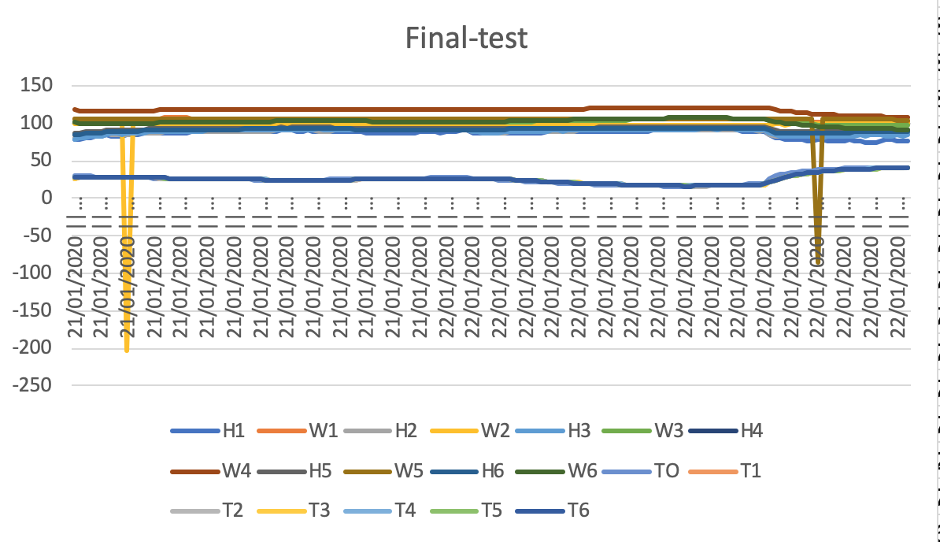

# 21. Problem solving

## 21.1 Accuracy problem solving

At the begining in the first experiments all of the load cells (weight sensor) measured values in the format like [number] grams but we analyzed that we don’t see most of the changes in weight because of only showing the first digits after that comma. Because of that the first experiments were not that successful. Afterwards I did software changes and the accuracy of the sensors started to be with two signs after the comma for examples 140.99.

However because of this change in the project we started to have way better results in the experiments and we could analyze the behavior of the textiles. Also was really visible how and when there were changes in the values.

## 21.2 Burned sensors

There were some problems on the final prototype after the Saxion Festival Smart Solutions Semester caused from visitors that pushed to much the load cells or damaged some of the sensors. I tested the load cells but as the picture below they always was giving zero value and does not matter if there is something on the metal plate or not. I tried so many things to make it work but after 3 or 4 hours I figure out that the sensors are not discalibrated and they are totally burned. After that took me several minutes to put the new load cells and test them and afterwards I figure out that one of chips that is connected with the load cells is burned. I change it and test the prototype again. In the end everything start to work.

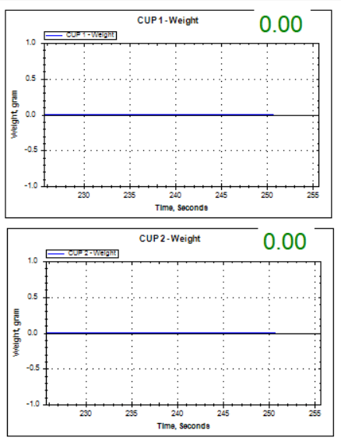

## 21.3 Defected Chips

I received an overdelayed order from TinyTronics. We ordered the last two chips HX711 of our prototype. But we received the package with big delay and in the end the chips in the package were defected. They were burned. I contacted the company and told them the problem. After that I tried to anaylize how to fix the problem. In the end I change some components around the chip and they start working again.

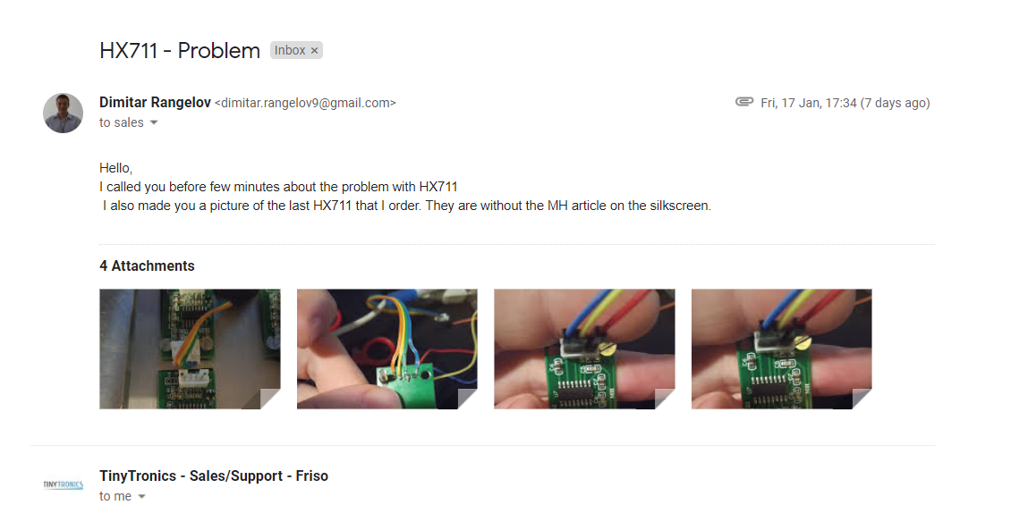

# 22. Skype interview Jorrit Memel

Respondent: Jorrit Memel - Lab coordinator REV’IT

Interviewer 1: Femke Visser – Chairman, Quality Manager,

Interviewer 2: Isabel Wesselink - Quality Manager

Interviewer 3: Harold Kip - Mechatronic Engineer

Interviewer 4: Dimitar Rangelov - Embedded Engineer and Software Developer

Interviewer 5: Le van Hoang Minh - Embedded Engineer

Interviewer 1: ‘Hello Jorrit. How are you?’

Respondent: ‘Hello Saxionners. I’m fine, thank you. How are you doing?’

Interviewer 1: ‘We are doing great, thank you. “We would like to ask a few questions regarding the first draft of the project plan. First of all, what did you think about the project plan?’

Respondent: ‘Required to a standard. In a standard the only thing that is within that standard is safety issues. Like physical safety issues. And the standard is, I will write it down is the 17092.’

Interviewer 1: ‘Was it 70 or 17?’

Respondent: ‘17, it is the cycle garments most protective. And I can get you that one. If I have to provide it to you that’s no problem. I will write that down. So, what happens, so like I told you again. REV’IT! Is in the workgroup nine commission and the 17092 is the standard that makes sure that you can certify your garments that their safety use in a couple of categories. We compose that standard together with some other companies, together with smaller laboratory. And then it has to go for formal voting. The EU commission has a consultant and that consultant will take a look at the standard and see that you have done your job right and that what’s written in that standard is actuallystate. One of the main complains about the consultant was that we didn’t talked about comfort. So, getting wet, getting warm, getting cold. We as a company think that we shouldn’t do so, because it’s a leisure work. So, it’s not professional use it’s for leisure. And if you talk about standards are, I mean, they need to comply to certain conditions. Then were talking about professional use. So professional use. There’s a difference between professional use and to leisure use. Meaning that if it’s cold and your owning a bike. You have the charge whether not to get on your bike or not. Same with raining. So, you can do an assessment if you want to go drive your bike or not. If you’re using it in a professional way if you’re a police agent of whatever then you can say today, I’m not getting on my bike, because it’s raining. So that the difference between the two. And that said we are interested in the comfort level of our rider. We want to make sure that you can stay dry but staying dry versus actually staying dry is not that hard. We have the ISO in the lab for that. We have the water test and you get a pretty decent idea of what is happening. For breathability it is a different story. The test we are using right now is referring to ISO. But actually, the standard we’re using right now is the ASTM. So were testing it according to ASTM 96/95. If you read that test method, you will see that the calculation to calculate the breathability of the fabric is done by using a graph. And of your comments was do we need to measure the weight of the cup at the beginning and end or do we need process. If your read that standard you see that you have to constantly measure the cup. The MVTR is measured by if you look at the graph. I’m taking a certain section out of the graph where the graph has a certain in climb. Therefore, you need to constantly measure what weight it is. You see the graph you go look for that climb and that’s what telling you what the MVTR uses the calculation. Now if your read the standard that you will find out. We can’t do that, so we do our own test right know. So, we measure it in the beginning and at the end. We calculate the MVTR but that will mean not according to the standard. But also, a problem for is that we, where we talked about like gore, gore needs to have a build op before it starts to work. But if you have fabrics like event for instance immediately starts to work. But we can’t see that, we can’t see what’s happening during this period. That the cups are in the oven. So that’s one reason more that, to have a constant reading of the cup. So, two things, we’re using the ASTM 96/95 we need to measure the cup constantly and this is the test that you are going to do is the right from the discussion that started when we had the 17092 out for voting. And that doesn’t mean necessarily agree to that. That we should indicate waterproofness in the cloth value or the breathability of the fabric. Because the breathability of the fabric, just open a zipper and you have more breathability then any magical fabric will do. So, we don’t necessarily agree with that. But we do think that it’s important for us to know the breathability. And what you’re going to do is most likely going to look at the ASTM 96/95, because if you take any of the, if you find another method and you think that way better tell me, and we discuss that. For easy steps this is a perfect start for us/you.’

Interviewer 3: ‘Okay great, thank you. Is it possible for you so send that standard over to us? Because currently we aren’t able to look into the standards. I found a lot of standards but most of them are, yeah you need to pay 80 bucks to see it.’

Respondent: ‘No problem at all. I already wrote it down that I will get you the standards. So, you get the 17092. You won’t see anything about breathability in there, but we mentioned also that we did the tear and dimensional stability test etc. and that standard will exactly tell you which standard we use and what it should comply to. Not that is important for the research but then you have an idea what the standard is about. So those are our final tests. Purely, the test purely done a physical and chemical. If you see that than you have a better idea better understanding. For your information again, what it tells us. There was a comment about the house consultant. That is the guy that tells you if the standard is okay or not. The house consultant he was, he has a major in environmental circumstances. So of course, he was like hey let’s get to the occasion. What I read was very strange that if you go on a short ride, then you need a high breathability cause you’re only out for a short while. This is pure rubbish. It doesn’t matter if you go for a short ride or for a long ride. Breathability is breathability and if something doesn’t breathe then it doesn’t breathe in short terms then it also doesn’t breathe in a long term. So, breathability is breathability. Whether you ride long, or you’re driven short. You have to understand that 17092 is mainly opposed by some Australian guy. That want to have their own standard in to place. It’s about money. If it’s not mandatory, still if we talked about membranes and buy a membrane or supplier gets the data related to the membrane. Tested purely alone. So, on itself, but then we don’t know what the fabric does. So, we need to do a counter test on the actual fabric itself, otherwise we can claim that something happens. And the jar gives a breathability of 30000 and the membrane itself. If we laminate, it to a glass window. The glass window has a breathability of 30000 so we need to access to complete, so membrane and the fabric itself. So that one of the reasons why we want to do this test, because everything our supplier says are data again purely based on the membrane itself. That’s why we are also not that interested in the membrane itself because you can have a high breathable membrane, but it has a sort of chemical composition and some chemical composition work rough, with the same chemical composition. But if you use it with a fabric that has a different composition then it can be reduced to zero of the breathability of the membrane. So, for us the complete package is important.’

Interviewer 3: ‘I also found out that two years ago you actually had another Saxion project with also a lot of data from humidity and temperature sensors which were woven into a suit. Is it possible to get that report? Because in that report might be also data relevant to us.’

Respondent: ‘Of course, I will do so. No problem, I will get you that report too. actually, so you know the first group came half and the second group came three quarters. So, there are two groups who worked on that and I will ask research and innovation to give it to you. No problem.’

Interviewer 1: ‘Okay great. So, we composed the main and sub questions. Well we had some comments from Jenny to make the main question less long. What did you think about the main question?’

Respondent: ‘While I’m reading, I see on page two the comment why it is important to measure the breathability. As I said the first point is that we can’t use the data from our suppliers. They say the membrane has a breathability of 20.000 RET. That is the membrane. But what does the whole package. What does it mean if it is laminated to another fabric? So, we need real data and not statistics from suppliers. But also, what we talked about is that okay we keep our drivers save with the products we have. Now we want to keep them comfortable as well. It is important to have them comfortable as well. The main question is way too long. It is page three if I’m not mistaking. To what extent can a device be developed which can gather the data of the evaporation time, humidity and temperature in the oven. I think the fact that you have the evaporation time, humidity and temperature in the oven and the weight Is sort of. If you want to make the main question shorter it is to be detailed. I would say make a device that can measure breathability. That is enough. That is the only thing I want to know right now or what is the breathability of the fabric. And that we need to know the evaporation time, humidity and temperature in the oven, the weight of the six cups. The time the time itself. We need to know the temperature and we need to know the weight of the cups. It would be super nice to know what the humidity is inside the cup and on the outside of the cup. The same with temperature. It would be super interesting to know what the temperature is within the cup or outside the cup. But those are steps that will come later. First you want to build a machine that measures breathability. So, I would keep that simple. That is your main task and in the sub questions themselves. Because you also had some comments on that if I’m not mistaking.’

All interviewers: ‘Yes’

Respondent: ‘She says it does not need to be in detailed. Just the device which measures breathability.’

Interviewer 4: ‘But for example, we can make this device to measure breathability and after that everything like time and weight can be our sub questions. In that case.’

Respondent: ‘I do agree on that. I would do it like that and make sure that you prioritize. So, your sub questions okay we make a device which can measure breathability. Sub question one; Can you make something that weighs the cup at all time? Sub question two; Can you make something that measures the temperature at all time? And then step by step you go to the more difficult question. But also, to the questions if they are not necessarily fulfilled than that isn’t a huge problem. But if we don’t know the weight, if we don’t know the temperature then we have kind of a problem.’

Interviewer 1: ‘Yes, I can imagine. I think we can definitely work with all this information. If you can provide us the standards, we can read them all through. We need to change the problem analysis a bit more, so it is more detailed.’

Respondent: ‘Just give some context. I don’t necessarily agree with Miss Hesse. For me you don’t hand out this report to someone on the street and ask; Hey do you understand what we are talking about. We are talking together within this project. But if Saxion want that that is fine. But if you give it some more context what breathability has to do with the comfort level. If you do research, for instance, the Australian guy wrote keep in mind a lot of politics do. It is not necessarily scientific piece that is completely true. But for that matter it doesn’t hurt either to say so. If you rewrite the sub questions and prioritize them, please. Tomorrow I will be here for the whole day and after that on Wednesday, Thursday and Friday I will be climbing in Italy. So, I won’t be here. It is also to get in touch with the outside world. But I think you have enough to structure the document.’

Interviewer 1: ‘Yes, definitely. I think we can go forward with this information. Well we have to hand in our project plan the 22nd of September. So, we will work with your feedback and with Jenny’s feedback to adjust the project plan and we will update you of course.’

Respondent: ‘Perfect, sounds great. And I will make sure you will get the standards, starting with the 17092. Sometimes I will provide you the older standard so you will not have the most recent standard, but for this it doesn’t matter much. As long if you have an understanding. Especially the ASTM 96/95 and the calculation of the breathability. What you also already found out is that this isn’t a very. We do this for ourselves. If someone else will use this standard they will build it another way and would have different outcomes. For us it is not important that we have an outcome that we can actually use towards our suppliers. For us it is to get a feeling of the fabrics we use and to indicate them according to our own test method. So, it doesn’t have to be an international standard. It is something for us. And that said I will forward you an email from Intrepid. Intrepid is a supplier of a membrane and had some interesting things to tell about test methods for breathability. And why he doesn’t like our testing method. But I will send that to you as well.’

Interviewer 1: ‘Great. In our last email we mentioned the cups and all the kinds of fabrics which we requested. Yes, you will send this to us.’

Respondent: ‘Yes, I will make sure I will send it out tomorrow. So, you will have the stuff you will need to start with. You required one cup if I’m not mistaking?’

Interviewer 3: ‘Yes, because it is a cup mainly to take measurements from and do a reference against. If we have the cup it is possible to make a drawing and send it out to make cheaper ones. Because to drill in a four-hundred-euro cup to put the sensor in it is a little bit risky.’

Respondent: ‘Yes, I will send one of the cups out to you as well. If you make sure I will get it back in time and it is still in one piece I would be very grateful. No problem.’

Interviewer 1: ‘To what address are you sending them?’

Respondent: ‘The address that you are going to mail me.’

Interviewer 1: ‘Okay, that is great. Yes, then we will await your answer and you will hear from us as soon as possible with the new project plan and if we need anything else or have any questions.’

Respondent: ‘Yes, let me know. I’m here tomorrow all day and today as well. If you have any questions do not hesitate to call.’

Interviewer 1: ‘Great. Well, thank you for everything.’

Interviewer 3: ‘Do you have any questions left for us?’

Respondent: ‘To be honest no. As long as you start with the ASTM 96/95 then you will have a better understanding for what is happening and what we are doing. And again, I’m not asking you to build an ISO whatever machine. I’m asking you to build something that can do these measurements and is purely for internal use of REV’IT! Itself. So, we have a better understanding about the breathability of fabrics. If you are going to create everything there is to know about membranes than you will know that if you want to test them in real life, some of you mentioned it, then we will have a hard time. During the process you find something that you think is worth to incorporate in the testing method because you that is giving you a closer represents in real life then go ahead. Be free. But start with the basics and see how far you will come.’

Interviewer 3: ‘Because I already found some papers from a university with the comparison of standards. It would be interesting to look at it.’

Respondent: ‘Yes, and if you can forward that paper to me as well. So, that is a question for you indeed. Then I will be very thankful for that. But start with the 96/95 and if you think it is completely rubbish than you email me and tell me Jorrit that is completely rubbish. We have way better methods in mind. Be my guest.’

Interviewer 3: ‘I don’t have any questions left.’

Interviewer 1: ‘Great. I think everything has been answered.’

Respondent: ‘Yes, fine. Goodluck and again I’m here today and tomorrow for any questions.’

All interviewers: ‘Thank you.’

Respondent: ‘Thank you. Bye.’